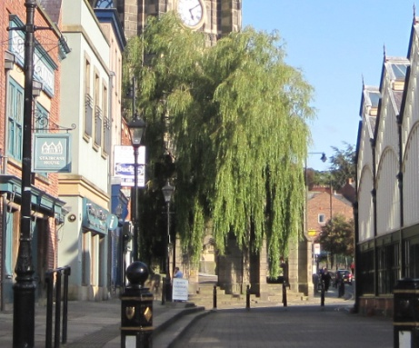
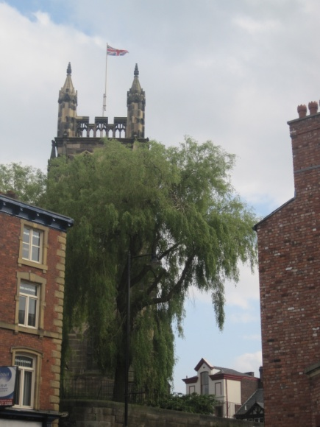
Cast your mind back to the summertime when the trees were in leaf and there was no sign of a snowflake. Like it or not, the time has come to say “good bye” to the problematic Willow trees. It will be strange to be without them (for awhile at

least) but felling will start on the 11th February (or thereabouts) now that all permissions have been received. You have to admit that this was not necessarily the best location to plant Willow in the first place, and although they have been trimmed over the years they are now over-sized and causing “expensive” damage.
We have chosen the replacement trees, with the help of the Council, who are of course responsible for the upkeep of the Churchyard. The new trees are ordered and will be planted when the time is right and the site prepared. Just think, we will have an open view to the Church, at least whilst the trees are small, which will be marvellous when the archway is repaired and the tower work completed.

Reminder
Shrove Tuesday (12th February)
Pancake Party at St Mary’s Rectory. 6pm – 8pm.

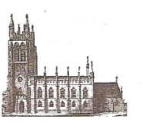
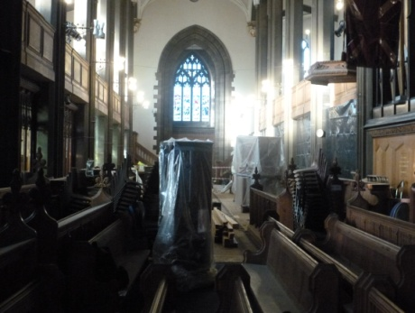
St Mary’s in the Marketplace. .
Securing the future for the next 100 years

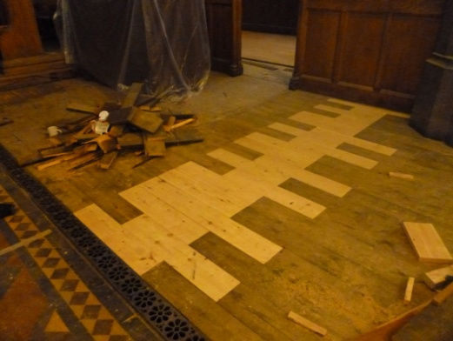
News from
St Mary’s
[incorporating Building News No 30]
10th February 2013
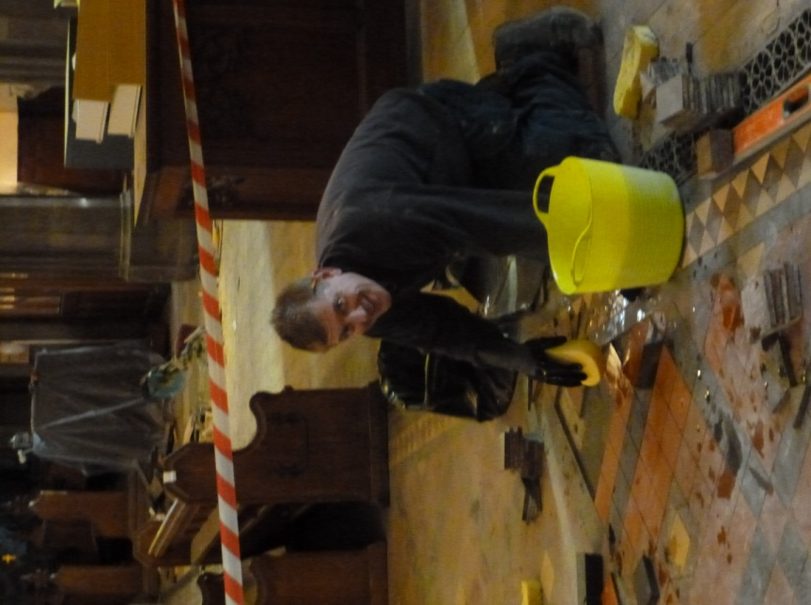
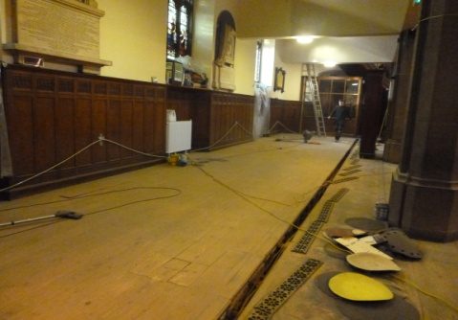
The second week of our closure and St Mary’s remains
a building site with many different trades working hard to complete the works on schedule. Items are wrapped and covered in sheet upon sheet of plastic to help keep the dust down – and there is certainly dust coming off the sanding of the floors, but what a result! The heating grills are up and there has been a considerable amount of patching to be done where the old floor boards were damaged. But the overall results of the sanding is fantastic – well it will be when all the dust is removed and the boards sealed and waxed. The south aisle is now completely sanded and the temporary electrics removed.
At various locations piles of tiles can be found whilst repairs to the tiled part of the flooring is being undertaken. The part being worked on being clearly taped off, to ensure no one walks on the tiles during this delicate operation. Quite a complex task to prepare the area, removing the old fixative and cleaning inch by inch, removing dust and grime, before putting the new tiles in place.
By far, the best idea at the moment it to allow the guys to get on with the task in hand and they are certainly putting the time in, including weekends. There was no way in the world we could have used the Church whilst all this work was being undertaken, but the results will be well worth the inconvenience.
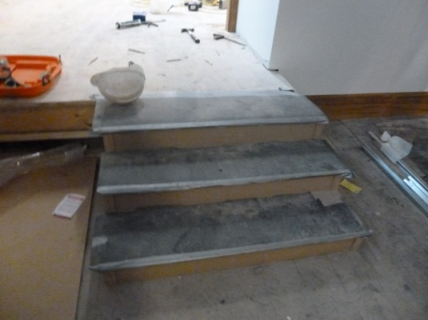
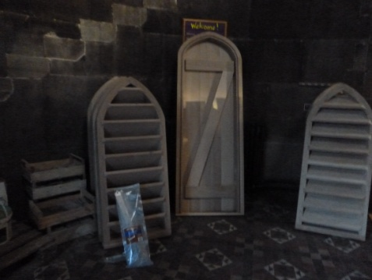
Sitting in the Tower at the moment, some rather impressive bits of wood – which I can only assume is heading upward. The attention to detail is to been seen to be believed really, pity that for the most part there is a lot that we will never actually see on it is in place, other than in photographs of course.
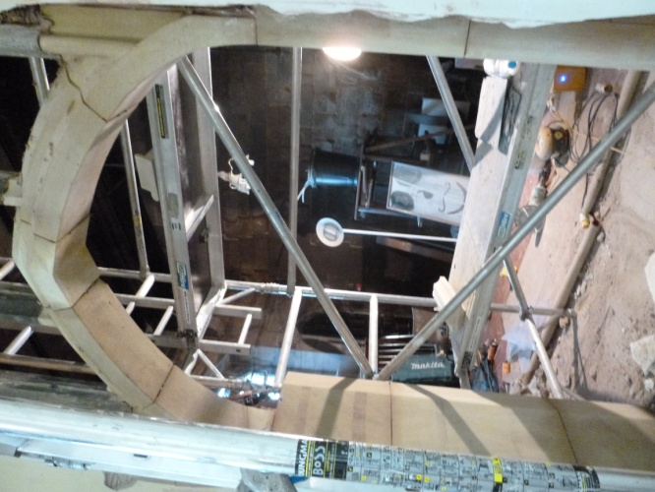
We will however see the new steps into the Heritage area. The lift will be placed to the left of these in due course. The new doors are also in place and beautifully varnished. The Stockport Heritage Trust are busy planning their return, working out where to place their display units and the joint running of the Church shop.
Another feature that we will most certainly be able to admire will be the new archway between Heritage and the former Choir Vestry. Although it will be boarded initially (with just a fire exit door fitted) the arch itself (and window above) will be a feature to be proud of, in-keeping with that area of the building.
The decorators are busy in the back, the black sheeting still in place providing a barrier between work in the north aisle and the rest of the Church. It won’t be long now before it all comes down.
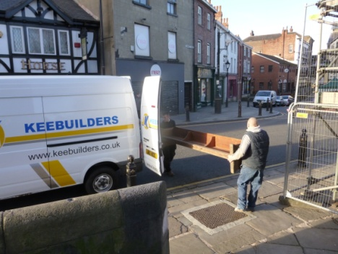
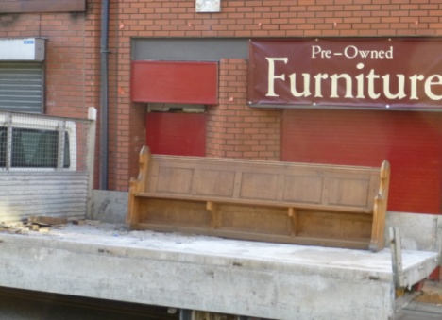
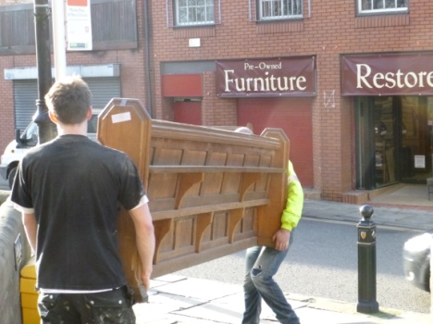
The pew issue remains, although many have now been sold, some still awaiting transportation to their new homes, others having already gone. We have a few left at St Mary’s, many others at St Mark’s. Edgeley. Let us know if you know anyone who may be interested in owning a little of St Mary’s. Private sales will continue until we are forced to consider selling to a reclamation company all those remaining in store. Viewing sessions have been held at St Mary’s and St Mark’s – viewing is now strictly by appointment and presently at St Marks. The pews although stored for several months are still in good condition - nothing that a duster won’t cure! Collections are also by arrangement at both locations.
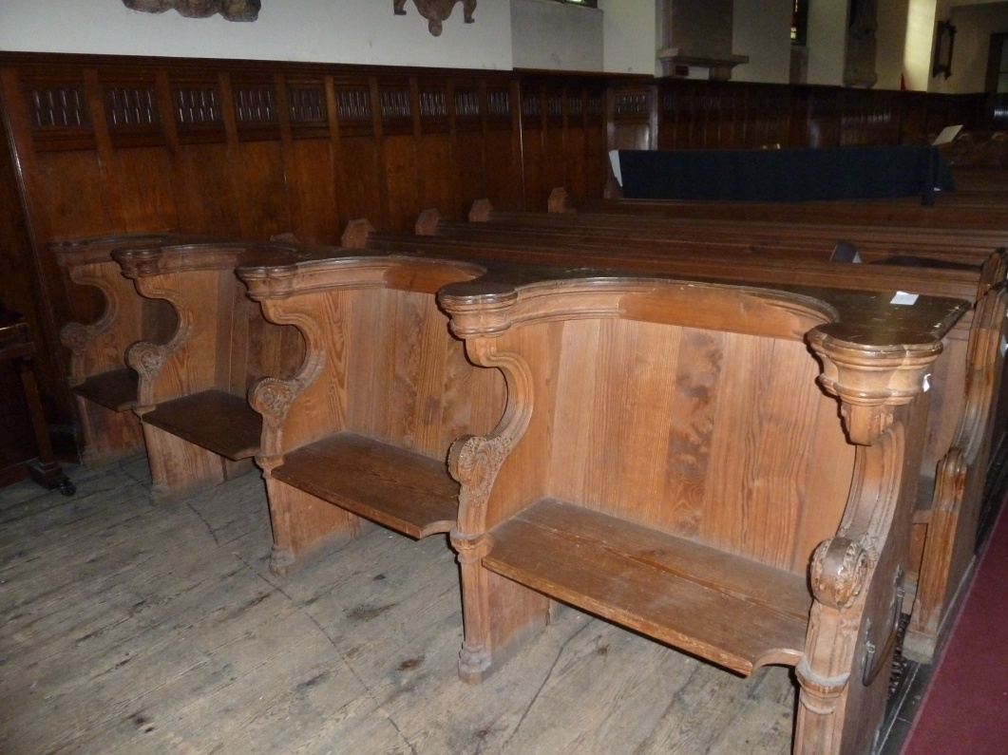
The Mayoral pews/frontals have been offered to Stockport Council, we await a decision as to whether or not they are to going to take them either at the Town Hall, Staircase House or at other location.
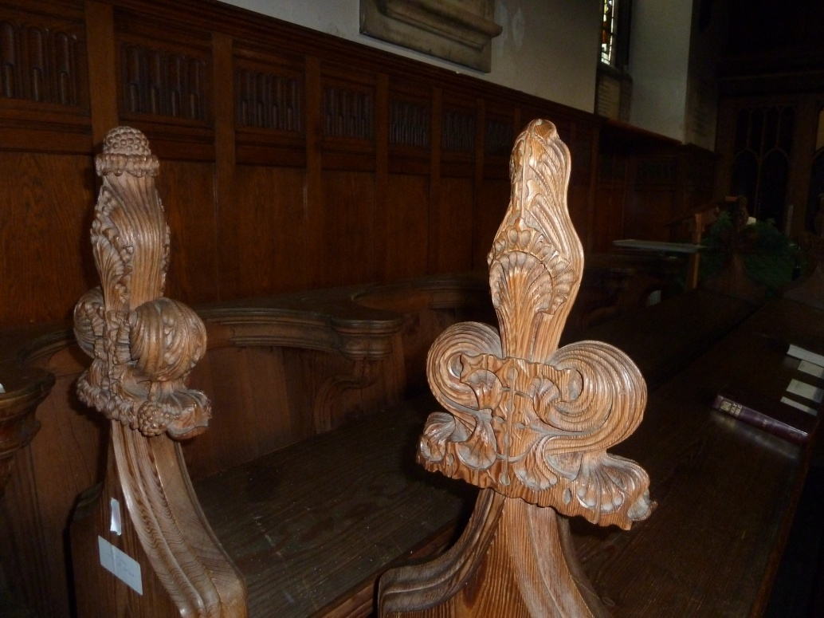
Pews are on the move – to Ireland, the Orkney Islands, and who knows where else by the time we have finished!

