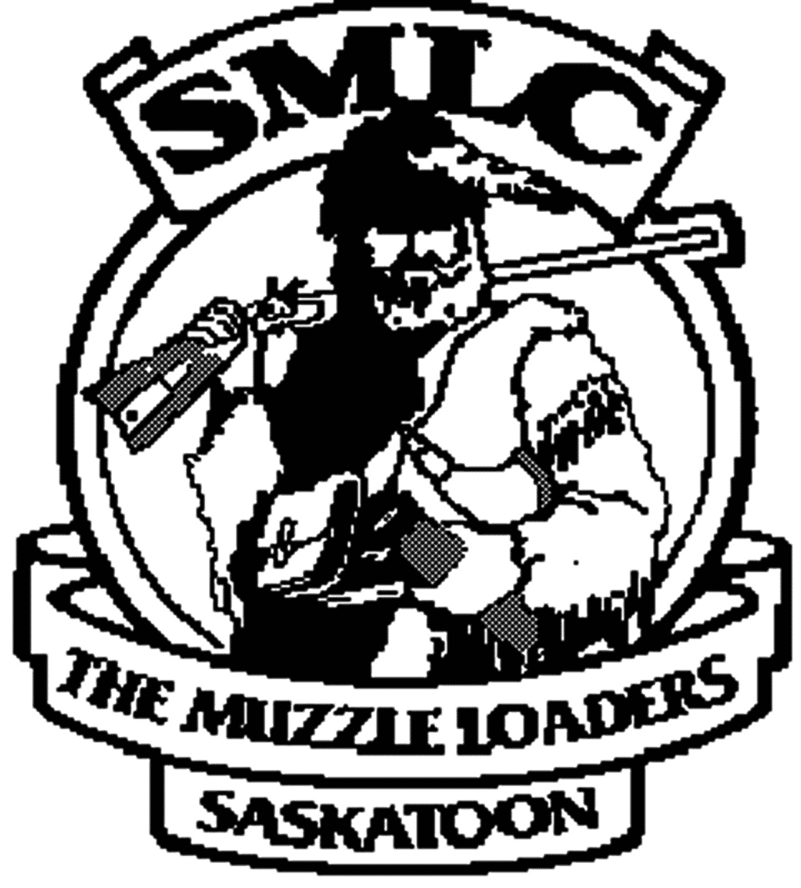

Saskatoon Muzzle Loading Club Inc
Box 643
Saskatoon, SK S7K 3L7

January 7, 2023

We are the Saskatoon Muzzle Loading Club Inc. (SMLC), a small club in Saskatchewan that has been active since 1963. Our Club is comprised of men, women and families that share a love of antique and muzzleloading firearms. Scores of kids have been taught to safely use and respect a firearm on our range. We host a variety of different shooting events every year. We are also affiliated with The Saskatchewan Black Powder Association (SBPA).
The SBPA was created in 1981 to start a special hunting season for those who wanted to hunt with more traditional muzzle loading rifles. After successfully lobbying the provincial Government, the muzzle loading seasons for deer, both whitetail and mule deer, moose, and elk that we enjoy today were created. Since then, the SBPA has gone on to become the umbrella organization for all kinds of black powder sports across the province. There are shooting ranges and clubs, like the SMLC, dedicated to shooting black powder as well as smokeless rifles and pistols of all kinds. At these ranges you'll find traditional side hammer muzzle loaders, high wall and antique military rifles including Sniders, and Springfields. The people you will find shooting these antiques and reproductions are among the most knowledgeable shooting enthusiasts you'll find anywhere.
At the SMLC we also have a Cowboy Action Shooting Range which hosts multiple events every year. Cowboy Action Shooting is a very popular shooting sport with members belonging to The SMLC as well as The Saskatchewan Association of Wild West Shooters and The Single Action Shooting Society, which is an international shooting club. All three clubs compete at different levels of “Sport Shooting” and competitions are held in countries all over the world. This handgun freeze has effectively stopped any new shooters from joining our sport and competing on an international level if they do not already own the required firearms. New shooters wanting to join and compete in their own communities or on an international level cannot purchase the proper firearms to engage or advance in this sport. This handgun freeze will be the demise of many great shooting sports.
We use handguns in our competitions from muzzle loading pistols to six shooters depending on the event. How do we keep our sport alive when no one can purchase or transfer handguns? Even with the freeze if legal licensed gun owners were able to continue to buy and sell the existing handguns in Canada it would greatly extend the life of our shooting sports. Our investment in our firearms is extinguished because of not being able to buy, sell or trade.
When clubs hold competition events the communities in the surrounding area benefit. Even a small event of 100 or so participants cascades into a wealth of income for the affected communities. Hotels, restaurants, shopping, campgrounds, fuel stations and many more. There are a vast number of clubs in Canada that will be affected from Vancouver Island to the East Coast.
Some shooting disciplines are still able to buy handguns for their sport (Olympic and Paralympic) allowing them to continue to train to be a shooter. How will a person ever know if they have the potential to become an Olympic shooter if they can never purchase a handgun? Why aren’t our shooting sports protected as well? Why are we being discriminated against as legal firearm owners because our sport isn’t on the world stage? Why are our shooting sports forced to die?
The sheer magnitude of what you have to do to legally own a handgun in Canada and the steps and rules you have to adhere to are already stringent enough. This handgun freeze, the previous bans and the proposed semi-auto ban will not work. Throwing new laws out there for political gain gives the anti-gun community a false sense of safety because these are not the guns predominantly causing the problem. Legal, law-abiding gun owners are unfairly targeted when it has already been proven that the vast majority of handguns used in crime in Canada are smuggled across the border from the USA.
Buybacks make no sense as you are taking a legal firearm out of the hands of a law-abiding citizen and spending tax payer money to do it. These billions of dollars could be used for more policing, more border security and more mental health resources. Places where it could make a difference. The firearms banned in May of 2020 still haven’t been dealt with and the owners of these banned firearms have them sitting in limbo as they can’t leave the owner’s residence.
PLEASE DO NOT LET OUR SHOOTING SPORTS DIE
Sincerely

