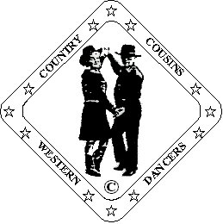
Ron & Ann Williams.
D&G Fully Qualified Instructors
023 92 341758 ronannwilliams@aol.com

How Could I

Partner Dance (64 Counts)
Choreographed By Ann Williams. 04/16
Music: “How Could I Love Her So Much” Jerry & The Ruf-Nex
CD “ Made In Texas” i Tunes
Thanks to Caroline & Terry for their help and Terry for helping with the teaching.
Beats/Step Description.
Start facing L.O.D. in Right Side By Side “Sweetheart” position.
Opposite feet. Man’s steps listed.

Step. Kick-Ball-Step. Step. Rocking Chair.
1 2&3 4 Step left forward. Kick right forward. Step right on ball of right beside left. Step left forward. Step right forward.
5-8 Step and rock forward on left. Recover onto right. Step and rock back on left. Recover onto right.

Man: Walk, Walk. Shuffle. Lady: ½ Turn Left. Shuffle Back.
9-12 Man: Walk forward stepping on left. right. Left shuffle forward.
Lady: Step onto right, left making ½ turn left to face R.L.O.D. Right shuffle backwards.
Raise right hands over lady’s head to finish with hands crossed in front, right on top.
Lady facing R.L.O.D man facing L.O.D.

Rock, Recover. Shuffle. (Lady: ½ turn shuffle) X 2
13-16 Man: Step and rock forward on right. Recover onto left. Right shuffle backward.
Lady: Step and rock back on left. Recover forward onto right. Left shuffle making ½ turn right to face L.O.D.
Raise right hands over lady’s head to finish in Right Side By Side facing L.O.D.
17-20 Man: Step and rock back on left. Recover onto right. left shuffle forward.
Lady: Step and rock back on right. Recover forward onto left. Right shuffle making ½ turn left to face R.L.O.D.
Raise right hands over lady’s head to finish with hands crossed in front, right on top.

Step. ¼ Turn. Cross Shuffle.
21-24 Man: Step forward on right. Turn ¼ turn right stepping left to left side. Cross right over left into right cross shuffle.
Lady: Step back on left. Turn ¼ right stepping onto right. Cross left over right into left cross shuffle.
Finish facing partner slightly offset left shoulder to left shoulder. Lady facing I.L.O.D. Man facing O.L.O.D.
Hands still crossed, right on top.

Step. ¼ Turn. Triple Step ½ Turn.
25-28 Man: Step forward on left. Step onto right making ¼ turn right. Triple step in place making ½ turn right on L.R.L.
Lady: Step forward on right. Step onto left making ¼ turn left. Triple step in place making ½ turn left on R.L.R.
Raise right hands over man’s head followed by left to finish with hands crossed in front, left on top.
You have now changed sides with partner, lady on man’s left, both facing L.O.D.

Walk. Walk. Shuffle. Walk. Walk. Shuffle.
29-32 Walk forward stepping on right, left. Right shuffle forward.
33-36 Walk forward stepping on left, right. Left shuffle forward.

¼ Turn. Cross Behind. ¼ Turn. Step. Pivot ½ Turn. ¼ Turn. Cross Behind. ¼ Turn. (Figure 8)
37-44 Step right forward making ¼ turn left. Cross left behind right. Turn ¼ turn right stepping onto right.
Step left forward. Release hands. Pivot ½ turn right to face R.L.O.D. Turn ¼ turn right stepping left to side.
Take up Open Double Hand Hold. Cross right behind left. Turn ¼ left stepping onto left.
Release forward hands, man’s left, lady’s right. Now facing R.L.O.D. holding inside hands.

Rock. Recover. Shuffle ½ Turn. Rock. Recover. Shuffle ½ Turn.
45-48 Rock forward on right. Recover onto left. Triple step ½ turn right to face L.O.D.
49-52 Rock forward on left. Recover onto right. Triple step ½ turn left to face R.L.O.D.
Chang hands on turns, finish facing R.L.O.D. holding inside hands.

Step. Pivot. ½ Turn. Shuffle. ¼ Turn. ½ Turn. Cross Shuffle.
53-56 Step right forward. release hands. Pivot ½ turn left. Rejoin inside hands. Right shuffle forward.
57-60 Step left forward making ¼ turn right. Turn ½ turn stepping onto right. Cross left over right into a cross shuffle.
Release hands for turns. Rejoin hands crossed in front for left cross shuffle, left hands on top.
Finish offset right shoulder to right shoulder

Changing Sides. Step. ¼ Turn. Shuffle Forward.
61-64 Step right forward. Turn ¼ right to face L.O.D. stepping onto left. Right shuffle forward stepping on R.L.R.
Raise left hands over lady’s head, right hands go to lady’s right shoulder into Right Side by Side position.
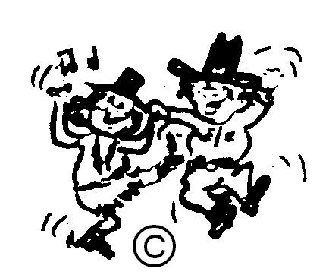
(Sweetheart) Now facing L.O.D.

HAPPY DANCING

