Nutrition Plus, Inc.
121 Mays Rd., Winfield, KS. 67156
Emily Roark Patti Brenn Susan Morrell
(620) 221-2777 (620) 218-1811 (785) 230-7441
roark2@cox.net pattibrenn@cox.net smorrell12@gmail.com
www.nutritionplusinc.com
May is:
4th – National Orange Juice Day
7th – National Provider Appreciation Day!!!
10th – National Shrimp Day
14th - National Buttermilk Biscuit Day
21st – National Pizza Party Day
28th – National Brisket and Hamburger Day

Important dates:

May 28th – Checks/Direct Deposits go out

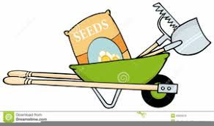
It’s Garden Time!

It’s planting season for many of our favorite vegetables and fruits. In the past many of our providers have enjoyed gardening with the daycare kids and have been very successful! Historically, children aren’t very eager to try new foods. By planning, planting, observing and finally harvesting their foods, an unpleasant experience now becomes fun for them! 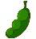 Not only can letting the kids garden with you, help them enjoy trying new foods, but it can also provide educational activities in a fun and unconventional way.
- Fine motor skills are used to sort and plant small seeds.
- Simple math skills are used when they measure and count seeds.
- Science lessons are learned when they observe that seeds need soil, water, sunlight and time to grow into plants. It’s also used to predict how large a plant will grow!
May 2021
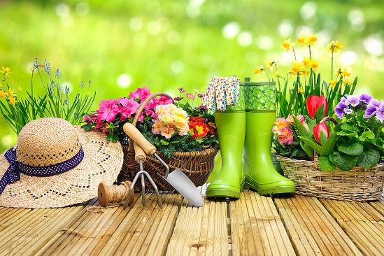

- Food safety and cleanliness is as important as ever. All children should know the handwashing steps and when it is important to do so. You can also be taught why it’s important to rinse fruits and vegetables with water before eating.
- Self-esteem and independence are important for all kiddos to learn and have reinforced regularly. You can do this by allowing them to work together in groups and other activities when appropriate. When doing new activities, show and help them at first. Then let them do what they can. This will give them chance to learn, try, and feel proud. Mistakes can happen. Have a plan in case these happen. I’ve observed many of you show great patience, and have no doubt you will do this nicely!
Please don’t be intimidated by the idea of gardening with the daycare kiddos. If it is new to you, you can always start small with container gardens like this:

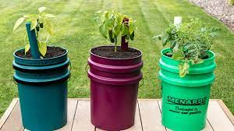

They don’t all have to be in-ground, rows after rows of different varieties. There are many container options available to view online.
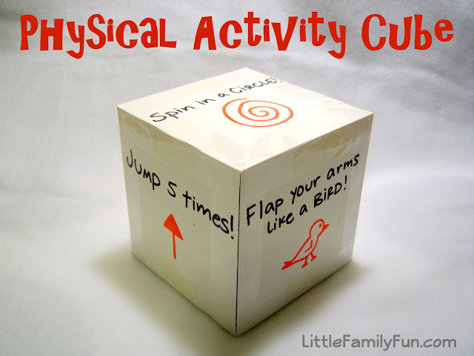
I thought this was a fabulous idea for a rainy day!

Using white cardstock, cut out 6 squares (about 6”x6” squares)
Write the activities on each square.
Tape the squares together using clear packing tape.
Before you tape the last square on, stuff in a few pieces of crumpled newspaper to give it more stability. Here are ideas of what to put on it:
*Spin in a circle
*Jump 5 times
*Flap your arms like a bird
*Hop on one foot
*Dance
*3 Sit-ups
There are many more fun activities that will work!

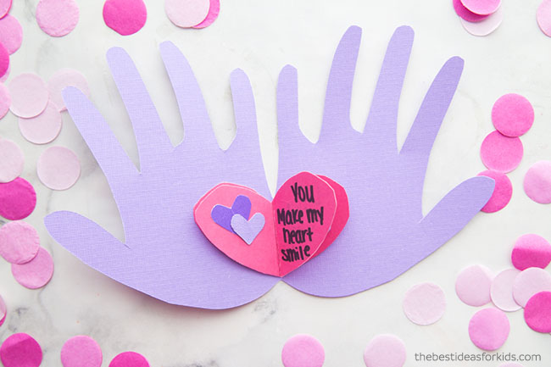
Handprint Mother’s Day Card
You only need 2 or 3 colors of cardstock or construction paper, glue, a marker and scissors. Fold the paper in half. Trace the left handprint on the paper, leaving the outside edge of the hand on the seam so it holds together when opened. Cut out. On another color of paper, cut out one medium size heart and two small ones. Glue the small hearts to the medium one, staggering for depth (only 1 small heart is needed if only 1 color). Glue the medium heart on the seam. Fold over to create the seam in the heart. Reopen and write a nice message for mom!

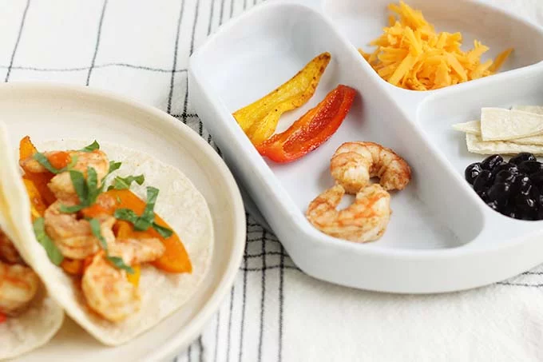
Easy Shrimp Tacos
Ingredients:
1 lb. frozen shrimp
1 bag mini bell peppers or 3 medium bell peppers
1 tablespoon canola or other neutral oil
1 teaspoon cumin
1/2 teaspoon chili powder
1/2 teaspoon garlic powder
1/4 teaspoon salt
8–10 corn or flour tortillas
Black beans, shredded cheese, salsa, shredded lettuce, and/or cilantro for serving

Thaw the shrimp according to package directions and remove the shells and tails.

Slice the peppers into thin strips and discard the seeds and stem. Warm the oil over medium heat in a large nonstick or stainless skillet. Add the peppers, cumin, chili powder, garlic powder, and salt. Toss to coat. Cover and cook for 4 minutes.

Stir in the shrimp. Cover and cook for an additional 4-6 minutes, stirring occasionally, or until the peppers are soft and the shrimp is cooked through and opaque.

Warm tortillas, dampen a paper towel. Wrap around a stack of tortillas and warm in the microwave for 60 seconds, flipping over halfway through.

As always, you are all appreciated! Thanks!!

