Trinity Times TimTimes
Volume 8, Issue 11
November 2021

My Ministry

Each year many people have stepped forward to establish the ministries that God is calling them to here at Trinity. Others may ask how they might determine God’s call for them. Although this question can have many answers Neil M. Alexander has written a leaflet for Methodist Discipleship Resources that I think can be very helpful to us all. Due to the length, I will post Part I this month and Part II next month.
istry in My Community
Ministry in My Community

Part I

“. . . love your neighbor as yourself”
(Leviticus 19:18)
“Accept one another . . . just as Christ accepted you,
in order to bring praise to God. (Romans 15:7)
“ . . . better a neighbor nearby than a brother
far away” (Proverbs 27:10)
“ . . . who are you to judge your neighbor?”
(James 4:12)

When the lawyer put Jesus to the test concerning the way to eternal life, Jesus told him to love God and neighbor: “Do this,” he said, “and you will live” (Luke 10:25-28).
The message is clear. But it can also seem overwhelming. After all, we can’t be responsible for all who are in trouble or in pain. We do not have the energy or the courage to love everyone! If not everyone, then who? As the lawyer asked, Who is our neighbor?

Know your neighbors.
Take a walk or drive around your community. What do you see? Who lives nearby? What are their hopes and hurts and needs? You are bound to the people and institutions around you. You depend on the quality of nearby schools, shops, entertainment venues, medical facilities, and places of worship to set the tone for life in your community. If children in your community are not safe from abuse; if single parents feel overwhelmed by daily tasks and obligations; if older adults feel lonely and abandoned; your life is diminished.

See your neighbors.
Sometimes we do not see our neighbors as they really are. Sometimes we look the other way. Yet, if you open your eyes to the hopes, hurts, and needs of others, you will find many opportunities for service and witness.
Families with members with mental or physical disabilities long for a few hours of relief so that caregivers can get away for a brief time. Older adults often have talents and expertise to share but few places to do so.

Young people want to serve God as peacemakers in a troubled world but are unsure where or how to start.
Do you see them? Children at home alone for long periods could use someone to call for help or reassurance. New residents are sometimes reluctant to venture into community or church activities when the regulars fail to extend a special welcome. Transportation to medical facilities can place a heavy burden on individuals and families dealing with extended illness. Do you see them?

In Christ,

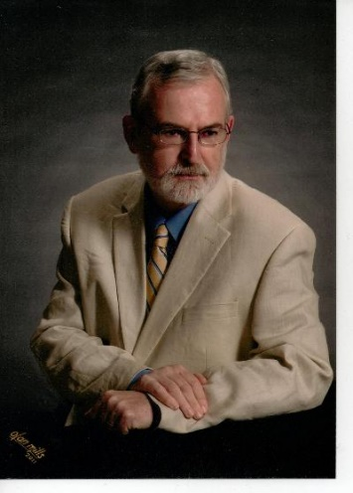
Pastor Doug

Trinity United Methodist Church
1160 Trinity Church Road
Newberry, SC 29108
803-276-1245 Office
803-543-0082 Pastor Cell
dobenton@umcsc.net
www.trinityumcnewberry.net
PLEASE VISIT OUR WEBSITE
AS OFTEN AS YOU CAN!

Peggy Bogart, Church Secretary
Head Usher: Harry Longshore
Choir Director: Jane Pollard
Organist: Eddie Welborn
Substitute Organist: Phyllis Sanders
Video Board: Josh Pitts, Foster Senn, Bryan Waldrop
Acolytes/Cross Bearers Coordinator: Open
Newsletter Editor: Harriet Stevenson

Sunday Worship:
Worship Service: 11:00 a.m.

We are a nurturing and open church to all who enter into our Sanctuary. We base our ministry on the Word of God and a caring spirit. Jesus invites us to share our ministry to all that come into our church.

We are a caring and loving church and we want to share your concerns. Let us know if you or someone you know would like to share a prayer request with us. We will be happy to pray for you. Contact Harriet Stevenson, Peggy Bogart, Church Secretary, or Pastor Doug to add or remove names from the Prayer List.
Recent Hospitalizations and/or Surgeries: Boyd Davenport
Known Hospitalizations:
Nursing Home: Gloria Brehmer (Springfield Place)
Prayers: James and Jeannette Poag, Robert Pollard, Shirley Berry, Tommy Werts
Family and Friends of Trinity: Wilson Bowles, Neil Thomas, Francis Leopard, Kinsley Bouknight, Candice Nelson, Janna Longshore, Alex Taylor

If you would like to place flowers in the church, please sign the flower chart located in the narthex entry. Record your name on the Sunday you wish to place flowers in the church. Please complete and return an Altar Flower Sheet form to the desk of Peggy Bogart, Church Secretary, with the wording for the bulletin.

Nov. 7- Bridget Bouknight
Nov.14 – Lynn Mohler
Nov. 21 – Joan Morris
Nov. 28 – Kelly Morris

Nov. 7 Phyllis Sanders
Nov. 14 Foster Senn
Nov. 21 Josh Pitts
Nov. 28 Harry Longshore

SILVER AND GOLD RETURNS
NOVEMBER 10, 2021
11:30 A.M.
FELLOWSHIP HALL
HOSTED BY HARRIET AND PHYLLIS
NO NEED TO BRING ANYTHING
JUST COME AND FALL FOR JESUS!!!

ALL MEN & WOMEN 55+ ARE WELCOME
RSVP TO HARRIET OR PHYLLIS
BY NOVEMBER 6

3 – Jane Woodward
8 – Michael Bouknight
11 – Jim Waldrop
18 – Myrtle Longshore
19 – Crystal Waldrop
21 – Doug Benton
27 – Jeannette Poag
27 – Noah Waldrop
28 – Gloria Brehmer
30 – Kruz Bouknight

When you go to bed on Saturday evening, November 6, be sure to set your clocks back an hour. Daylight Savings Time ends at 2:00 a.m. on November 7.

2021

Sunday | Monday | Tuesday | Wednesday | Thursday | Friday | Saturday
 | 1 | 2 | 3 | 4 | 5 | 6
 | Trinity Women’s Club  6:00 p.m.  . | Called Adm Council Meeting 6:00 p.m. | Trinity Men’s Club  7:30 p.m..
7 | 8 | 9 | 10 | 11 | 12 | 13
Birthday and Anniversary Recognitions  HOTDOG COOKOUT & BAKE SALE AFTER SERVICE  all Saints sunday  Daylight Savings tIME ENDS | Administrative Council  6:30 p.m. |  | Silver and Gold  11:30 a.m.  Fellowship  Hall | . Veterans Day  .
14 | 15 | 16 | 17 | 18 | 19 | 20
MYF Meets  5:00 pm | . |  |  | . |  | .
21 17 13 14 15 16 17 18  Deadline for Turn in of Shoeboxes | 22 14 15 16 17 18 | 23 14 15 16 17 18 | 24 14 15 16 17 18 | 25 14 15 16 17 18  Thanksgiving Day  Be Grateful | 26 26 14 15 16 17 18 | 27 14 15 16 17 18
28  Advent  Begins | 29 | 30
Visit our website: www.trinityumcnewberry.com Visit our FB Page: trinityumcnewberry

Organizations and Opportunities to Serve:

Trinity  Women’s  Club  1st Monday  6:00 p.m. | 2021 Leadership Committee: Harriet Stevenson, Susan Longshore, Dixie Waldrop  The Trinity Women’s Club will have a hotdog lunch after the 11:00 a.m. service on November 7. There is no cost for the lunch, but donations will be accepted. They will also be having a bake sale in the Fellowship Hall. You may eat in or take out. The proceeds from this fundraiser will help defray the cost of shipping the new cookbook which will be coming out soon as well as local projects for the Trinity Women’s Club.  Next Meeting: November 1 - 6:00 p.m. - Devotions: Sharon Baughman

Silver  And  Gold  2nd  Wednesday  11:30 p.m.  __________  Men’s Club  1st Wednesday  7:30 p.m. | The Silver and Gold will have their first meeting of the year on November 10 in the Fellowship Hall with a Soup Luncheon. You do not have to bring anything. Harriet Stevenson and Phyllis Sanders will be the hosts and will provide everything. The theme will be Fall for Jesus: He Never Leaves. We hope to have a good crowd. For the safety of others, if you have not had your covid vaccinations, please consider not attending any Silver and Gold meetings at this time. We will have a devotional program and a drawing at the end with gifts provided by Harriet and Phyllis. All seniors, 55+, male or female, are invited and encouraged to attend our meetings. You do not have to be a member of Trinity to attend. WE WILL BE ELECTING LEADERSHIP POSITIONS FOR 2022 AT THIS MEETING.  MARK YOUR CALENDARS: NOVEMBER 10, 11:30 P.M. , FELLOWSHIP HALL  Officers: President- Johnnie Pitts; Vice President-Ashley Wilson; Sec/Treas-Wilson Senn; Program Coordinator-Foster Senn.  The Men’s Club met on Wednesday, October 6 and enjoyed BBQ prepared by Ashley Wilson. All men are encouraged to attend our meetings. You do not have to be a member of Trinity to participate in the Men’s Club.  Next Meeting: Nov. 3 at 7:30 p.m.
Invite a friend to come to church with you! All are welcome!
With YOUR help, we can grow our membership at Trinity! We
miss those who have not returned to church yet! Please consider joining us! The time is now! Trinity needs you!

- Caroline Senn, daughter of Sharon and Foster Senn, was named Homecoming Queen for Newberry Academy. Congratulations,
Caroline.
- Rebecca Bundrick was recognized as our oldest Grandparent and Frieda Kesler was recognized as our youngest grandparent during Grandparents Day, which was held on Sunday, September 12.
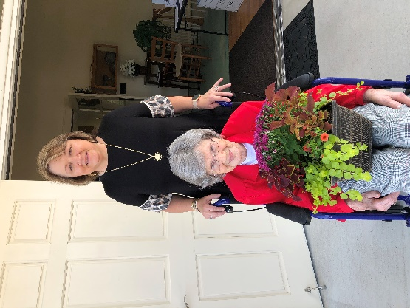
- Caroline Senn also participated in the SCISA Student Government conference at
The State House in Columbia.
- Caroline Senn was also a member of the Newberry Academy Volleyball team who won its 2nd straight SCISA Class A Volleyball Championship downing Wardlaw Academy 3-1. Congrats Eagles!

- Joe Brehmer, son of Steve and Beverly Brehmer, and Coye Cutshall, son of Mark and Ashley Cutshall were both recently recognized by the Newberry County Touchdown Club for their Outstanding Play on the NHS football team.

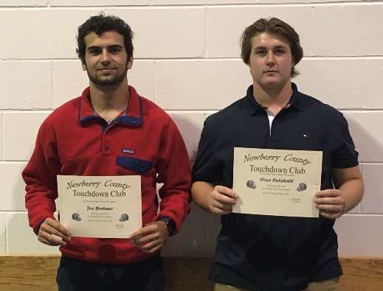

Sunday, Nov. 21, 2021

Samaritan’s Purse and Operation Christmas Child
Sponsored by Trinity United Methodist

- Pick up your shoebox from the narthex of the church.
- Fill it with toys, gifts, and other items for a girl or boy. Take them out of packaging.
- Attach label to box and rubber bands around box.
- Pray for the child who receives it.
- Return box to Trinity by Nov. 21, 2021.

It all starts with a simple gift. Will you prayerfully consider joining us in this exciting ministry? These boxes can truly make a difference in a child’s life and allows the boy or girl a chance to get to know Jesus. We will deliver the boxes to the local drop-off in Newberry.
Methodist Youth Fellowship (MYF) – Josh and Erin Pitts, Leaders;

The MYF would like to thank everyone who participated and/or helped with their spaghetti lunch fundraiser in October. It was their largest fundraiser to date and was successful only because of your support.

Upcoming Events:
Nov. 14 – MYF meets at church: 5-6:30 p.m.
Nov. 21 - MYF will leave after church to have
lunch and shop for items for a Christmas Tree angel. Return to church by 4:00 p.m.

MYF will also be posting items for sale on
Facebook that were not sold at last year’s
virtual craft show. They will be at a
discounted price this year so be on the
lookout for this sale!

Growing up at Trinity, I fondly remember some of the traditions of Advent.
Advent season always included the lighting of a new candle each Sunday on the advent wreath. I also looked forward to the Chrismon tree appearing and wondering who put it up because it was so tall; then the poinsettias appeared around the altar. Wreaths were hung on the doors and windows. It was always such a wonderful time of year for me. I always looked forward with growing anticipation to Advent, probably because that meant Christmas was near. Now I look forward to Advent with a much deeper meaning.

The Advent Wreath which is comprised of an evergreen wreath and four candles, is much more than just decoration; it also holds deep symbolic meaning. Thought to have originated in the time of the Protestant reformer Martin Luther, the wreath — which is shaped into a perfect circle — is meant to symbolize the eternity of God. The four candles placed in the middle of the wreath are purple; this symbolizes both the royalty of Christ the King but also the four weeks that make up the Advent season. A larger white candle is usually placed in the middle and is known as the Christ candle.
Traditionally, the candles are lit each week of Advent, and the Christ candle is lit last – on Christmas Eve or Christmas Day – as a way to remind Christians that Jesus is the light of the world.

The Chrismon Tree is my favorite Advent decoration. The word “Chrismon” is a contraction between the two words “Christ” and “monograms.” It is a Christmas tree that is decorated not with the traditional Christmas ornaments, but with ornaments that represent various Christian symbols found throughout history. The Chrismon Tree was originated in the 1940s by a lady named Frances Spencer, a member of Ascension Lutheran Church in Danville, Virginia. She trademarked the Chrismon name in 1957 and began the Chrismon ministry around the same time. Each Sunday in Advent, we will explain some of the Chrismon symbols to you. The symbols on our tree were made by the members of our church.

Advent is a time to reflect on the most crucial time in the history of our Christian faith; when God arrived in human form to live among his creation and create a way for all of us to escape the sin of the world into which we were born. Remember the rich symbolism found within the walls of Trinity this season and celebrate Advent with your friends, your family, and your fellow believers in Christ.

Have a blessed Advent season,

Harriet Stevenson, Editor

Trinity United Methodist Church
1060 Trinity Church Road
Newberry, SC 29108

