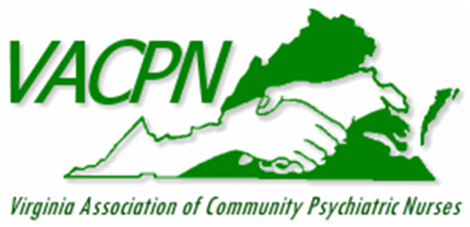
Save the date!

Virginia Association of Community Psychiatric Nurses
Presents
Post-Pandemic Self-Care: Recovery through Nature Therapy
An educational conference at Shrine Mont in Orkney Springs, VA
April 27-29, 2022
Join your peers for an educational conference that focuses on Recovery and Self-Care. Additional program and fee details will be posted at a later date.
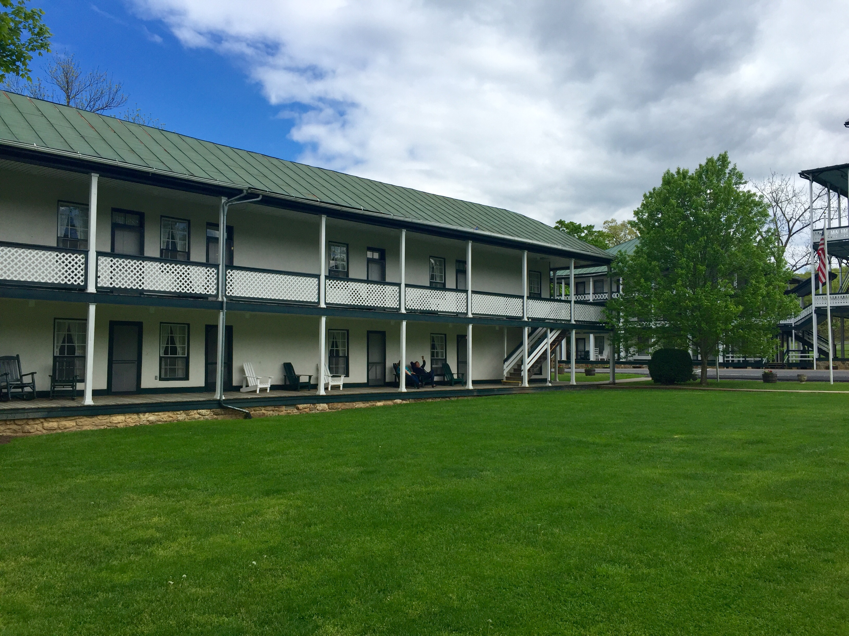
217 Shrine Mont Circle, Orkney Springs, VA 22845
www.vacpn.net
The Virginia Association of Community Psychiatric Nurses is approved as a provider of nursing continuing professional development by the Virginia Nurses Association, an accredited approver by the American Nurses Credentialing Center’s Commission on Accreditation.

Non-nurses and non-members are welcome to attend our conferences; however, only members can vote during our business meetings.

