POSITIVE FUTURE CONSULTANCY
Limited
SAFEGUARDING CHILDREN,
YOUNG PEOPLE AND ADULTS AT RISK

POLICY AND PROCEDURE

Adopted for POSITIVE FUTURE CONSULTANCY
LTD
From
HALTON BOROUGH COUNCIL
CONTENTS

PAGE No.
- INTRODUCTION 3

- POLICY STATEMENT 4

- PURPOSE 4

- SCOPE 5

- RESPONSIBILITY 5

- COMMUNICATION NEEDS 7

- KEY DEFINITIONS AND PRACTICE GUIDANCE 8

- REACTING TO DISCLOSURES OF ABUSE 10

- REPORTING ABUSE 11

- RECORDING 12

- CONFIDENTIALITY AND INFORMATION SHARING 12

- PROCEDURE 13

12.b FLOWCHART – CHILDREN/YOUNG PEOPLE 14
12.c FLOWCHART – Adults at risk 15
Appendix 1 Halton Inter-Agency Safeguarding Adults Procedures – Aide Memoire 16
Appendix 2 Designated Child Protection and Safeguarding Lead 18
Role and Responsibilities
Appendix 3 USEFUL INFORMATION 19

- INTRODUCTION
POSITIVE FUTURE CONSULTANCY LTD recognises its obligations and duty of care as an organisation working with children, young people and adults at risk as covered by the Children Acts (1989 and 2004), Working Together guidance (2013) and the No Secrets Act (2000).
To fulfil this aim the organisation will implement the following procedures:
- Carry out a full recruitment procedure for all members and volunteers including obtaining references and an Enhanced DBS check

- Appoint a Designated Child Protection and Safeguarding Lead

- Plan the work for the organisation so as to minimise situations where the possibility of abuse may occur

- Have policies and procedures on the management and supervision of all activities, and provide training on the implementation of them

- Establish a system whereby young people and adults at risk may talk with an independent person

- Implement and issue guidelines to all members and volunteers working with young people and adults at risk on how to deal with abuse or suspected abuse. Ensure members and volunteers attend safeguarding training suitable to their role and responsibilities.

This document will be monitored and reviewed by the members on an annual basis and/or updated as and when appropriate should any changes in legislation occur.
- POLICY STATEMENT
As one of its major activities POSITIVE FUTURE CONSULTANCY LTD aims to serve the needs of young people and adults at risk by promoting an holistic approach to the support offered to clients in a safe, secure, caring environment. In doing so POSITIVE FUTURE CONSULTANCY LTD takes seriously the welfare of all young people who come into contact or who are involved in POSITIVE FUTURE CONSULTANCY LTD activities.
POSITIVE FUTURE CONSULTANCY LTD recognises that it is the responsibility of each member to see to prevent or minimise physical, sexual or emotional abuse and neglect of children, young people and adults at risk, and to report any abuse disclosed or suspected.
POSITIVE FUTURE CONSULTANCY LTD is committed to supporting resources and training for those who work with young people and vulnerable adults.
POSITIVE FUTURE CONSULTANCY LTD is committed to building and maintaining good links with the statutory child and adult social care authorities and all partner agencies.
The Counter Terrorism and Security Act 2015 was published on 12th March 2015. Section 26 of the Act places a duty on schools in England (and Wales) to prevent people being drawn into terrorism. This duty applies to all schools, whether publicly-funded or independent, and organisations covered by the Early Years Foundation Stage framework. The duty also applies to children’s homes. Statutory guidance has been published and is expected to come into force on 26th March 2015. Schools leaders (including governors) must: ➢
- establish or use existing mechanisms for understanding the risk of extremism
- ensure staff understand the risk and build capabilities to deal with it
- communicate and promote the importance of the duty
- ensure staff implement the duty effectively

- PURPOSE
To provide a set of principles regarding the safeguarding and promotion of the welfare of children, young people and adults at risk who are, or may be at risk of harm. These will be applied in conjunction with the procedures of Halton Safeguarding Children Board (HSCB Pan Cheshire Multi agency Safeguarding Children Procedures www.haltonsafeguarding.co.uk) and Halton Safeguarding Adults Board (Safeguarding Adults in Halton Inter-Agency Policy Procedures and Guidance 2010 www.haltoov.uk)

- SCOPE
All those working for POSITIVE FUTURE CONSULTANCY LTD have a duty under Section 11 of the Children Act 2004 to safeguard and promote the welfare of children, and to promote the welfare of adults at risk under No Secrets 2000.
Safeguarding should not be seen as a spate activity from promoting welfare, as safeguarding or protecting a young person or adults at risk from significant harm is an aspect of promoting their welfare.
A child/young person (in the context of the services that POSITIVE FUTURE CONSULTANCY LTD provides) is defined as a person less than 18 years of age (Children Act 2004).
The fact that a child has reached 16 years of age and is living independently or is in futhur education, is a member of the armed forces, Is in hospital or in custody, does not change his or her entitlement to services or protection under the Children act 1989.
An adult at risk is any young person who has reached the age of 18 who is, or may be in need of community care services by reason of mental or other disability, age or illness.

Signed on behalf of Positive Future Consultancy …………………………… (Director)
Date :

- RESPONSIBILITY
POSITIVE FUTURE CONSULTANCY LTD has a duty to safeguard and promote the welfare of children, young people and adults at risk (as defined in Section 4.SCOPE) from abuse and neglect. The responsibility for fulfilling this duty extends to all members and volunteers of POSITIVE FUTURE CONSULTANCY LTD, and those delivering the services on behalf of POSITIVE FUTURE CONSULTANCY LTD.

Everyone should be clear about their role and responsibilities and to whom they are accountable.
The directors of POSITIVE FUTURE CONSULTANCY LTD oversees all aspects of safeguarding policy and strategy including ensuring members and volunteers have access to safeguarding training relevant to their role and responsibilities and that members and volunteers receive adequate support and supervision.
The directors have overall responsibility for ensuring that all aspects of this policy and procedure are implemented by all POSITIVE FUTURE CONSULTANCY LTD Employees and volunteers.
A designated Child Protection and Safeguarding lead Officer should be appointed from within the organisation to have responsibility for the co-ordination and implementation of the association’s safeguarding policy and procedures.
The following guideline should be followed:
- The directors should ratify the appointment
- The person should be a senior member with experience of working in children/youth/social services context
- The person must be capable of being sympathetic to young people but objective in the pursuance of their task – with an ability to cope with the shock and upset abuse allegations may produce.
- The person must be able to act confidentially, speedily and decisively, relating well to statutory authorities, parents/carers etc.
- The person must be trained or willing to undergo training in procedures, be prepared to brief member on appropriate local policies and procedures development and be able to review their effectiveness
- The person must have clearly defined line with other members/volunteers
- The person must have freedom to act when dealing with abuse cases
- The person must need to be able to keep confidential records for monitoring purposes.
The Safeguarding Lead is responsible for ensuring that POSITIVE FUTURE CONSULTANCY LTD fulfils its duties to protect adults at risk and its duty under Section 11 of the Children Act 2004 to safeguard and promote the welfare of children in accordance with government guidance, the policies and objectives of Halton Safeguarding Children Board and Halton Inter-Agency Policy, Procedures and Guidance for Safeguarding Vulnerable Adults.
The Safeguarding Lead is responsible for ensuring that all members/volunteers have access to multi agency training via the Safeguarding Boards and that all staff receives adequate support and supervision.
The Safeguarding Lead is responsible for developing effective working relationships with social care departments, agreeing referral criteria and arrangements and dealing with any issues or problems that arise between Social Care Services and POSITIVE FUTURE CONSULTANCY LTD.
The Safeguarding Lead is responsible for ensuring any allegations against members/volunteers are dealt with according to procedure.
All members/volunteers within POSITIVE FUTURE CONSULTANCY LTD have responsibility and obligation to apply this policy and any procedures in their day to day work wherever appropriate.
- Being aware of, and alert to, the risk factors and signs of abuse and neglect.
- Ensuring that when a disclosure is made that they support and assist the person making the disclosure appropriately (see procedure).
- When a concern of abuse or neglect arises as an allegation, or as a result of an observation or disclosure, recording the information as per procedure and bringing the matter to the attention of the Safeguarding Lead
- Assisting any consequent action by children’s or adult social care or other agencies by attending meetings or contributing information, as required.
- Attending relevant multi agency training as required by POSITIVE FUTURE CONSULTANCY LTD

- COMMUNICATION NEEDS
If a child, young person or adults at risk (as defined in Section 4.SCOPE) has specific communication needs due to language or disability, it may be necessary to use the services of an in interpreter or specialist worker, or to make use of other aids to communication.

- KEY DEFINITIONS AND PRACTICE GUIDANCE
  - Definitions and Types of Abuse
Children and Young People:
- Abuse and neglect are forms of maltreatment
- Somebody may abuse or neglect a child by inflicting harm, or by failing to act to prevent them
- Children may by abused in a family, an institutional or community setting by those known to them or, more rarely, by a stranger
- The abuse may be from an adult or adults, or a child or children.
The basic types of abuse in relation to children and young people are defined in Working Together 2013 as:
- Physical
- Emotional
- Sexual
- Neglect
Physical Abuse
Physical abuse may involve hitting, shaking, throwing, poisoning, burning or scalding, drowning, suffocating, or otherwise causing physical harm to a child. Physical harm may also be caused when a parent or carer fabricates the symptoms of, or deliberately induces, illness in a child.
Emotional Abuse
Emotional abuse is the persistent maltreatment of a child such as to cause severe and persistent adverse effects on the child’s emotional development. It may involve conveying to children that they are worthless or unloved, inadequate, or valued only insofar as they meet the needs of another person. It may involve not giving the child opportunities to express their views, deliberately silencing them, or ‘making fun’ of what they say or how they communicate. It may feature age of developmentally inappropriate expectations, being imposed on children. These may include interactions that are beyond the child’s developmental capability, as well as overprotection and limitation of exploration and learning, or preventing the child participating in normal social interaction. It may involve seeing or hearing the ill-treatment of another. It may involve serious bullying (including cyberbullying), causing children to feel frightened or in danger, or the exploitation or corruption of children. Some level of emotional abuse is involved in all types of maltreatment of a child, though it may occur alone.
Sexual Abuse
Sexual abuse involved forcing or enticing a child or young person to take part in sexual activities, not necessarily involving a high level of violence, whether or not the child is aware of what is happening. The activities may involve physical contact, including assault by penetration (for example rape of oral sex) or non-penetrative acts such as masturbation, kissing, rubbing and touch outside of clothing. They may also include non-contact activities, such as involving children in looking at, or in the production of, sexual images, watching sexual activities, encouraging children to behave in sexually inappropriate ways, or grooming a child in preparation for abuse. (Including via the internet.) Sexual abuse is not solely perpetrated by adult males. Women can also commit acts of sexual abuse, as can other children.

Neglect
Neglect is the persistent failure to meet a child’s basic physical and/or psychological needs, likely to result in the serious impairment of the child’s health or development. Neglect may occur during pregnancy as a result of maternal substance abuse. Once a child is born, neglect may involve a parent or carer failing to:
- Provide adequate food, clothing and shelter (including exclusion from home or abandonment);
- Protect a child from physical and emotional harm or danger;
- Ensure adequate supervision (including the use of inadequate care-givers; or
- Ensure access to appropriate medical care or treatment.
It may also include neglect of, or unresponsiveness to a child’s basic emotional needs.
Adults at risk
- Abuse is a violation of an individual’s human rights by any other person or persons
- It may consist of a single act or repeated acts
- It can occur within a relationship
- May result in significant harm, or exploitation of, the person subjected to it

The basic types of abuse in relation to vulnerable adults are defined in No Secrets 2000 as:
- Physical
- Sexual
- Psychological –including emotional
- Financial or material
- Neglect and acts of omission
- Discrimination and oppression
- Institutional
- Domestic
- Bullying
  - Signs and Symptoms
The following are issues to be aware of – the list is not exhaustive and is covered in more detail on HSCB training. (See section 5.RESPONSBILITY).
Children and Young People (as defined in Section 4. SCOPE):
- Injuries which the child cannot explain convincingly or which are on part of the body where accidental injury is unlikely.
- Injuries which have been treated inadequately or not at all
- Sudden speech disorders
- Self-harm or mutilation
- Reluctance to have parents contacted
- Sudden or unexplained changes in behaviour
- Recurrent urinary tract infections without apparent cause
- Frequently smelly or dirty
- Constantly hungry
- Tired all of the time
Adults at risk (as defined in Section 4.SCOPE)
- Injuries that are not satisfactorily explained
- Unexplained burns to the body, e.g. soles of the feet, palms of the hands and back
- Person appears anxious or withdrawn, especially in the presence of the alleged perpetrator
- Person exhibits low self esteem

- Person has urinary tract infections, vaginal infections or sexually transmitted diseases that are not otherwise explained
- Inadequately explained withdrawals from accounts
- Inadequately explained inability to pay bills
- Personal possessions being systematically removed from the home
- Lack of privacy, including editing mail, restricting visits, control of phone
- Person is malnourished, has sudden or continuous weight loss and is dehydrated

- REACTING TO DISCLOSURES OF ABUSE
It is POSITIVE FUTURE CONSULTANCY LTD duty both to seek to prevent abuse and to report any abuse discovered or suspected. When workers suspect, discover or are told, learn about abuse, they should follow the reporting procedures outlined in Section 9 REPORTING ABUSE below.
You may suspect abuse, you may discover or witness abuse or someone may report abuse to you. However you become aware of abuse, it is important that you apply the following guidance:
- Do not delay
- Do not confront the person who is alleged to be responsible for the abuse told by staff or the child or young person. Those records must be accurate and factual.
- Record in writing what is said, using the child, young person or vulnerable adult (as defined in Section 4.SCOPE) own words, as soon as possible. Note the date, time any names mentioned to whom the information was given and make sure the record is signed and dated – see Section 10.RECORDING.
- It is not your role to investigate – concentrate on presenting information clearly.
- Pass on your information to the appropriate person – see flow charts
- Do not discuss with anyone other than the person to whom you should report the matter.

If a child, young person or adults at risk (as defined in Section 4.SCOPE) wants to talk about abuse:
- Accept what the child, young person or adults at risk (as defined in Section 4.SCOPE) has to say, keeping calm and looking at them directly
- Let them know that you need to tell someone else, do not promise confidentiality
- Let them know that they are not to blame if they have been abused
- Be aware that the child or young person may be being threatened.
- Never push for information
- Reassure the child, young person or vulnerable adult (as defined in Section 4. SCOPE) they were right to tell you and you believe them
- Let the child, young person or adults at risk (as defined in Section 4.Scope) know what you are going to do next and that you will let them know what happens
- If it is considered that the person making the disclosure is likely to be at risk by returning home, immediate contact should be made with Children or Adults Social Care (dependant on the age of the person as defined in Section 4.SCOPE) or the police.
- REPORTING ABUSE – Suspected disclosed or discovered

- All members/volunteers should be aware of the appropriate reporting procedure – this process is illustrated by the flowcharts – see Section 12.b.2 (children and young people and Section 12.c (adults) – as defined in Section 4.SCOPE
- All staff should first make a decision as to which reporting procedure they should follow as defined in Section 4.SCOPE. This should be discussed with the designated Child Protection and Safeguarding Lead as detailed in Section 5. RESPONSIBILITY.
- It is the responsibility of the designated Child Protection and Safeguarding Lead to ensure that cases of abuse are reported. It is normal procedure to contact the local Social Care team. If the child, young person or vulnerable adult (as defined in 4. SCOPE) is in immediate danger the police should be contacted. The number of your local Social Care duty teams both children/young people and adults is included in the flowcharts.
- Any member/volunteer can start the process and share concerns with an outside agency – Social Services, NSPCC – if they feel that their Safeguarding Lead is not dealing with their concerns properly or are implicated in some way.

- Consideration should be given, on a case-by-case basis, to the support which can be given to an abused child, young person or vulnerable adult (as defined in Section 4.SCOPE) recognising that the support needs to be non-judgemental, appropriate and long term. External help available through partner agencies may be advisable.

- RECORDING

- Notes should be made as soon as possible
- As far as possible use the exact words the young person or vulnerable adult used.
- A full record including dates and time of events and to whom the disclosure was made for should be completed in the Safeguarding Log and a note made on the clients file starting the date and the fact that a Safeguarding issue was raised and a full record is located in the Safeguarding Log.

- CONFIDENTIALITY AND INFORMATION SHARING
Where there emerges a safeguarding issue, agencies should share relevant information they have about the person who is the subject of the allegation, and about the alleged victim. Confidentiality cannot be guaranteed where there emerges a safeguarding issue; members must take care to explain to children and/or their parents or carers that they have a legal responsibility to report allegations, disclosures or wider causes for concern. Wherever possible, consent should be sought from children or their parents/carers for sharing information. Information regarding allegations, disclosures of abuse or causes for concern should not be shared with parents or carers where this information is likely to place the child at greater risk of harm. Where this is uncertainty as to whether an allegation, disclosure or cause for concern constitutes abuse or neglect, members who consult with other professionals (for example Named Safeguarding Officer or Partner Agency) should wherever possible protect the identity of the child until further action is determined.

  - Managing Allegations against members (including Volunteers)
Where allegations against members are made the Safeguarding Lead (07775946175) needs to be notified immediately.
Halton’s Allegations Against Adults (AAA) procedures should be followed in all cases where it is alleged that a member/volunteer has:
- Behaved in a way that has harmed, or may have harmed a child.
- Possibly committed a criminal offence against, or related to a child.
- Behaved towards a child or children in a way that indicates he/she is unsuitable to work with children.
Consideration should also be given to events in the members/volunteers personal life that might impact upon their capacity to act appropriately in situation where a child/children are at risk. For example, where they have perpetrated Domestic Abuse or where their own child/children are subject to Child Protection Plans. Responding to the allegation in a timely and fair manner is essential. POSITIVE Future Consultancy LTD will consider what immediate actions are required to reduce any risk to children within the organisation. This may include the member/volunteer being moved to a position in the organisation where they have no contact with children, young people or adults at risk (as defined in Section 4.SCOPE), or could include that the person is suspended from duty whilst an investigation is undertaken.
A referral should be made to the Local Authority Designated Officer (LADO) Katherine Appleton, who, where appropriate, will arrange for a Strategy Meeting to be undertaken. In the event that the LADO is not available the organisation should request to speak with a duty worker within the Safeguarding Unit. The contact details for LADO are0151 511 4942.
POSITIVE FUTURE CONSULTANCY LTD will record as much detail as possible about the initial disclosure but will not take statements from children or members/volunteers or investigate the matter further.
POSITIVE FUTURE CONSULTANCY LTD will ensure that the member/volunteer is made aware that an allegation has been made, but will not provide any further details initially. They will be advised of the procedures regarding allegations and that they have appropriate support.

- Procedure
- General Overview
- The two flowcharts below should be followed to ensure that any disclosure or suspicion of abuse is dealt with appropriately and effectively.
- Before proceeding, decide which flowchart applies to the situation you are dealing with based on the definitions of the child/young person or vulnerable adult detailed in Section 4. SCOPE.

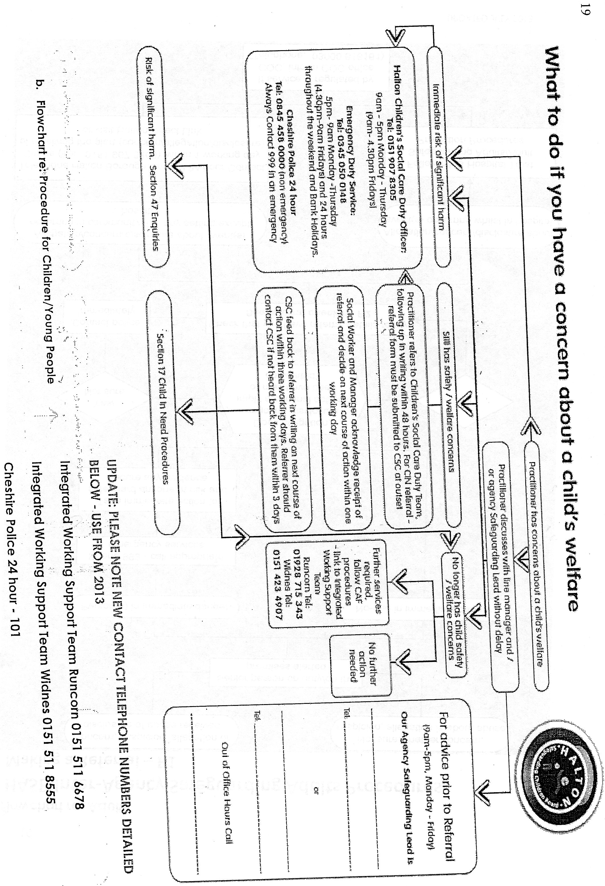

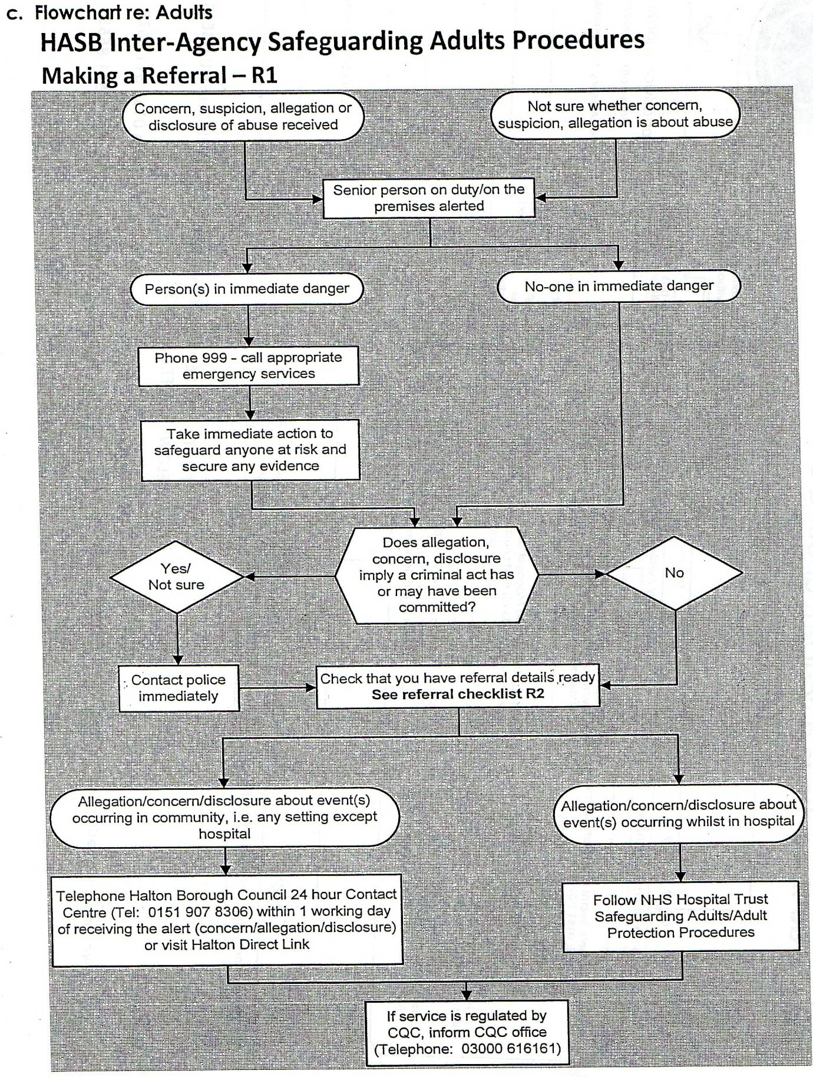

APPENDIX 1
Halton Inter-Agency Safeguarding Adults Procedures
Aide – memoire –Making a Referral – R2
- Principles
- Inter-agency working
- Clarity of role and responsibilities
- Do not investigate unless agreed in Strategy Discussion/Meeting that this is your role.
- Preserve evidence – ensure not contaminated
- Do not promise inappropriate confidentiality
- Do not make promises you cannot keep
- Avoid collusion
- Consult with/inform line management at all stages
- Share information on a ‘need to know’ basis – must not jeopardise investigation or place alleged victim or other[s] at risk; confidentiality considerations
- Effective communication
- Record – timely, accurate and legible. Record the concern/allegation/disclosure, referral, enquiries, decisions, actions taken, date and name of writer on all records, etc. – case file, Protection/Safeguarding/Care Plan, body chart, etc.
- Actions – agreed, person responsible, timescale, review and record progress
- Anti-oppressive practice – challenging discrimination, bullying and inappropriate behaviour

- Process
  - Actions and Communication
Carry out and communicate actions as appropriate/agreed, if required, throughout the following process [i.e. from step 2.2 to 2.8 below] e.g. immediate safeguarding action and safeguarding plan, disciplinary and ‘whistleblowing’ procedures.
2.2 Immediate safeguarding action when required
a) Is the alleged victim in immediate danger? Secure safety, e.g. removed alleged perpetrator or victim.
b) Is alleged victim suffering or likely to suffer harm or are any other people at risk? Secure safety.
c) Does the alleged victim need medical attention? Seek any medical treatment needed.

d) Is the alleged victim likely to need medical examination? Police will arrange.
e) Does alleged victim’s property need to be protected? If so, ensure evidence is not contaminated in any way, in doing so.
2.3 Initial enquiries and fact-finding:
a) Accept what the alerter tells you
b) If you’re not sure whether the alert is a matter of abuse, refer it anyway (to Social Services, and the police if it is or may constitute a criminal matter).
c) Do not investigate
d) If you need to gather any more information to inform a referral to the police and/or Social Services, speak with the alerter and/or alleged victim – confine this to using ‘TED’ (Tell me; Explain; Describe’) approach. Keep this to the minimum required.
e) Do not ask ‘leading questions’ or offer suggestions – i.e. questions that will lead the person to answer in a certain way or to give a certain answer.
f) Preserve evidence – e.g. if alert is about sexual or physical abuse, do not do anything that might destroy evidence – e.g. lock room, do not bathe/shower alleged victim or remove/change their clothes; do not question alleged victim or witnesses any more than absolutely necessary (use ‘TED’ approach).
g) Do not confront the alleged perpetrator or them of the concern/allegation/disclosure.
h) Inform Police immediately – where concerns may constitute a criminal offence, or to protect the person/others, or there is a need to preserve evidence.
2.4 Referral
a) Refer concerns, allegations and disclosures to Halton Borough Council Social Services Call Centre on 0151 907 8306 or Halton Direct Link. For concerns/allegations/disclosures about events occurring in hospital, refer to the NHS Hospital Trust’s adult protection/safeguarding procedures.
b) Ensure that you have collated information available.
c) Refer all concerns/allegations/disclosures that may or do constitute a criminal offence to the police. Ensure that you have collated information available.
d) Inform CQC if concern/allegation/disclosure relates to a regulated service.

2.5 Strategy Discussion – Inter-agency [Within 1 working day of receipt of referral] and/or Initial Strategy Meeting within 3 working days of receipt of referral.
a) Social Services arranges and co-ordinates
b) Forum for information sharing, risk assessment, agrees immediate actions, responsibilities and timescales including safeguarding/protection, agrees interim services and support, agrees enquiries and investigations to be undertaken, consideration of use of advocate if there are any capacity issues, considers whether other procedures come into force e.g. disciplinary, ISA, ‘Whistleblowing’.
2.6 Follow-up Strategy Meeting [should be within 10 working days of receipt of referral]
a) Social Services arranges and co-ordinates
b) Considers findings of investigations/enquiries
c) Decides what information is to be shared by whom, with whom, when – including service user, representative, family, alleged perpetrator, other agencies/teams, referrer.
d) Decides whether Case Conference is needed
e) Reviews actions agreed and taken
f) Devises Safeguarding Plan if no Case Conference required
g) Agrees timescale for review.
2.7 Case Conference [Should be within 20 working days of receipt of referral]
a) Social Services arranges and co-ordinates
b) Review findings
c) Devises safeguarding plan, agree actions and responsibilities
d) Agrees review timescale
2.8 Conclude
a) Communicate as necessary and agreed – who, what, when, by whom – e.g. alleged victim/representative, staff, CQC, advocate/IMCA
b) Ensure Protection/Safeguarding/Care Plan communicated and carried out

c) Ensure any other actions/procedures carried out as agreed and required – e.g. disciplinary, ISA
d) Complete records – Including service user[s]’ record[s], staff records if alleged perpetrator.

APPENDIX 2
Role and Responsibilities of the Designated Child Protection and Safeguarding Lead
- Provide support, advice and guidance to colleagues
- Shares good practice
- Recognise signs/indicators of abuse and decide when referrals to Children’s or Adult’s Social Care/other relevant agencies are appropriate
- Liaise with senior members of staff (where the role is not carried out by the senior member of staff) to inform him/her of any issues or on-going investigations. Ensure there is always cover for the Designated Child Protection and Safeguarding Lead by having a named deputy or team of deputies
- Liaise with relevant agencies (where appropriate) to inform the decision on whether to make a referral to Children’s Social Care (IWST, Safeguarding Unit, etc.) or Adult Social Care
- Attend and effectively contribute to Child in Need, Case Conference, Core Groups, Child in Care reviews, Adult Social Care Review Meetings and any other meetings requested by other agencies. Provide written reports at such meetings. If unable to attend, send apologies and submit a comprehensive written report.
- Ensure the organisation’s Safeguarding Children, Young People and adults at risk related policy are up to date and reviewed annually.
- Ensure every member has access to and understands the organisation’s Safeguarding Children, Young Person and adults at risk related policy (Including whistleblowing, etc.).
- Ensure that clients have access to and have seen Safeguarding Children, Young Person and adults at risk policy which alerts them to the fact that referrals may be made and the role the organisations has in this to avoid possible future conflict.

- Keep detailed accurate and secure written reports of referrals and concerns. Ensure these records are stored in a locked filing cabinet or secure database.
- Monitor and track clients who are subject to Children’s or Adult Social Care intervention.
- Ensure all members/volunteers have safeguarding training as part of their induction and attend subsequent training appropriate to their role, at least every 3 years.
- Attend training appropriate to the role of the Designated Child Protection and Safeguarding Lead at least every two years.

APPENDIX 3
Useful information
Booklets/Documents
- HSCB Safeguarding Children Induction Booklet
- What to do if you are worried a child is being abused-available from HSCB website below
- Guidance on Safer Working Practices for Adults who Work with Children and Young People
- HSCB resources i.e. credit card sized copy of flowchart available via the internal and HSCB training
- Working Together 2013
- Information Sharing: Guidance for Practitioners and Managers 2008
Websites
- Halton Safeguarding Children Board www.haltonsafeguarding.co.uk
- Halton Safeguarding Vulnerable adults www.halton.gov.uk
Click on ‘Health and Social Care’ in the left hand column
In right hand column under ‘in this section’ click on ‘Safeguarding adults at risk – Professionals’
- www.def.gov.uk

