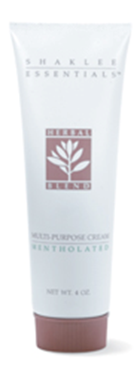
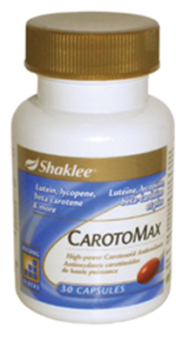
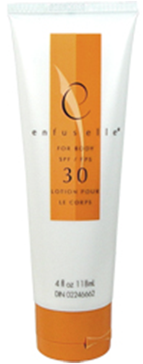
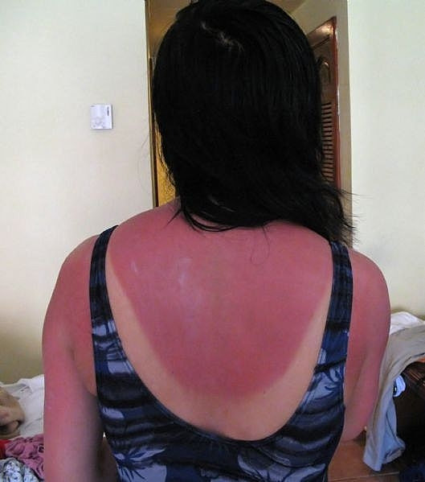
What to do if you get a Sunburn

(Of course, the obvious recommendation is to use Shaklee’s Sunscreen
to prevent a sunburn)
STEP 1:
Dilute Basic H2 … ½ water & ½ Basic H2 in a spray bottle and spray on the burned area (since Basic H2 is a surfactant that makes water 200x wetter, this helps to keep the moisture in the burned skin).

STEP 2:
Gently apply Shaklee’s Mentholated Skin Cream all over the burned area. This cream is “Nature’s Pharmacy” … a superior first aid healing cream, which contains sage, coltsfoot, restharrow, horse chestnut, horsetail, yarrow, rosemary, dandelion, matricaris, and althea, along with cooling oil of wintergreen and menthol and witch hazel.

STEP 3:
Shaklee Hand and Body Lotion is another great cream to apply.
- It is “nick-named” a 6-hour moisture infusion, and provides an instant moisture surge and continued release for up to six hours.
- It contains Vital Repair+, which is 7 antioxidants involved with healing the damaged tissue

STEP 4:
Calming Complex is just one more of Shaklee’s options … it helps the skin recover from environmental damage caused by sunburn … it significantly improves your skin’s ability to retain moisture, and features an advanced liposome technology that delivers the extraordinary protective and soothing benefits of beta glucan.

STEP 5:
Supplementing internally with extra CarotoMax is also a very wise choice. The plant pigments known as carotenoids and flavonoids found in this product work together to protect human cells from free radical damage.

