The tower floor, tiling round the font, and the floor area used as the play area (beneath the pulpit) for visiting children has had a wash-down with a strong industrial cleaner and a quick coat of professional quality polish applied - floors will be stripped and done again properly when the flooring is repaired and made good. For now it makes keeping the dust down easier and we have some temporary filling-in where tiles are missing for health and safety (rather than cosmetic) purposes.
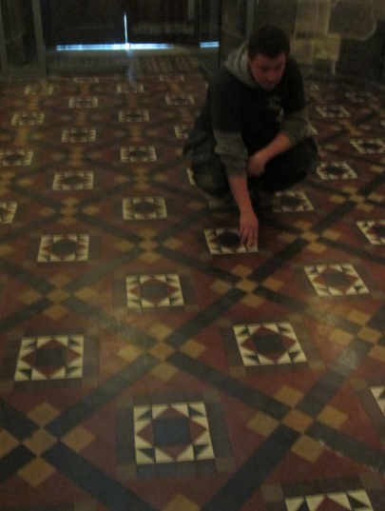
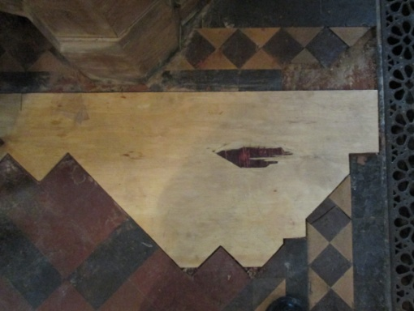

The anticipated date of handover for the tower and internal refurbishment is the 15th February 2013, but in order to complete Phase 1 of the interior we MUST raise the additional cash required for the glazing of the chapel, creation of the dias and building of chair store(s) We have received various donations since the launch of the appeal for which we give a very BIG “THANK YOU” but we’re not there yet and need to inform our Architect very soon if we are to complete everything we want to do. Can you help us raise some well needed cash?

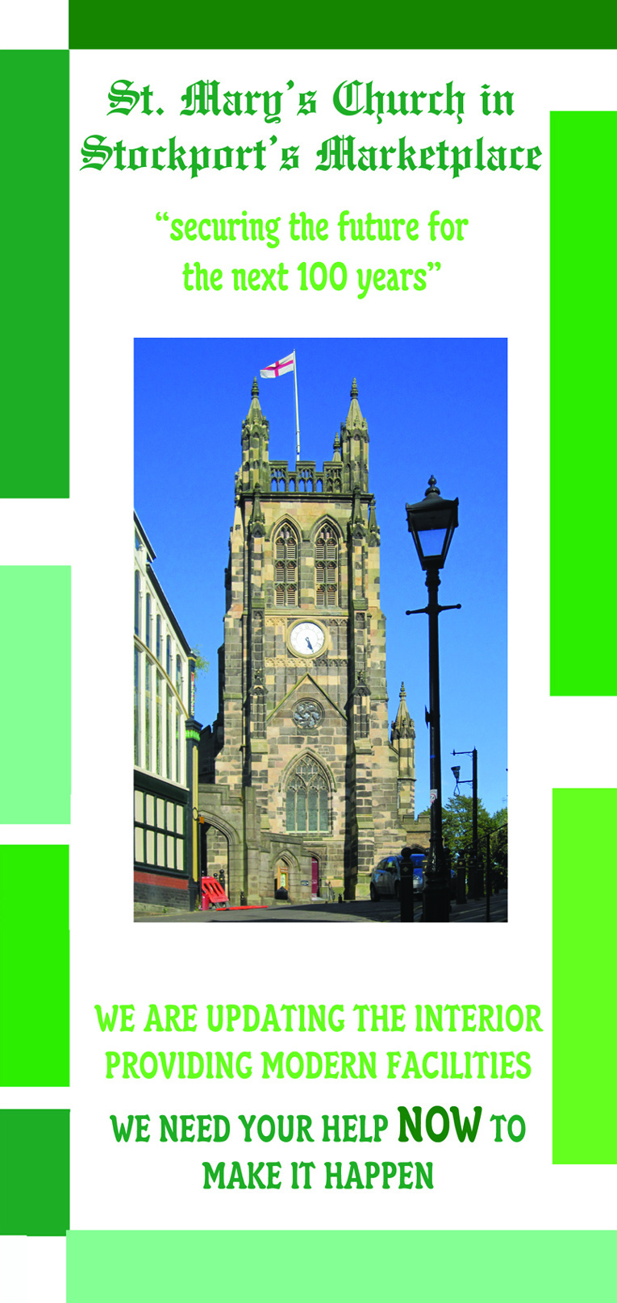
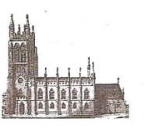
St Mary’s in the Marketplace.
Issue No 18 (18th November 2012)
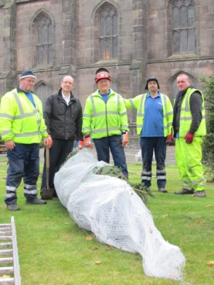
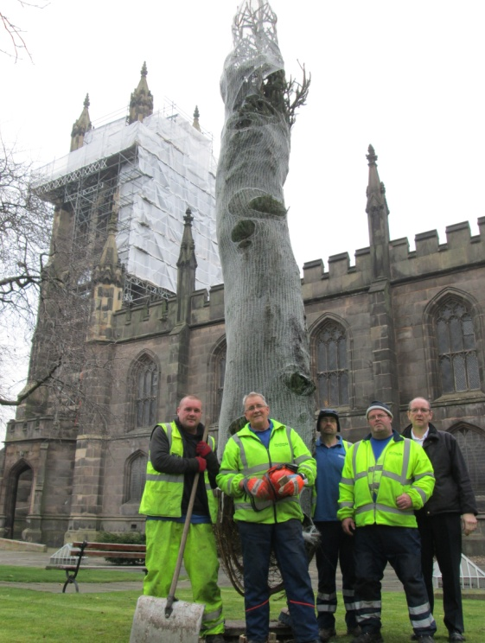
“Securing the future for the next 100 years”

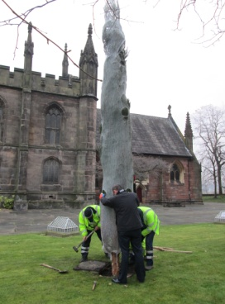

Christmas is clearly just round the corner – the outdoor tree having arrived this week - and as work continues inside and out - the end of the present projects are now just about 12 weeks away! We are well past the half-way stage and we’ve keep open with a busy Christmas Programme ahead.
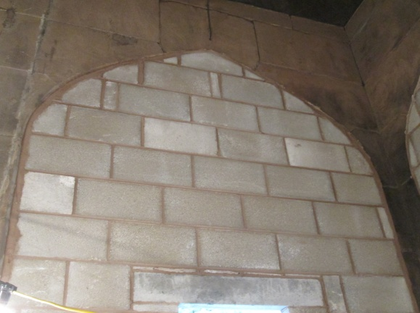
The interior walls of the toilets - despite a few ups and downs with the materials being used - are now taking shape. Not an easy task to fill-in the original archways and a little strange for us to see the area now filled in with the windows in place.
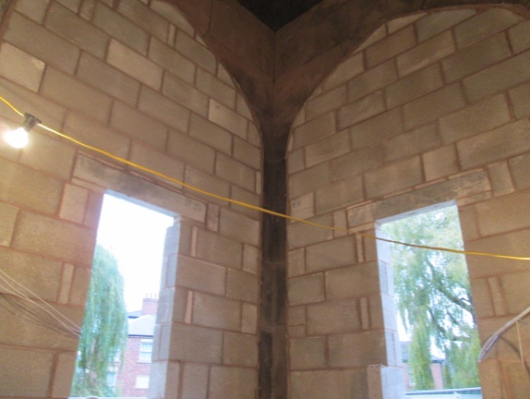
The kitchen is just about ready for the plastering stage – we can’t wait for the units to arrive!
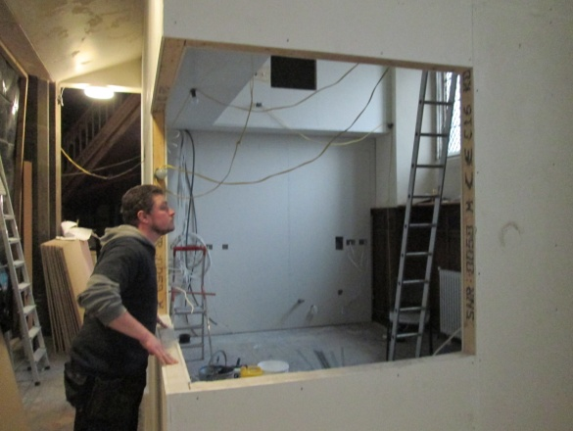
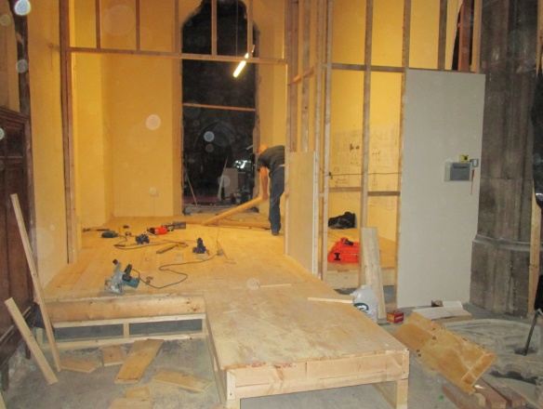
Work continues with the new flooring – and you can see now just what a difference in floor levels are involved and the need for the lift to be installed.

Thank You –
The Affinity Show Choir
This last week saw our “Appeal Concert” featuring the award winning Affinity Show Choir and for the first time the opportunity to turn ourselves around and face “west”, again showing what a difference having a clear Nave can make to the use we can make of the space.
All proceeds (£300) have been paid into the Interior Appeal Account – a lovely evening of close harmony singing enjoyed by all. We look forward to seeing Affinity back at St Mary’s again in the very near future. Thanks to Lesley Carson and all her ladies for giving their time and supporting our Interior Appeal.
