Prescription for Blood (14 years and younger)
Neil D. Jaddou, M.D., USCIS CIVIL SURGEON
36950 Ryan Rd., Sterling Heights, MI 48310, 1615 West Big Beaver, St. A4 Troy, MI 48084
Physician Signature______________________________________ Beaumont Acct. # 2036

Name (PRINT)___________________________________________________________________________

___x___ QuantiFERON TB Test (QFTTB)

Diagnosis: Z11.1

Beaumont Lab Blood drawing Stations

Walk-in, NO APPOINTMENT NECESSARY, (Take with you your insurance card and driver license), can eat or drink water, it will not affect the test. Being on menstrual cycle will not affect the test.
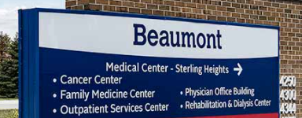
1- Beaumont Sterling Heights Medical Center East Campus

Address: 44250 Dequindre, Sterling Heights

Sterling Heights East Campus
Park and enter building called ATRIUM Entrance.

Across from Troy Beaumont hospital, between 19 mile and south Blvd. Ph#248-964-6123

Walk-In, No Appointment. Open Monday– Friday: 7am – 4pm

2- Beaumont hospital, Royal Oak Medical Office Building

Address: 3535 W. 13-mile, Royal Oak

Park in the medical office building and go to the first floor of the medical building. Ph#(248) 551-8000.

Walk-In, No Appointment. Open Monday– Friday: 7am – 6pm

