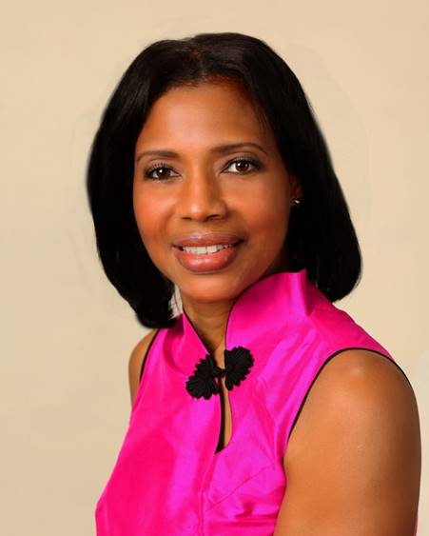
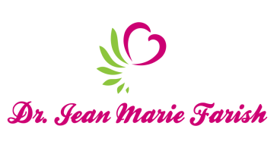

LOVE LIGHT NewsLetter

I am excited to host my VoiceAmerica Empowerment Show-LOVE LIGHT with amazing Guests to cultivate a lifestyle of love and wholehearted connections through worthiness. My show is aligned with my mission to live an altruistic and heart centered life.

MEET LOVE LIGHT GUEST

AUGUSTA SMITH
EXECUTIVE DIRECTOR, LIFE OF MISSISSIPPI

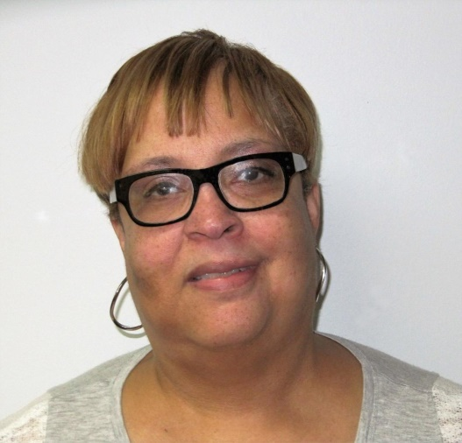

March 6, 2020

EMPOWERING PERSONS WITH SIGNIFICANT DISABILITIES

ABOUT Augusta Smith

Augusta Smith is the Executive Director of Living Independence for Everyone (LIFE) of Mississippi. Life is a nonprofit agency that is dedicated to empowering people with significant disabilities to be as independent and as fully involved in their communities as they can and want to be.

Ms. Smith has been instrumental in developing People First Language, Disability Etiquette and Caregiver Support training. These trainings are provided statewide and allow everyone to understand the power of words and to be aware of the stress that some caregivers live with each day. She has also planned and coordinated a youth and parent retreat for several years. These retreats allow families a unique opportunity to expand their expectations and understand the meaning of true independence. She has also participated in several national Adapt actions.

Ms. Smith has worked for the Center for Independent Living for 22 years. Ms. Smith became involved with the Independent Living movement when her son was being discriminated against because of his disability. The fight became personal and she has dedicated her life’s work to assisting others.

Ms. Smith attended the University of Southern Mississippi where she studied Psychology and recently received her BS in Theology.

https://www.lifeofms.com

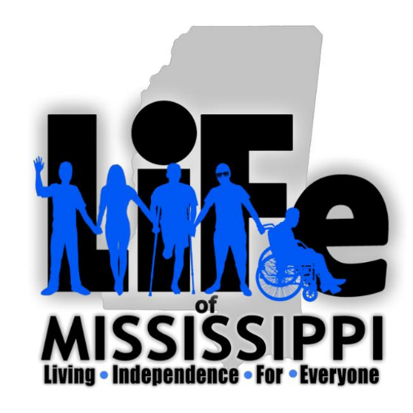

“An empowered self is a loving self, and keep your love light shining.”

