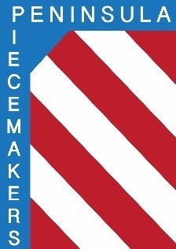
Peninsula Piecemakers Quilt Guild
P.O. Box 1295
Newport News, VA 23601

Board of Directors Meeting March 21, 2022

Attendance:
Board
President: Rhonda Gianturco Vice President: Karen Carr
Executive Treasurer: Natalie Hutchinson(abs) Executive Secretary: Lois Bates
Day Coordinator: Mark Fowler Day Treasurer: Lori Murdock
Day Secretary: Linda Tozier Night Coordinator: Kitty Tully (Zoom)
Night Treasurer: Debbie Martin Night Secretary: Susan Waddles

1. President Rhonda Gianturco called the meeting to order at 5:02 p.m.

2. Mark make a motion to approve the minutes of the February 21, 2022 meeting. Karen seconded. Motion approved.

3. The Treasurer’s report was accepted. Balances: Executive $18,937.90
Day Chapter $1977.33 Night Chapter $2090.43

4. Old Business:
a. Masks: After a short discussion Mark made a motion to follow church and state guidelines regarding masks which at this time means masks are optional. Lori seconded. Approved.
Rhonda gave Donna Albright and Pat Sappenfield spreadsheets of membership to use instead of the sign in sheets. It will be easier to keep track of who is in attendance.

b. Nominating committee: No one has volunteered to be on the nominating committee and nominations must be presented at the April meeting. Night coordinator is the only vacant position. Several names were suggested to Rhonda and she will make some phone calls.

5: New business: Karen continued to ask for program suggestions.

6. Meeting was adjourned at 6 p.m.

Respectfully submitted,

Lois A. Bates

