Cost of Capital
Cost of capital includes the cost of debt and the cost of equity.
The cost of capital determines how a company can raise money (through a stock issue, borrowing, or a mix of the two). This is the rate of return that a firm would receive if it invested in a different vehicle with similar risk.
Cost of Debt
The cost of debt is computed by taking the rate on a risk free bond then adding a default premium. This default premium will rise as the amount of debt increases (since, all other things being equal, the risk rises as the amount of debt rises).
Since in most cases debt expense is a deductible expense, the cost of debt is computed as an after tax cost to make it comparable with the cost of equity (earnings are after-tax as well). Thus, for profitable firms, debt is discounted by the tax rate. The formula can be written as

(Rf + credit risk rate)(1-T)
T is the corporate tax rate
Rf is the risk free rate

Cost of Equity
Capital Asset Pricing Model (CAPM)
CAPM is by far the most common tool used in practice to assess the Cost of Equity when valuing a company.
Cost of equity = Risk free rate of return + Premium expected for risk
Cost of equity = Risk free rate of return + Beta x (market rate of return- risk free rate of return) where Beta= sensitivity to movements in the relevant market
E_{s} The expected return for a security
R_{f} The expected risk-free return in that market (government bond yield)
β_{s} The sensitivity to market risk for the security
R_{M} The historical return of the stock market/ equity market
(R_{M}-R_{f}) The risk premium of market assets over risk free assets
The risk free rate is taken from the lowest yielding bonds in the particular market, such as government bonds.
CAPM utilises β, and the equation to calculate β (beta) is:
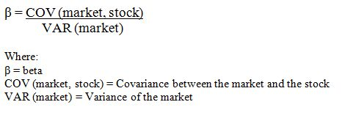
The Variance of the market is a measure of how volatile or varied the distributions of returns from the market are, and the Covariance between the market and the stock in question is a measure of how closely the returns from the stock move in line with the returns from the market. The results of this equation are:
- If a stock moves in a particular direction when the market moves in that direction, Beta will be greater than 1 if the stock returns are more volatile than the market returns, and will be between 0 and 1 if the stock returns are less volatile than the market returns;
- If a stock return moves in a particular direction when the market return moves in the opposite direction, Beta will be less than -1 (greater in magnitude) if the return moves are more volatile than the market return moves, and will be between 0 and -1 if the stock return moves are less volatile than the market return moves;
Build-Up Method
A well-used alternative to CAPM is the Build-Up method. The Build-Up method of calculating the Cost of Equity uses building blocks to get to a final Cost. Some more commonly used building blocks are:
- Risk Free Rate (Government Bond Rate);
- Debt Margin (what the Banks want in addition);
- Operating Risk Premium (charges for risks associated with management execution of business plans);
- Financial Risk Premium (how much more should you be asking for based on the fact that debt gets paid first);
- Liquidity Premium (how easy or difficult it is to exit your position).
So the way we approach determining the Cost of Equity is to simply add the Required Return allocated to each of the identified factors. A worked example is as follows:
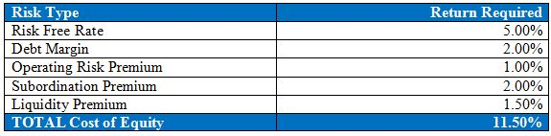
The key advantages of this method are that you actively identify which factors are contributing to your Cost of Equity and charge for those risks according to your view.
Weighted Average Cost of Capital (WACC)
WACC is a calculation of a firm's cost of capital in which each category of capital is proportionately weighted. The WACC of a firm increases as the beta and rate of return on equity increases.
The WACC equation is the cost of each capital component multiplied by its proportional weight and then summing:
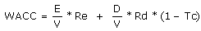
Where:
Re = cost of equity
Rd = cost of debt
E = market value of the firm's equity
D = market value of the firm's debt
V = E + D

