OneVision. Supplements

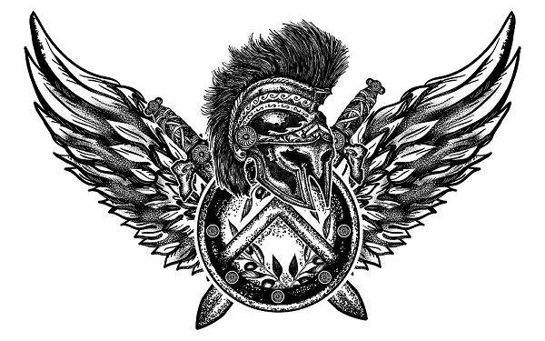



OVS KILLER PRE-WORKOUT

OVS | Premium Quality Pharmaceutical Grade Killer Pre-Workout Formula has an extensive ingredient profile to get you extra motivated for high-intensity training, super focused on the task at hand, unparalleled energy levels and increased stamina to get you pumped and achieving your goals faster while leaving the competition behind. Further research to our formula has demonstrated that OVS Killer Pre-Workout is one of the most powerful strength and performance stimulant-based supplements on the market that can also assist with muscle growth. All of these key factors are key to reaching your fitness goals. Here at OVS, we use premium quality ingredients and strict production standards across our entire products range for those seeking and demanding only the best in sports nutrition and supplementation.

THE OVS DIFFERENCE.

 What is OVS Killer Pre-Workout?

This powerful and versatile pre-workout provides unmatched energy, focus, motivation and pumps. Its formulation includes 7 active ingredients with a strong stimulant focus. Enhancers include stimulants to keep you going against fatigue but without sacrificing mental clarity or sharpness.

OVS Killer Pre-Workout is a mix of nutrients, vitamins and amino acids along with some caffeine and sugar that will help you push your limits. Our pre-workout formula contains ingredients that deliver long-lasting energy and help develop the muscle and endurance you need for intense training.

OVS Killer Pre-Workout contains caffeine, among other ingredients, which provides the necessary energy to attack a vigorous workout and keep going. It also contains ingredients that will move blood through your muscles and increase their capacity for energy. OVS Killer Pre-Workout is best paired alongside OVS BCAAs, which can help to build muscle while you work out, reduce muscle soreness after the fact, and facilitate protein synthesis even when you're not working out.

Formulation: Beta-Alanine, Creatine Monohydrate, L-Arginine, Agmatine Sulfate, N-Acetyl L Tyrosine, Caffeine Anhydrous, Choline Bitartrate

What are the benefits from OVS Killer Pre-Workout?

Supplementing OVS Killer Pre-Workout is useful before exercising because it can greatly increase ones performance. One serving 20-30 minutes before exercise can drastically improve focus and energy levels for people who need to work out in the morning or after a long day of work where their energy may be depleted.

Motivation, Are you at Peak Performance?

If you are accustomed to counting the minutes spent in the gym, OVS challenges your thinking. Your effort level and results largely depend on how well each workout is so don't think of it only as hours. OVS Killer Pre-Workout has been designed to maximize effectiveness for you so that you get the most out of every workout. When you know that your achieving your potential this change in mentality can literally alter your workouts, while inspiring and breaking mental barriers down.

Beta-Alanine

Included in this formulation is high-quality pharmaceutical grade beta-alanine. Consuming beta-alanine will cause a tingling sensation 5-10 minutes after ingestion, this feeling will continue to be felt through your workout.

<https://www.ncbi.nlm.nih.gov/pubmed/21659893>

“4 grams of beta-alanine per day enhanced performance (shuttle run, flexed-arm hang) and body ratios (increased muscle / lower fat)”

<https://www.ncbi.nlm.nih.gov/pubmed/19210788>

” ”A study of young healthy males consuming 6 grams of beta-alanine per day paired with HIIT significantly improved performance, peak VO2 max and lean mass compared to HIIT alone.”

THE OVS DIFFERENCE

In order to ensure utmost customer satisfaction, we pride ourselves on a service that is based on high-end products. We are able to keep our quality high because we rely on three cornerstones: tailored manufacturing, raw ingredient traceability, and laboratory tested supplements. Our business is committed to maintaining the strictest quality control standards and we ensure all of our products are 100% exact to specification.

DIRECTIONS & INGREDIENTS

Directions

Mix one serving with 250ml of water until completely dispersed. To achieve the best results, consume continuously during your workout.

Ingredients

Beta-Alanine, Creatine Monohydrate, L-Arginine, Agmatine Sulfate, N-Acetyl L Tyrosine, Caffeine Anhydrous, Choline Bitartrate, Malic Acid, Flavour, Sucralose.



