INTRODUCTION

One Step Anti-Syphilis Cassette Test is a rapid direct binding test for the visual detection of anti-syphilis antibodies in serum as an aid in the diagnosis of syphilis infection. Test results are read visually without any instrument. It is based on the principle of double antigen sandwich immunoassay for determination of syphilis antibodies in serum. Purified recombinant syphilis antigens are employed to identify anti-Syphilis antibodies specificially. This one step test is very sensitive and only takes about 10 to 20 minutes.

SPECIMEN COLLECTION

For serum, collect blood into a container without anticoagulant. Allow the blood to clot and separate the serum from the clot. Use the serum for testing.

If the specimen cannot be tested on the day of collection, store the serum specimen in a refrigerator or freezer. Bring the specimens to room temperature before testing. Do not freeze and thaw the specimen repeatedly.
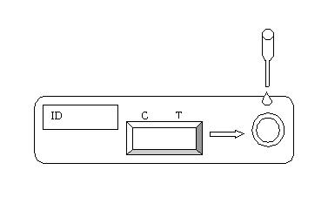

TEST PROCEDURE

- Review specimen collection instructions. Test device, specimens and controls should be brought to room temperature (18-30°C) prior to testing.

- Remove the test device from its protective pouch (bring the device to room temperature before opening of the pouch to avoid condensation of moisture on the membrane). Label the device with patient or control identifications.

- Draw approximately 0.2ml sample. Dispense entire contents into the sample well. Alternatively, hold the pipette in a straight up and down position - not at an angle. Dispense 4 drops (approximately 0.2ml) of the specimen or control into the sample well. For each sample or control, use a separate pipette and device.

- Wait for 10-20 minutes and read results. Do not read results after 30 minutes.

INTERPRETATION OF RESULTS

Negative
Positive Invalid
C T C T C T
- Negative: Only one colored band appears on the control (C) region. No apparent band on the test (T) region.

- Positive: In addition to a pink colored control (C) band, a distinct pink colored band will also appear in the test (T) region.

- Invalid: A total absence of color in both regions is an indication of procedure error and/or the test reagent has deteriorated.

STORAGE AND STABILITY

The test kits can be stored at room temperature (18 to 30°C) in the sealed pouch to the date of expiration. The test kits should be kept away from direct sunlight, moisture and heat.

PRECAUTION

- For in vitro diagnostic use only.
- Do not use test kit beyond expiry date.
- The test device should not be reused.

Latest revision 09.05.2011

ATLAS LINK, INC USA Headquarters:
No. 811 Zeyang Plaza, No.166 Fushi Road 10758-A Ambassador Drive
Shijingshan Dist., Beijing 100043, China MANASSAS, VA 20109 USA
Tel: 86-10-88909112 Fax: 86-10-88909115 Tel: 703-3663851

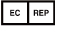
CIRIANO GLOBAL S.L. (UNILATEX GROUP)
CIF: B50927532 C/Blancas 4-6, 1 B Oficina 1
50001 Zaragoza Spain
Tel: 34-976910399

