School Transport Policy
2015+

Board of Management Scoil Bhríde Nurney
2015+
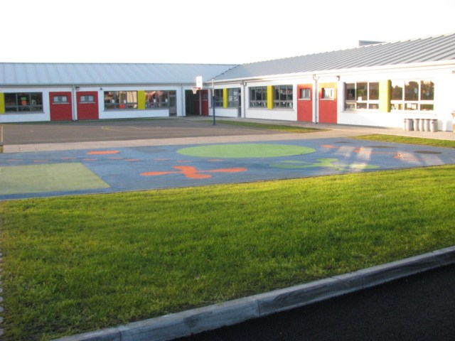
Scoil Bhríde

School Transport Policy

Introduction :
This policy was drawn up by the BOM of Scoil Bhríde Nurney in 2015 to formalise the arrangements for transporting students to and from school.

Rationale :
The policy was formulated to inform all interested parties of their obligations under the scheme and to inform them of the school’s role in the scheme.

Content :
- The school transport scheme is run under the direction of the Department of Education and Science.

- There is no obligation on the school to provide an escort to supervise the children on the bus.

- The school will open to receive pupils at the hour of 9.10am. No responsibility is accepted for pupils arriving before that time. Classes will commence each day at 9.20am. No pupils should arrive later than 9.20am. Parents who wish to have their children escorted home after school should make their own arrangements to have them met at the school gate and the person escorting them should be at the school gate no later than 2pm for infants and 3pm for all other classes as the school cannot accept responsibility for looking after the children after that time

- Schools are not party to the School Transport System (this is a private paid contract between parents and their service provider) and the fact that the pupils are conveyed to or from school by bus does not impose any additional obligations on the school or teachers. No arrangement exists for the supervision of pupils who arrive at the school, whether by school bus or otherwise, before the official opening time. No arrangement exists for the supervision of pupils who remain after school hours awaiting collection, whether by school bus or otherwise.

- The School and its B.O.M. accepts no responsibility for discipline on the bus.

- All children are expected to be in attendance at school at the official opening time of 9.20am and children will not leave the school grounds before the official closing time of the school without the written consent of parents. Children will never be allowed to walk or cycle home on their own, during school hours. They must always be collected from the classroom by a parent/guardian or named other.

- The school is not responsible for lost or stolen bus tickets and will not undertake to replace such tickets.

- It is expected by this school that all service providers used in the transportation of children use buses which meet the regulations as laid down by the relevant authorities i.e. the Dept. of the Environment, the Dept. of Education and Science and the Dept. of Transport.

Roles and Responsibilities :

- It is the responsibility of the Department of Education to provide a bus service for those children who are entitled to such a service, in accordance with their rules and regulations.

- It is the responsibility of the service provider to run an efficient and safe service.

- It is the responsibility of the parents to organise transport for their children to and from school and to inform the school of these arrangements and any alterations to these arrangements for whatever reason.

- It is the responsibility of the children to behave in accordance with the standards expected by the Department of Education and Science and the service provider.

- It is the responsibility of the service provider to co-operate with school opening and closing times.

- It is the responsibility of Bus Éireann to facilitate schools to organise their school year in conjunction with other schools in their transport network in order to contribute to the efficient running of the service.

Timeframe for Implementation :
This policy is being implemented in practice at present and will continue as such until the need arises for review.

Appendix 1

GUIDELINES FOR DISCIPLINE AND PROCEDURES FOR DEALING WITH ALLEGED MISBEHAVIOUR ON SCHOOL TRANSPORT
Bus Éireann is responsible for the day-to-day operation of the School Transport Scheme under the general direction of the Department of Education and Skills. Bus Éireann is responsible for the discipline and safety of pupils while travelling on school buses. Pupils availing of transport are expected to behave in a responsible manner having regard for their own safety, that of other passengers, the driver and other road users. In cases of misconduct, sanctions will be imposed by Bus Éireann. These have been agreed in consultation with the Department of Education and Skills and are set out below:
1. Misbehaviour: In the event of misbehaviour by pupils, such as failing to obey the instructions of the driver, not wearing their safety belt, etc., the school bus driver will:
- seek an assurance from the pupil(s) that there will not be a repetition.
- If there is a recurrence, the driver may ask the Inspector to speak to the child.
The matter will be concluded at this point. If there is a similar recurrence after this procedure is exhausted, the matter will be treated as serious misconduct.
2. Serious Misconduct:
- When the alleged misconduct is of a serious nature, the driver will report the matter to the Inspector, who will inform the local Bus Éireann Manager immediately and instructions will be given as to what action should be taken. The Inspector will also inform the school authorities of the position.
- The matter will be fully investigated by Bus Éireann personnel in consultation with the Transport Liaison Officer (T.L.O.)/ Chairperson of the Board of Management/ Principal and with the assistance of the school authorities.
Serious misconduct consists of behaviour which poses a threat to the safety and well-being of pupils, the driver, or the safe operation of the service generally. Intimidation of pupils, damage caused to fixtures and fittings on the vehicle or to the property of others, and behaviour which may endanger other road users is included in this definition. A pupil who disregards the instructions of the driver/Inspector or does not respond to discipline and continues to be a source of misbehaviour may likewise be charged with serious misconduct.
3. Procedure for Investigation of Serious Misconduct:
In the event that there is a complaint of serious misconduct, the following procedures will apply:
- Initial enquiries by the bus driver following an incident or complaint, involving speaking to students who travel on the bus, including the pupil(s) allegedly involved or the subject of complaint.
- The bus driver will report the matter to the Inspector who will contact the Principal(s) of the relevant school(s)to report the incident. The Principal(s) will assist by interviewing the student(s) who travel on the bus regarding the incident/ complaint.
- The Inspector and the Principal(s) will report the result of their interviews to Bus Éireann immediately for further investigation. Bus Éireann will give the pupil concerned all the details of the complaint made against him/her and inform him/her that there will be further investigation by Bus Éireann, without prejudice, and explain how the investigation will operate.

- Investigation by Bus Éireann Personnel
The investigation by the Bus Éireann Inspector will involve:
- Interviewing the bus driver.
- Interviewing pupil(s) alleged to be involved in the incident/complaint in the presence of School Principal/Teacher or Parent or both. The pupil(s) concerned will be given the opportunity to respond to the allegations at this interview. Pupil(s) will also be given an opportunity to make written submissions. Where applicable, written submissions should be made within one week of the alleged incident.
- Interviewing other students who travel on the bus. Details and statements will be recorded by Bus Éireann Personnel from students travelling on the bus where they had witnessed an incident. Students will be made aware of the consequences of giving false or misleading information, intentionally or otherwise. Pupils may be interviewed separately, or as a group, to establish the veracity of the account of the incident/complaint. All interviews should be conducted with sensitivity and with due regard to the rights and confidences of all parties concerned. The Garda Authorities will be informed where deemed necessary and full co-operation will be given in any further investigation.

- Sanctions.
Once the investigation has been concluded and the pupil(s) responsible identified, the following sanctions may be imposed:**
- Pupil warned as to future conduct.
- A written undertaking requested from pupil(s)/parent(s) that the pupil will not again misbehave himself/herself on the undertaking that if the pupil does not comply with the undertaking more serious measures will be considered, up to and including the withdraw l of the travel permit.
- Withdrawal of the travel permit for a specified period or permanently, at the discretion of the Bus Éireann Manager.
In instances where a permit is being withdrawn, the pupil will be allowed to travel home on the service and parents / guardians will be advised of the circumstances by Bus Éireann.
In circumstances where a permit is being withdrawn and written confirmation is not immediately available, details of the sanction imposed will follow within seven days.
Where it is not possible to identify the culprits, having investigated the incident with the assistance of the T.L.O. and school authorities, it may be necessary to withdraw the service for a period, for example, in cases where there is:
- Danger to pupils, drivers and other road users.
- Severe damage to the vehicle, where the vehicle will have to be repaired, including damage to the seat belts or fixtures.
** If, in the opinion of Bus Éireann, the misconduct is of a sufficiently serious nature which compromises the safety of pupils or the safe operation of the service, Bus Éireann may take immediate action to suspend the individual(s) concerned from transport while investigation is still underway.

For more Information please visit the following link:
http://www.education.ie/en/Parents/Services/School-Transport/Guidelines-for-Discipline-and-Procedures-for-Dealing-with-Alleged-Misbehaviour-on-School-Transport.pdf

Ratification of School Transport Policy

This policy was adopted by the Board of Management on _________________

Signed: _________________________ Signed: __________________________
Chairperson of Board of Management Principal

Date: __________________________ Date: __________________________

Date of next review: __________________

