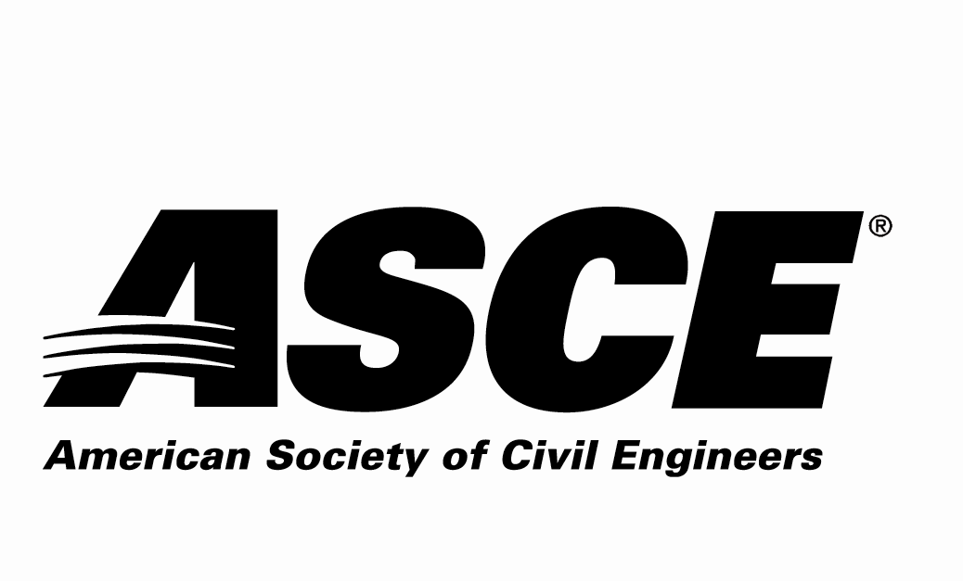 | REGION 7

Individual Nomination Form

Lifetime Achievement Award

Due Date: Nominations must be received by April 30, 2020

Application Materials Required
Individual Nomination Form and Electronic Photo of Nominee

Entry Instructions
Electronic submittal is requested. Please e-mail the following 2 electronic files (less than 10 MB per e-mail):
- File 1: Filename = nominee’s last name.pdf
Individual Nomination Form
- File 2: Filename = nominee’s last name.jpg
Photo of the nominee to be used in the awards program

e-mail to: jctaylor@burnsmcd.com
E-mail subject line = ASCE R7 Award Application – Lifetime Achievement for (nominee’s last name)

For more information contact:
Jennifer Jacka-Taylor - ASCE Region 7 Awards Committee
jctaylor@burnsmcd.com or 816-823-6252

Award Criteria
This award is intended to recognize the lifetime efforts of civil engineers service to further advance the field of civil engineering through their contributions, innovative concepts, research, and materials. The nominee for this award shall be a Registered Professional Engineer and be a member of ASCE in Region 7.

Awards Ceremony
The selected individual will be recognized in 2020 at awardee’s Section or Branch meeting.

Nominator Contact Information (person making the nomination - self nomination encouraged)
Name:
Employer:
Address:
 | Street |  |  | City | State | Zip
Phone Number:
Email Address:
ASCE Membership#:
P.E.? Yes or No

Nominee Contact Information
Name:
Employer:
Address:
 | Street |  |  |  | City |  | State | Zip
Phone Number:
Email Address:
P.E. Registration State |  |  |  | P.E. Registration #

Nominee ASCE Membership Information:
ASCE Section nominee belongs to:
Colorado Section
Denver Branch Northern Branch Southern Branch SW Branch Western Slope Branch
Iowa Section
Kansas Section
Wichita Branch
Kansas City Section
Nebraska Section
South Dakota Section
Black Hills Branch Eastern Branch
St. Louis Section
Wyoming Section

Lifetime Achievement Nomination Information Section:
Please answer the following questions as thoroughly as possible and ensure that the response to this nomination information section is 3 pages or less.

1. Describe the nominee’s ASCE involvement.

2. Describe the nominee’s other professional activities.

3. Describe the nominee’s contributions to the Civil Engineering Profession.

4. Provide any other information regarding the nominee to be considered for this award.

