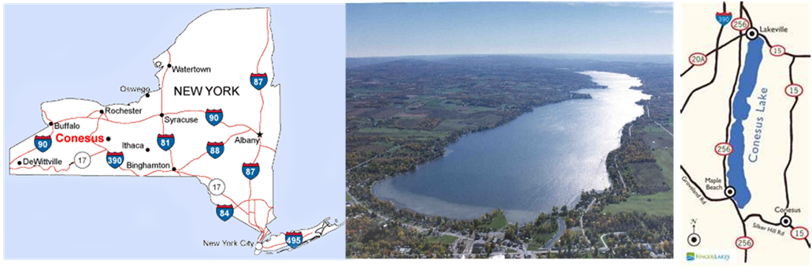

Lake Conesus was dying …
The Story of the Banning of Phosphates in New York State Lake District

Lake Conesus is the western-most of the 11 Finger Lakes in western New York. The lake is 8 miles long.

In the 1970s, people with homes and cottages along Lake Conesus were concerned. Their lake was dying … it was overrun with algae, which was dramatically reducing the oxygen availability to the fish … and fish were dying.

A concerned Shaklee distributor, who was aware of the advantage that Shaklee cleaners and laundry products offered, asked Shaklee Corporation if they would DONATE Shaklee Cleaners to each lakeside homeowner. The company agreed, and 512 lakeside homes received the donated products, (the Shaklee Distributor recruited the Boy Scouts to deliver the product to the 512 dwellings).

The lake started to recover, and as a result of this “Shaklee Environmental Stewardship Project”, the state of New York permanently banned phosphates in the lake district.

