CLASS OF 2022
The Class of 2022 is clearly one of the deepest classes that the Memphis metro area has to offer. Realistically there are over thirty (and probably close to 50) kids that most teams would love to have. With a class so deep you’re bound to have a bunch of quality competitive teams. We’ve had a chance to see basically every team and here’s what we came up with;

11. Memphis Legends
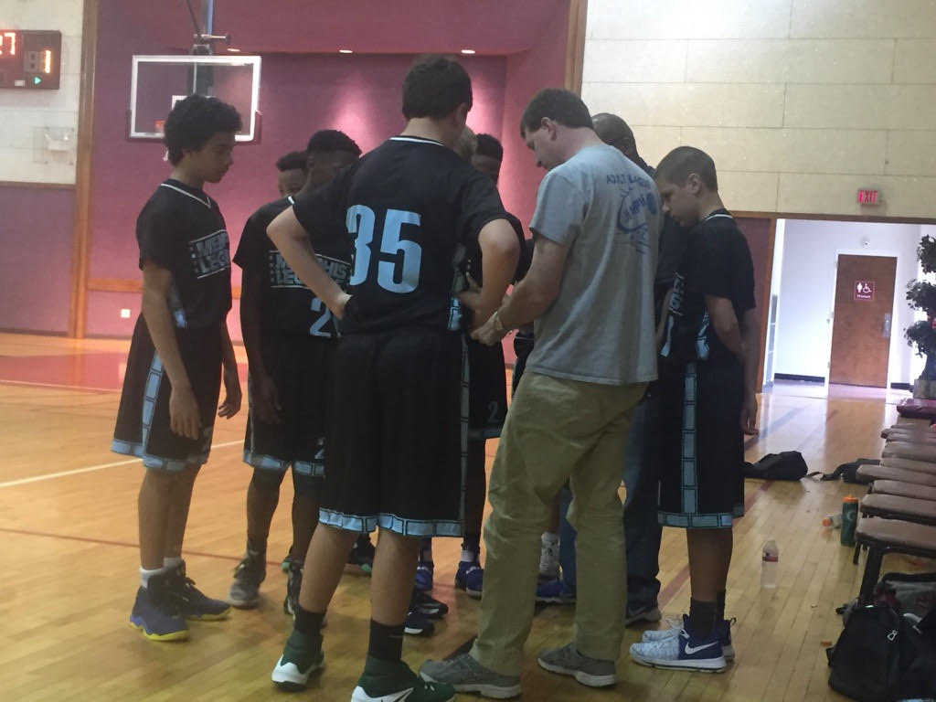
One of the few new teams on the scene, The Legends, coached by Mike Williams, boast a roster capable upsetting some of the higher ranked teams on our list. Of course it’ll take some time and chemistry but the talent is there.
The Legends strong point will surely be their outside shooting as they have three certified snipers in Owen Babb, Peyton Piacenti, and Harden Williams. Add the fact that Babb, though not frequently talked about, is one of the better players in the class and Piacenti is definitely one of the most underrated.
Throw in solid PG Daniel Cappocaccia, athletic slasher Caleb, and a bruiser in the paint likes JT Fite and you have the makings of a strong core group.

10. M33M
Former professional basketball player turned coach, Erik Buggs, looks to makes his mark on the Memphis basketball scene in a different way this time around. With the Mike Miller machine behind him and his squad Buggs is set to embark on a new journey.
Big man James Barton will be a big part of M33M’s success. He is big, athletic, and relentless, and he will be a problem for opponents. Add the likes of the long Ahmed Ali a capable scorer and Jack another big.
These four alone are good enough to put M33M in the mentionables. A win or two against a higher ranked team and Bugg’s M33M squad could find itself somewhere around the top of the totem pole.

9. Team Tarheel
Another one of the newer programs, Coach Psycho Adams has assembled a group of North Mississippi and preparing them to do battle across Stateline.
A lot of pressure will be put on Micah Mickens, a two-way guard that will d-up and can shoot it. Plus they’ve got a dominant big. Those two playing good together, and some other things falling into place, and Team Tarheel starts making their way up the food chain.

8. Life Changers
Another new squad looking for respect is Coach Jordi Montgomery’s Life Changers team. The team has a solid roster with PG Tim Montgomery and swingman Chip Brunt.
In the post they’ll be depending on Bear Miles a kid who can get it done around the rim, has a nice midrange jump shot, and can at times step outside and knockdown the trey.
Defensively, they have one of the best kids in the class, in superfast, high motor KJ Westbrook, who has also developed an outside shot.
On the offensive end the scoring load will be placed on AJ Dilworth, a shifty slasher with a knack at getting to the rack and a high arching long ball that can be deadly. Landon Armstrong will be another shooter in the stable capable of doing damage from the outside as well.
The Life Changers guards will have to be able to handle the pressure that EVERY Memphis team is known for if they want to catapult themselves into the company of the elites.

7. NPAC Redhawks
One of the longest running programs in the city, Coach Sam Beattie’s Redhawks have a few notable players that are primed and ready for the big stage.
Chris Martin, “the shooter”, is a kid that rack up points in no time fast. His claim to fame is his volleyball line range shot that his coach has nicknamed a “layup”.
Jacoby Hughes, is another big time player, a guard trapped in a big’s body, Hughes can put on the floor and run point if need be, he step outside and shoot if they need a 3, or he can go down low and bang if that’s what the his team needs.
Then you add “Big Jake” a big standing well over six feet that rebound and alter and block shots.
With a solid core and a lot of chemistry the Redhawks are ready to tip off against anybody.

6. Team Calvin Warriors
Coach Calvin Butler’s TCW team is two years in the game and despite lack of size this scrappy bunch is definitely a team that will cause any opponent problems. They are a high energy, fast paced group that are capable of competing with anyone.
The guard tandem of Landon Glasper and Aniez “Man” Butler is a nice duo with both capable of running the show and both capable knocking down big outside shots.
Though TCW hasn’t made their way across the bridge yet, that time is coming, and when they do I’m sure they’ll have point to prove.

5. Team Dez
Yet another new team to the class, Coach Kemion’s Team Dez squad boasts an assembly of overachievers.
In the paint they’ll have the long and athletic Markese Washington who is probably the best big in the class. Put Bear Miles beside him and Deshawn Dunn, another athletic, high motor guy and a kid they call “Big Devin”, a forward with guard skills, and you have the makings of something.
KD Dandridge, one of the best lockdown defenders in the class, will be a nightmare for whoever he’s assigned to.
And then there’s Ladricus Pittman, a guard that can absolutely light it up from long range.
Team Dez will be depending on a total team effort when competing against some of the higher-ups but if all their boys come to play any opponent is in for a long night.

4. Memphis Wareagles
Although you may not ever get to see Coach Hayden’s Wareagles squad match up against any of the other teams on our list. We can’t deny the fact that they are good. Well coached and well conditioned.
The Wareagles team has two of the classes long running studs in Dallan Hayden and Ashton Strother, two kids that have been on the scene a long time.
Add Cam Miller, a long athletic big that would start on any team on this list and you already have a competitive squad.
And then there’s Peyton Piacenti, a high IQ, long range bomber that’s capable of making the difficult shots in the lane and is one of the best shot blockers, YES “shot blockers”, in the class.
The Wareagles have a good group of experienced ball players that are accustomed to playing big games and are definitely one of the better teams on our list.

3. Team Thad
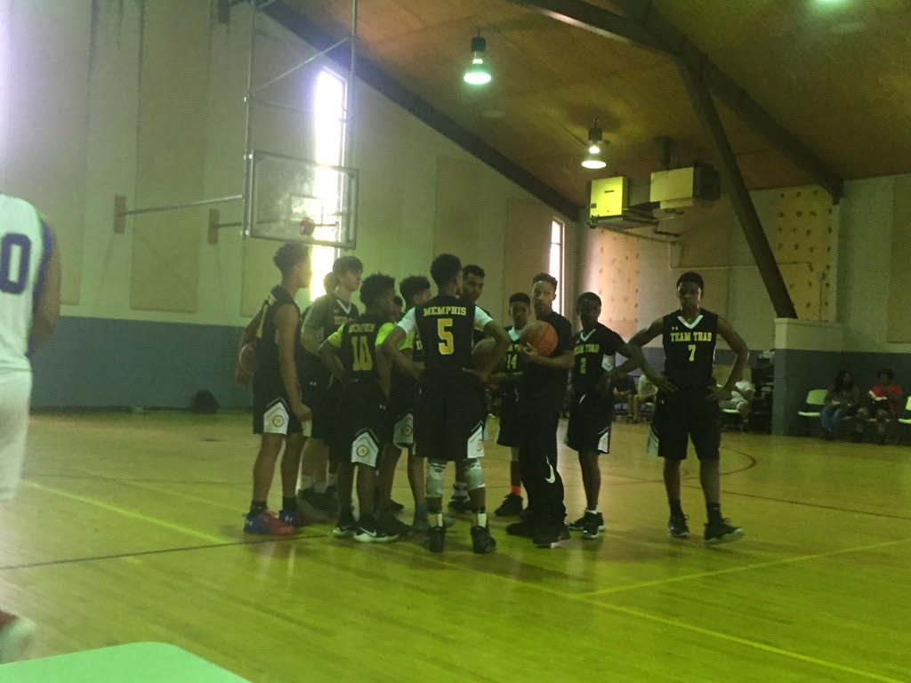Formerly the Tennessee DreamChasers, Coach Brandon Johnson’s Under Armor squad is again one of the elite teams in the class. Though we don’t consider them to be the #1 team as we did last year they are surely a force to be reckoned with.
First of all they have the best player in the class; Chandler Jackson. He can handle the ball, he can shoot, he can pass, he can rebound, he can defend, he can block shots. It would’ve been easier to say what he can’t do.
Then add Cartier “Turtle” Beverly, the X-Factor. Arguably one of the top 5 kids in the class, He’s another high energy kid that gets it done on both ends of floor.
And they are DEEP! They got DJ and Bryce down low, two bigs that can stretch out to the wings. And they’ve added the big and athletic Carlos. Phil, Dricus, and HD3 give them consistent outside shooting. Chunky gives them energy on both ends. Armani is aggressive defender capable of locking down the opponents’ best offensive threat. And Melvin Jackson is another solid guard that is interchangeable in the starting lineup.
Their depth is perfect for the style of play that Coach Johnson is known for; Pressure, pressure, pressure on defense. Get out and run on offense. Look for this Team Thad in a Championship Game near you.

2. Memphis Basketball Association.
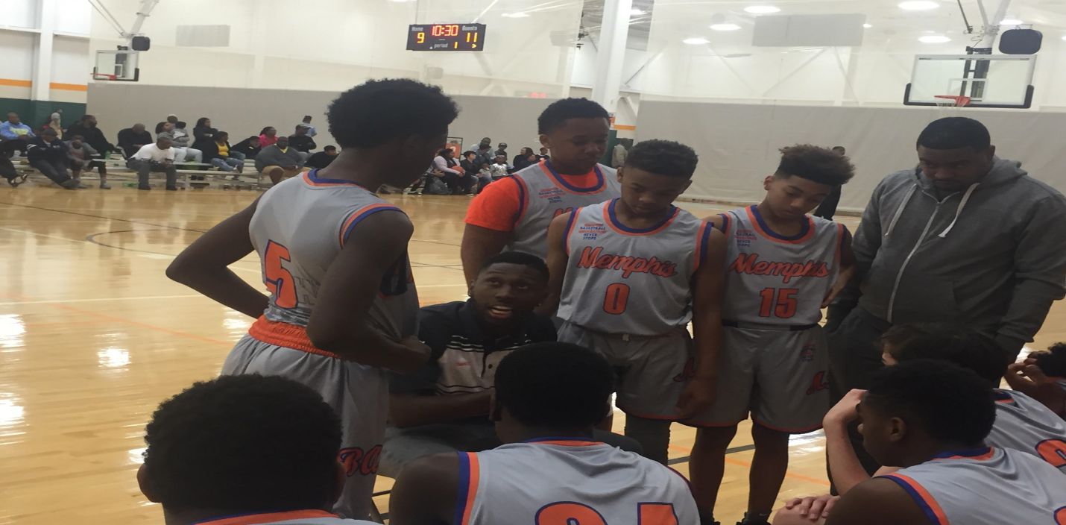
Two years in and MBA’s 2022 squad doesn’t look to be fading away anytime soon. Back bigger and better this squad just might find itself in the top spot before the season over.
Coached by Coach Tavaris Boga, MBA perhaps has the most potent starting lineup of any team in the class. Two point guards; Mason Shropshire a deadeye shooter who isn’t phased by defensive pressure and the left-handed Mane Carter who no one can stay in front of, make full court pressure a bad idea.
Guard MJ Boyd has stretched out and stepped his game up and is now consistent double-figure scorer, who you can’t leave open.
Add forwards like the long and athletic Jon Chalmers and the strong sharp shooting Chris Gilliland and you got a big lineup with a lot of weapons.
Off the bench they bring bigs like Big Donte, easily the biggest kid in the class, and Hunter Pratt, a fundamentally sound kid good enough to start. Snoody Wilkinson is hands down the best defender on any of the teams, and he’s only a 6th grader. And you can’t leave out AJ Dillworth, another 6th grader capable of bringing that offensive spark off the bench.
MBA definitely has a squad capable of garnering national attention.

1.Memphis Wildcats
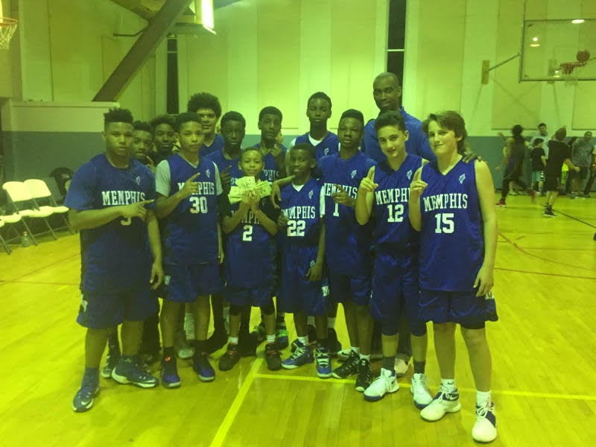
After a subpar 2016 season Coach Moore’s Wildcats look like the kind of team the program is known for.
PG JR Jacobs is still leading the way as the floor general capable of scoring in a plethora of ways whether it be an outside shot or his patented floater. Lefty Kobe Wilkes is still capable of being a big time contributor. Kyler Herring is still one of the better bigs in the class. He has a soft touch but knows when to get physical and use his size to his advantage.
The Wildcats also boast a great defender in a kid by the name of TJ who can and will shoot the long ball.
D&D, Donte & Daniel add to their depth chart with their work around the rim as well.
But perhaps the piece that catapulted them into the top spot is a newcomer, Caleb, a grit&grind kind of kid that will get in it on defense and take you to the rack on offense.
These Wildcats have established themselves as the team to beat but for now they’re sitting pretty in that top spot.

PLAYERS TO WATCH. (In alphabetical order).

Mane Carter. Guard. Memphis Basketball Association
Cartier Beverly. Guard. Team Thad
Caleb Gill. Guard. Memphis Wildcats
Chandler Jackson. Guard. Team Thad
Markese Washington. Forward. Team Dez

