Amelia-Nottoway Technical Center News 10/23/2020
ANTC STUDENT SPOTLIGHT!
Tiara Epps, ACHS Senior
Cosmetology II
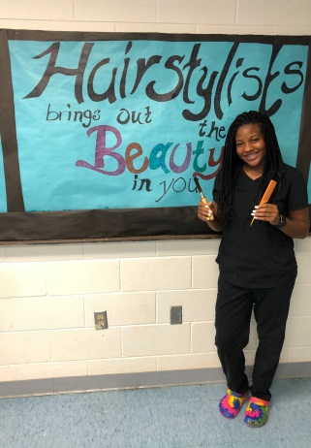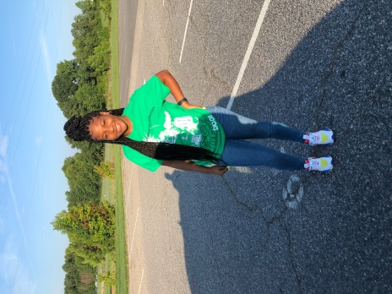
What brought you to ANTC? Cosmetology; when I was young I fell in love with braiding hair.
What is your dream job? Registered Nurse
What is your favorite class that you have taken so far? Why? Geometry; I love finding angles in different shapes.
What is the best advice you have been given by your instructor at ANTC? Time is money is something my instructor always says because you need to use your time wisely.
What is your favorite memory at ANTC? Making Vision Boards; I could see everything I wanted in the future all on one board.
What was the first feeling you had when you attended ANTC? No feeling; I felt at home and was welcomed with love.
What words of wisdom do you have for other students? Do what you want and whatever makes you happy.
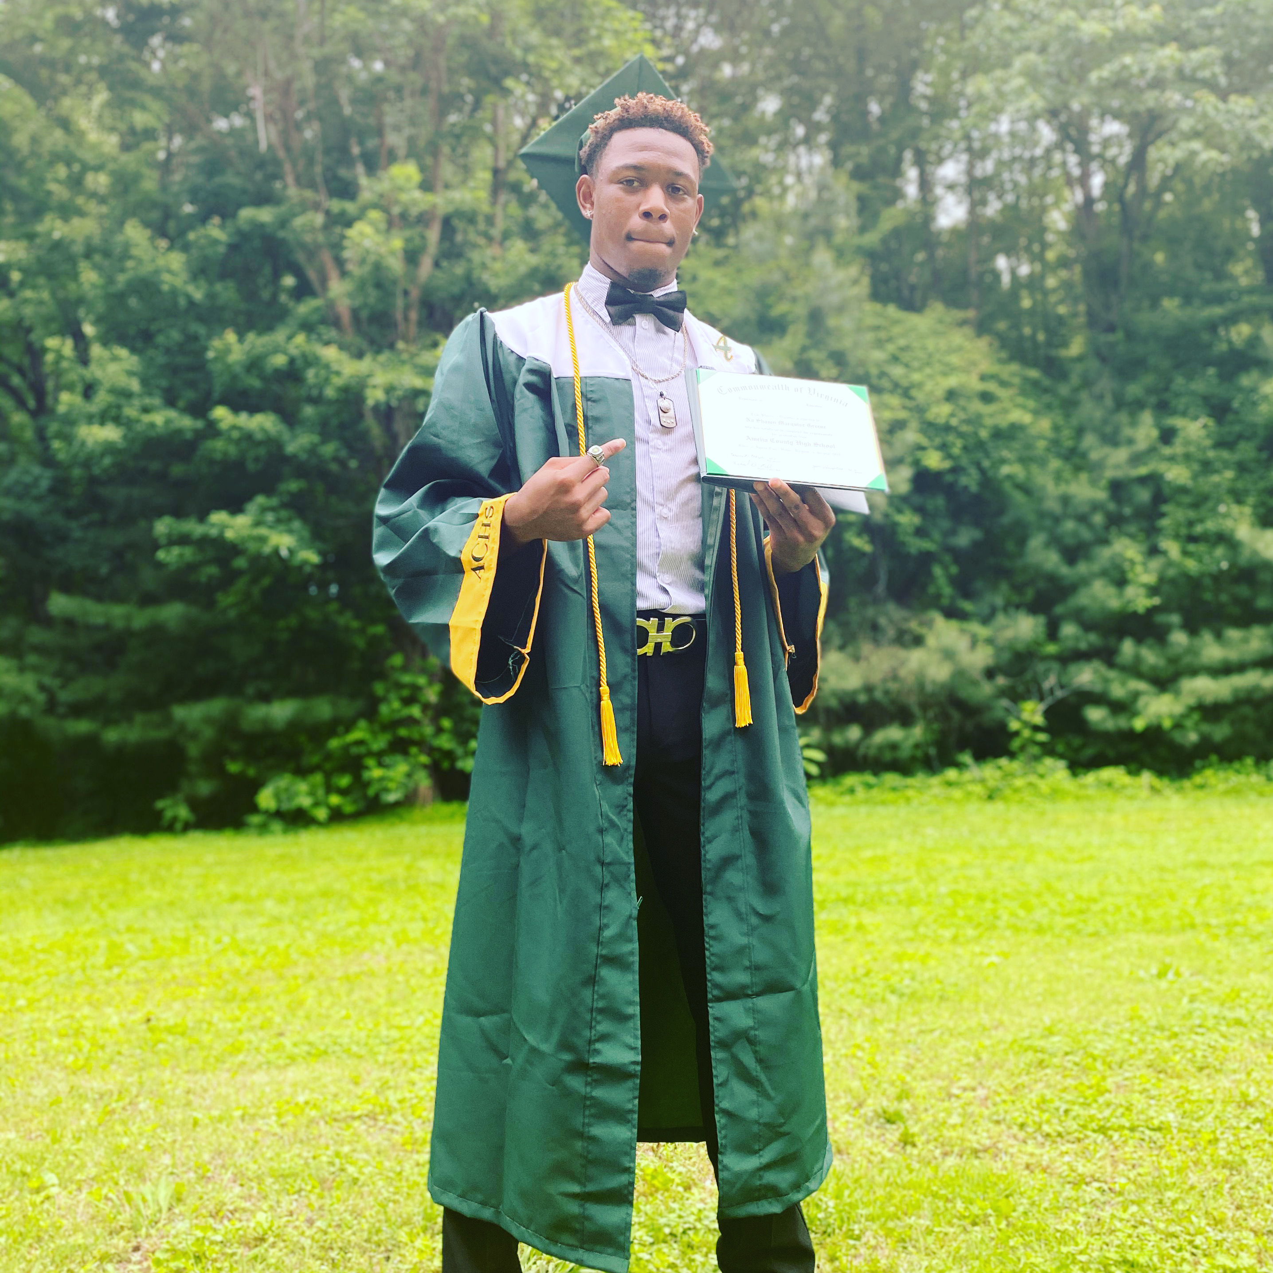
ANTC ALUMNI HIGHLIGHT!
Na-Shawn Green
High School: Amelia County High School
ANTC Program: Criminal Justice
Career: Freshman at Ferrum
Major: Health & Human Performance
Minor: Coaching
Future: Athletic Trainer/Coaching Position
DID YOU KNOW?
Superintendents
Amelia County Public Schools Nottoway County Public Schools
Dr. Lorena Harper Dr. Tameshia Grimes
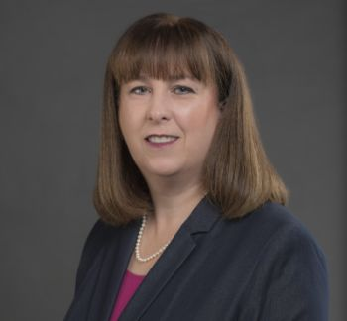
According to the 1977 Agreement, the first chief administrative officer of the Joint Committee shall be the Superintendent of the Schools, who shall serve alternating two (2) year terms. Presently, Dr. Lorena Harper of Amelia County Public School is serving in her second year as the Executive Superintendent for Amelia-Nottoway Technical Center.

ANTC serving our Alumni!

AMELIA-NOTTOWAY VOCATIONAL CENTER DEDICATION
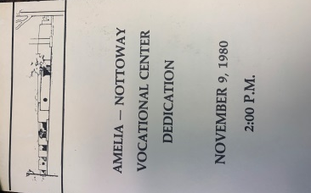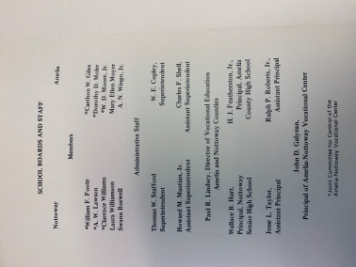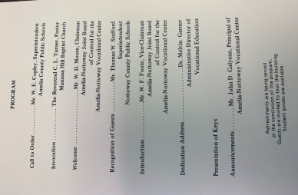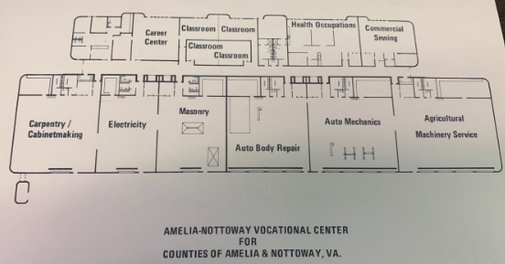
Career and technical education (CTE) is an integral part of the modern American education system. Although is may appear that CTE has only been praised recently, CTE has a proven history of preparing students for high-demand careers. Even when CTE was called “vocational education” or “vo-tech,” it still played an essential role in students’ lives.

Multiple Paths to Success!
George Washington | U.S. President | Earned a surveyor’s certificate
Soichiro Honda | Founder of Honda | Honda opted to be an apprentice auto repairman and later founded Honda Motor Company.
Mary Kay Ash | Founder of Mary Kay Cosmetics | Mary Kay Ash did not pursue a college education, but found success in the cosmetics business.
Ingvar Kampard | Ikea Founder | Ingvar struggled with dyslexia, but was able to start Ikea with no higher education.
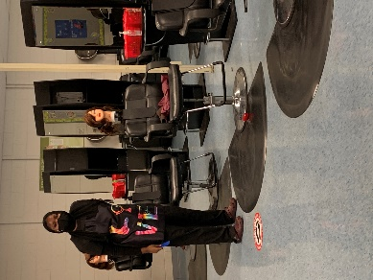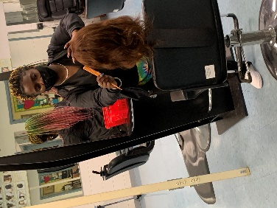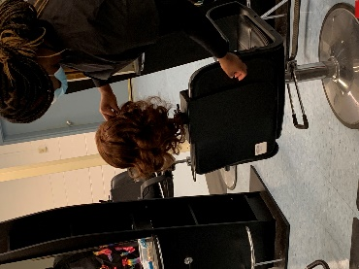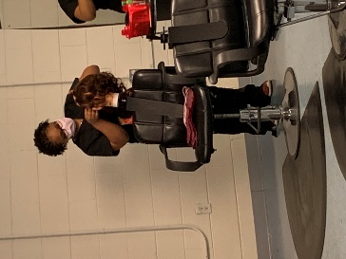
Current Program Feature: Cosmetology I & II, Nottoway High School

Skills: Styling Hair

Tasks/Competencies: Set hair, using rollers. Demonstrate hair wrapping and sculpting techniques.

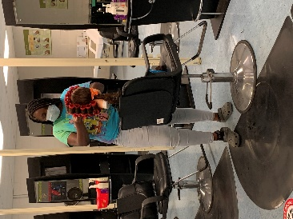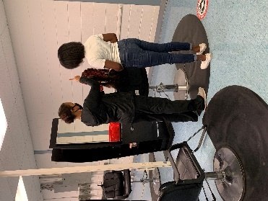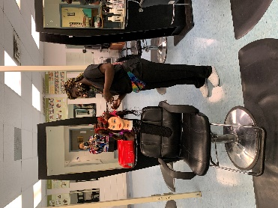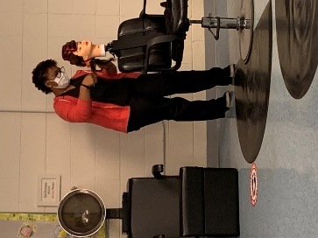
Cosmetology II – State Board Prep
