Shaklee Sports Products for People who work hard Physically or in the Heat:

Need more energy and endurance?
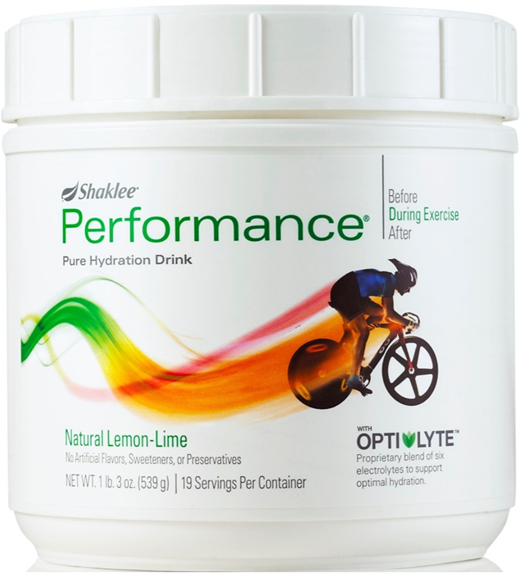
Shaklee Performance is a thirst-quenching lemon-lime drink mix containing a balance of three types of carbohydrates (fructose, glucose polymer, and glucose) PLUS electrolytes to prevent dehydration (calcium, phosphorus, sodium, potassium, chloride, magnesium ions). These electrolytes are mineral ions that are lost through perspiration.
Everyone who is working hard and perspiring is challenged in three areas:
- Replacement of fluid lost through perspiration
- Replacement of minerals lost through perspiration
- Energy Replacement
Whether you are mowing the lawn, working in construction or landscaping, or cleaning the attic on a hot day, you need to stay hydrated to keep moving. Anyone who engages in any activity that causes perspiration for 20 minutes or more would benefit from Shaklee PERFORMANCE, which contains water, electrolytes and energy (carbohydrates). Strenuous work draws constantly from the “fuel” that helps sustain energy output, especially when you are perspiring.
Water alone is NOT your best choice. The right mixture of electrolytes and carbohydrates along with water can help optimize hydration and help spare stored muscle fuel.
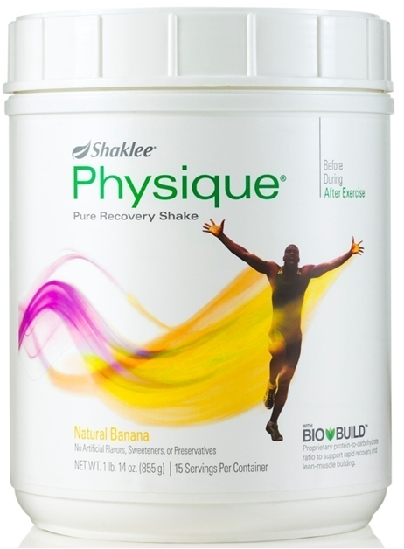
Shaklee Physique is also a gift for people who work hard physically. It is designed for muscle recovery and strength. It is a drug-free way to build lean muscle mass, and is useful to ANYONE who has a desire to maintain excellent muscle strength, mass, and tone. Physique contains a unique protein and carbohydrate blend called Bio-Build, which is designed to:
- Rebuild muscle stronger
- Increase muscle mass
- Restore energy to fatigued muscles.

Testimony: Construction Worker shares his story ...
“In my many years in the construction trade, I worked a lot of long hot hours in the sun. I used to come home totally exhausted. When I started using Shaklee Performance through the day, I noticed I wasn’t so fatigued and had more energy left at the end of the day.
If I did particularly hard physical work, I would end the day taking Physique so that I wouldn’t be sore the next day. It also helped muscle strength, and reduced the risk of muscle wear & tear, or muscle injury. I also use Physique after playing basketball. I’m now 63 years old, but I can still keep up to the 20 and 30 year old guys. Without Physique, this would be virtually impossible. Thank you Shaklee!” Ivan Willmore

