Trinity Times
Volume 10, Issue 9-10

September & October
2022

Volume 10, Issue 9/10
September & October 2022

Our bible is very specific about what God requires when we pick a leader or how we conduct our lives. As Christians we cannot pick or choose which of these things we can give ourselves or others a pass on. God requires a higher standard for us, our leaders, and others, if our world, nation and society are to survive. Let us pick up our bibles daily and genuinely seek God’s word. And remember when it comes to God’s word,
no-one gets a pass.
What God Requires of leaders
-A person who seeks first the Kingdom of God and his righteousness.
-A person who loves God with all their heart, mind, strength and soul.
-A person who loves all of God’s children and treats them with dignity.
-A person who is above reproach.
-A person of peace, love, and understanding who -seeks to unite and not divide.
-A person who prays for and forgives both friend and enemy.
-A person who attends church, reads, studies, knows, teaches, and lives by God’s words.
-A person who is faithful to their spouse, and family.
-A person who when necessary will defend the word of God over the laws of man.

-A person who does not seek to build up their own name, or brag or gloat about themselves but rather
seeks to glorify God and considers all others greater than their selves.
-A person who will always admit when they are wrong and seek forgiveness from God and from others.
-A person who is honest in all things and does not lie.
-A person who does not judge others or seek to make himself look better than others.
-A person who does not try to hurt, cause pain, disgrace, or get even with others and will work toward the good of all.
-A person who is quick to hear, slow to speak or to anger.
-A person whose speech is always gracious.
-A person who does not love to argue but seeks ways to find common ground and understanding.
-A person who is not a lover of money or power.
-A person who seeks to share all that they have with others.
-A person who welcomes the stranger, feeds the hungry, clothes the naked, and visits the sick, lonely, and imprisoned.
-A person who can put aside all bitterness, wrath, anger, and malice.
-A person who chooses to defend, honor, and protect not just his family or nation but all of God’s children as well as all that God created on this earth.

Love and peace,
doug

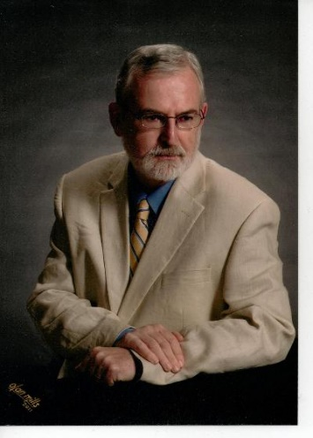

Trinity United Methodist Church

1160 Trinity Church Road
Newberry, SC 29108
803-276-1245 Office
www.trinityumcnewberry.net

Pastor Douglas Benton
803-543-0082 Pastor Cell
dobenton@umcsc.org

www.trinityumcnewberry.net
PLEASE VISIT OUR WEBSITE
AS OFTEN AS YOU CAN!

Peggy Bogart, Church Secretary
Head Usher: Harry Longshore
Choir Director: Open
Organist: Eddie Welborn
Substitute Organist: Phyllis Sanders
Video Board: Josh Pitts, Caroline Senn,
Foster Senn, Bryan Waldrop
Acolytes/Cross Bearers Coordinator: N/A
Newsletter Editor: Harriet Stevenson

MYF SPAGHETTI FUNDRAISER!!

SUNDAY, SEPT. 25

MYF FUNDRAISER AFTER
CHURCH SERVICE IN
FELLOWSHIP HALL.
EAT IN OR TAKE OUT
FREE – JUST MAKE A DONATION
TO MYF

MONEY WILL BE USED FOR MYF ACTIVITIES
We are a caring church and want to share your concerns. Let us know if you or someone you know would like to share a prayer request with us. We will be happy to pray for you. Contact Peggy Bogart, Church Secretary, or Harriet Stevenson, Communications Chairperson, to add or remove names from the Church Prayer List.

Nursing Home:
Trinity Member Prayers: Shirley Berry, Boyd Hendrix, Robert Pollard, Jeannette Poag, Pastor Doug and Carrie, Faye Senn, Wade and Frances Pitts
Family and friends of Trinity: Kinsley Bouknight, Woody and Connie Kreuzinger (Carrie’s parents), Ann Coker, Rick Coker, Freddie Bundrick, Doris Mohler, Jacob Welborn, Harriet Connelly, Charles Melvin “Doc” Pitts, Charlotte Berry, Faith Benton (Pastor Doug’s niece), Buffy Benton (Pastor Doug’s sister-in-law), Keith Rankin and family

Sept. and October Readers and Greeters
Readers Greeters
Sept. 4 Crystal W. Watkins M.
Sept. 11 Dixie W. Clarissa H.
Sept. 18 Lynn M. Linda L.
Sept. 25 Frieda K. John P.
Oct. 2 Kelly M. Debbie L.
Oct. 9 Phyllis S. Myrtle L.
Oct. 16 Sharon B. Joan M.
Oct. 23 Betty W. Harriet S.
Oct. 30 Josh P. Sylvia H.

Please contact Kelly (803-924-5715) if you are unable to serve or can’t find someone to switch with. If you switch, please let her know as well. Readers will receive a bulletin in the mail with scripture included. Greeters need to be in the Narthex by 10:40 a.m.

THANK YOU FOR YOUR SERVICE!

13 – Ruthie Jane Spicer 4 - Robert Pollard
22 – Andrew Morris 7 – Jed Daniel Brehmer
24 – Colton Poag 9 – Laura Spicer
24 – John Pollard 12-Rhett & Reid Lindler
26 - William “Boo Boo” Johnson 14 - Marie Somers
17 – Laura Mohler
21 - John Longshore
22 - Barbara Carter
26 - Bryan Waldrop
30 - Frieda Kesler
30 - Johnnie Pitts Jr

The windows in the church have been replaced with brand new modern windows. This will help with the utility bill as we were losing a lot of air through the old windows. We are in the process of measuring, purchasing and installing new blinds in the church as well. Thanks to all who contributed to this much needed project at Trinity.

The Trinity Women’s Club and the Trinity Men’s Club is joining together to purchase benches for the front porch. Many like to arrive at church early and stand on the porch and talk before the service starts. We hope this will make it easier for those who might like to sit while enjoying a conversation or two each Sunday. Thanks for coming up with this great idea!

Harriet Stevenson received a $200 grant from the Royal Neighbors Difference Maker Fund. Her project is preparing Blessing Bags for the homeless. These bags will be given to Newberry County Sheriff’s Deputies to place in their cruisers. The bags will consist of socks, toothbrush, toothpaste, crackers, applesauce, granola bars, mints, lip balm, small first aid kit with single dose Advil, bandaids and antibiotic ointment, hand sanitizer, water, comb/brush, body wipes, plastic spoon/fork, soap, deodorant and sunscreen.She needs volunteers to help pack the bags. You will receive a t-shirt and recognition for volunteering. Please let Harriet know if you can volunteer to help with this important project. If you can donate any extra of these items, it would be greatly appreciated and will help us to fill more Blessing Bags. $200 doesn’t go very far these days.

Congratulations to our Pastor and Carrie who
celebrated their 1-year wedding anniversary
on August 7th.

SEPTEMBER 11th – BRING A GRANDPARENT TO CHURCH

The purpose of Grandparents Day is threefold: to honor grandparents, to give grandparents an opportunity to show love for their children’s children, and to help children become aware of the strength, information and guidance older people can offer. All children are asked to invite their Grandparents to join them at church on September 11th and all Grandchildren are asked to invite their Grandparents to join them. We will recognize those Grandparents who are present during the church service. This is our day to celebrate you! We will take your photo together after church and the following Sunday we will deliver to you a beautiful 5 x 7 photo, one for the grandparent(s) and one for the grandchild(ren), that will be cherished forever. Absolutely FREE! This is Trinity’s way of saying WE LOVE YOU!

UPDATE:
Mrs. Jeannette Poag has a new address. She is living with her granddaughter, Heather, who just moved into a new house. Her address is 3536 Wheeland School Road, Prosperity, SC 29127. Her phone number is 803-597-8168. Her daughter Becky said she is doing well but is very lonely. If you have the time, I am sure she would appreciate a call or visit.

MYF Leaders - Josh and Erin Pitts
The MYF enjoyed their trip to Carowinds in August. The youth will meet on Sept. 10 for an outing to Stars and Strikes Entertainment in Columbia where they will enjoy bowling and arcade games. And on Sept. 25 they will have their annual Spaghetti Fundraiser after the church service. All of welcome to attend. The dinner is free but donations will be accepted. The money will go toward future MYF group activities.
On Oct. 23, the youth will have a meeting at the church from 5:00 to 7:00 p.m. After that, the MYF will start planning for Trunk or Treat which will be held on Oct. 29. This will be the first year back for Trunk or Treat since covid. Start making your plans now to decorate your trunk and then join the MYF for a fun night.
.

September 5 Labor Day
September 6 Trinity Women’s Club – 5:30 p.m.
September 7 Trinity Men’s Club – 7:30 p.m.
September 10 MYF outing to Stars and Strikes Bowling & Arcade, Irmo
September 11 Grandparents Day – Photos taken after the church service
September 12 Administrative Council Meeting – 6:30 p.m.
September 14 Silver & Gold – Lunch - Country Café on Hwy. 39, Cross Hill – 11:30 am
September 22 First Day of Fall
September 25 MYF Annual Spaghetti Fundraiser after church (eat in or take out)
October Pastor Appreciation Month
October 3 Trinity Women’s Club 5:00 p.m.
October 5 Trinity Men’s Club – 7:30 p.m.
October 10 Administrative Council – 6:30 p.m.
October 16 Wear Pink to church in support of Breast Cancer victims and survivors
October 16 Golden Age Sunday and Pastor Appreciation Sunday including catered lunch.
October 23 MYF Meeting 5:00 – 7:00 p.m.
October 29 TRUNK OR TREAT IN CHURCH PARKING LOT!
Nov. 7 Charge Conference at Trinity UMC – 6:30 p.m.

OCTOBER is Breast Cancer Awareness Month.
It is alarming to know that 1 in 8 women will be
diagnosed with breast cancer in their lifetime. While
you can’t prevent cancer; it is important to be proactive
about your health. In fact, there are things you can do to help reduce certain types of cancer.
Wear Pink to church on October 16th and pick up a packet after church with information
About the signs, symptoms and prevention of breast cancer.
AND

SUNDAY, OCTOBER 16th
HONORING THOSE 70 AND OVER DUR ING CHURCH SERVICE
CATERED LUNCH AFTER CHURCH SERVICE
TO SHOW OUR LOVE FOR OUR
GOLDEN AGERS AND OUR PASTOR!
This will take the place of our 5th Sunday event.

Take a break and enjoy this work-related humor!
- My first job was in an orange juice factory. I got canned because I couldn’t concentrate.
- When I couldn’t hack it as a lumberjack, I got the ax.
- I wasn’t suited to being a tailor.
- Working in the muffler factory was too exhausting.
- I was a banker … until I lost interest.
- I realized there was no future in being an historian.
- Any way I sliced it, I couldn’t cut the mustard at the deli.
- I studied to become a doctor but had no patients.
- My job at the coffee shop was always the same old grind.
- When I worked as a plumber, the tasks were too draining.
- I was hired at a gym but wasn’t fit for the job.
- Finally, I got a job at a bakery; I kneaded dough!
Church Positions

As of December 31, 2022, the following two church positions will become available as Josh and Erin Pitts and Kelly Morris will be stepping down as the leaders of these groups. The Choir Director position remains open also. The Nominations Committee is actively seeking replacements for the following positions:

* MYF Leader(s) * The Choir Director position remains open
* Worship Chairman * Opening in January-Newsletter producer

If you or someone you know would be interested in filling one of these positions, please see Pastor Doug for more information. We are also looking for someone to produce the newsletter.
The Last Two Months in Pictures

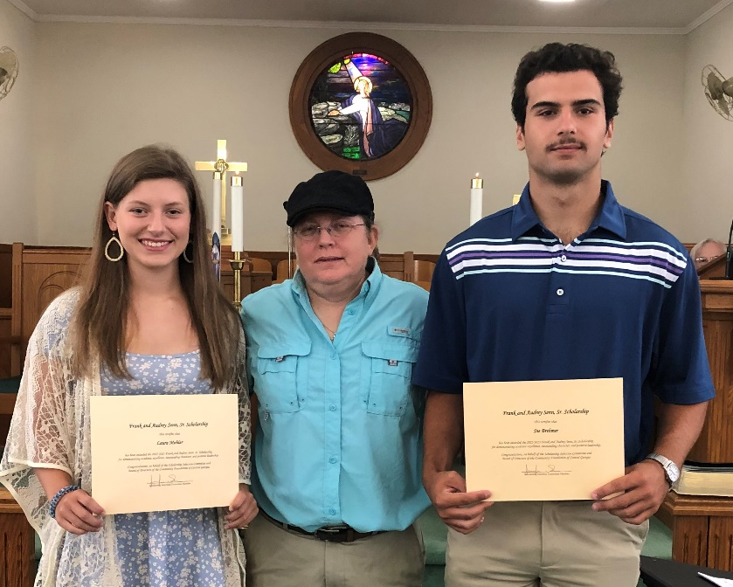
Scholarship Presentation
Winners of the Frank Sr. and Audrey Senn Memorial Scholarship, Laura Mohler and Joe Chesley Brehmer, pictured with Jenny Senn, who represented the Senn family. The purpose of the scholarship is to provide college, technical or trade school scholarships to students who are members or regular attendees of Trinity or Trinity MYF.

Rural Life Sunday

Rural Life Sunday – Honoring our local farmers .

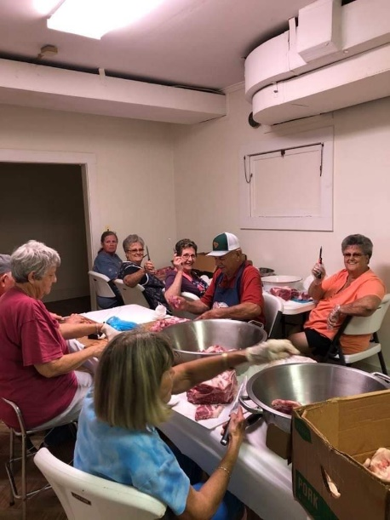
Kruz worked hard all night!
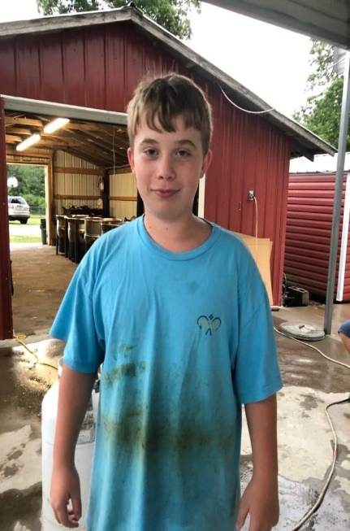
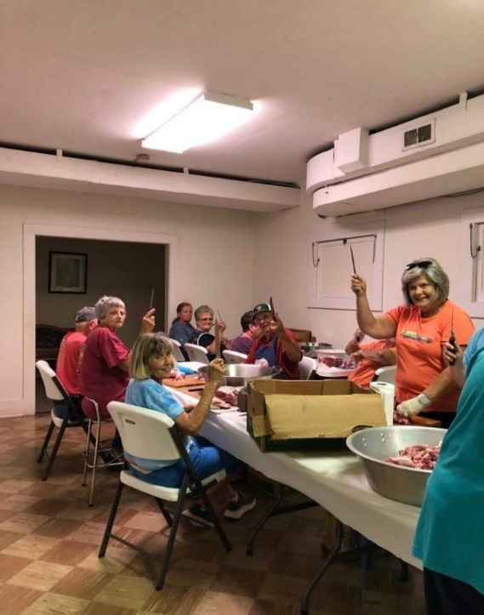 More meat cutters!
Cutting up meat for hash.

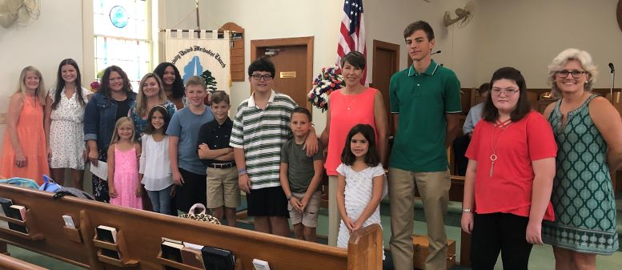
Blessing of Backpacks and Back to School Blessing 2022

Dear Lord, our children return to school this month. We pray that they are returning to a place of peace, friendship, learning, and safety through your presence in the school every day. We entrust our precious ones to teachers, administrators, and staff and ask that these adults respond with the heart of Jesus in their every interaction with our children. May they all see your face and know your presence as they look into the faces of every person on the school grounds. In Your Name We Pray, Amen.

Back to School Bash – Games and Ice Cream
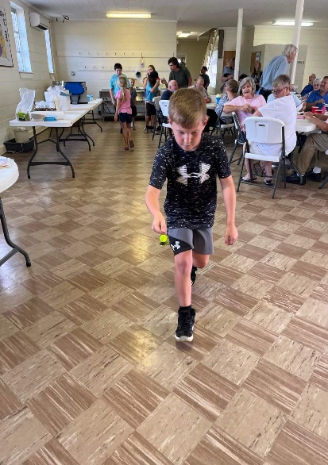
MYF having fun at Carowinds
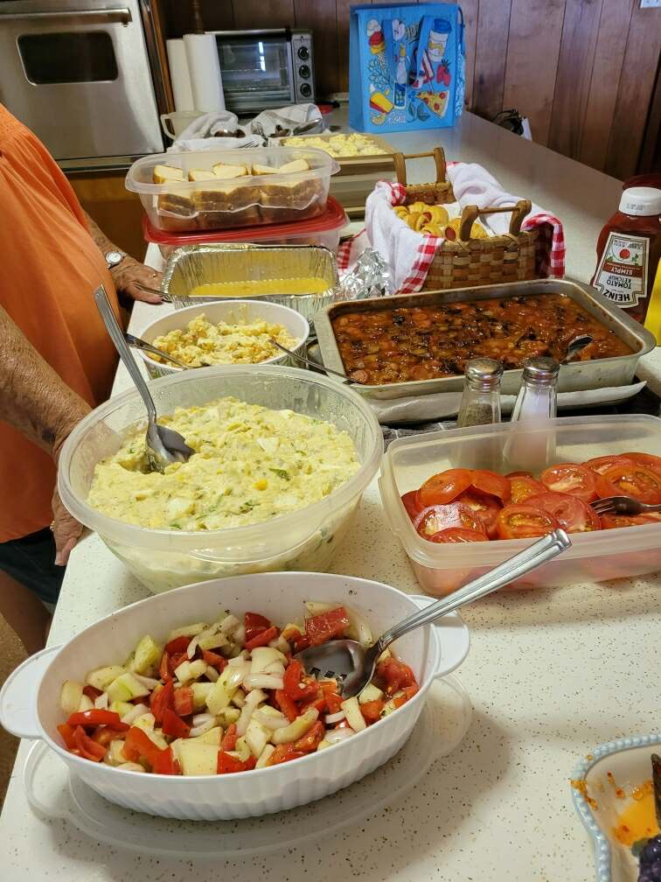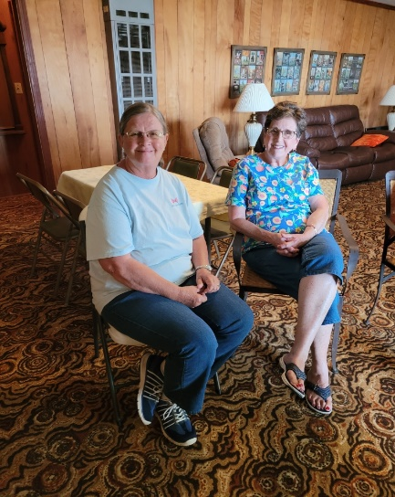
Silver and Gold at The Waldrop’s Lake Home MYF at Carowinds

Trinity United Methodist Church
1160 Trinity Church Road
Newberry, SC 29108

