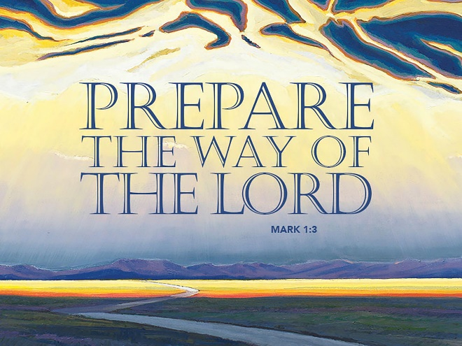
This Is Just The Beginning!
December 10, 2017
Mark 1:1-8

Grace and peace to you from God our Father and from Jesus Christ who brings us the Good News of God’s love, amen.
I welcome this new Church year. Each year with Advent we begin following a different Gospel. This year most of the Gospel readings will come from the Book of Mark. We just finished up the year of Matthew. I love all the books of the Bible, but Matthew, which we concentrated on last year isn’t my favorite Gospel. Matthew does have a great birth story complete with the Wise Men from the east and all, but it’s also referred to as the most Catholic of the four Gospels. Catholics believe we are saved by God’s grace, but with an assist from our own effort in the form of good works. Things like Jesus comments after he gives the disciples the Lord’s prayer, where Jesus says if you don’t forgive your neighbors, then your heavenly Father will not forgive you either. You see, in Matthew some of the verses seem like you have to do something to accomplish your own salvation.
On the other hand, Lutherans believe we’re saved by God’s Grace and that Jesus accomplished everything needed for our salvation in his death and resurrection. As we begin this new Church year most of the Gospel readings will come from Mark’s Gospel. Now, Mark is known as the most Lutheran of the four Gospels. In Mark’s Gospel, for example, the disciples are depicted as totally clueless when it comes to anything related to Jesus, the cross, and almost all of his teachings. In Mark’s Gospel Jesus says the disciples don’t even have faith. At least in Matthew, he says, “Oh, you of little faith…” Also, in Matthew’s version they have some redeeming value and they get better as the story progresses. In Mark’s version, the disciples start out clueless and actually get worse. They progress from not understanding Jesus teachings, to confusion, to doubt, to unbelief, and finally to denial and betrayal. They never get any better and they never get a clue. The only thing the disciples have they can cling to is the fact that Jesus picked them. Isn’t that the very definition of Grace? They didn’t do anything, they didn’t contribute to their salvation. The only thing they have to rely on is Jesus. My friends, that’s quintessentially Lutheran!
So, welcome to the year of Mark. I love that we get to start at the beginning. The first thing Mark wants us to know is this book is the beginning of the Good News of Jesus Christ, the Son of God. Right from the get go we’re told Jesus is the Son of God. We might take that tidbit for granted and say of course Jesus is the Son of God. We’ve been saying the Apostles and Nicaean Creeds since we were old enough to talk, but as we read through Mark’s story let’s all take note of how many of the people in this Good News tale understand who Jesus is and what it means that Jesus is the Son of God. I’ve already given you a hint about the disciples…
Mark begins with some loaded words that again, we tend to overlook or take for granted. The first is the name of Jesus. Mark calls him Jesus Christ. When we’re angry some of us use that expression, but that’s not what Mark intends. The Greek word for Christ is Christos and it means the anointed one or the Messiah. I wondered what Mark wants to convey at the very beginning of his Good News by telling his audience this Jesus is the Anointed one. In Bible days three classes of people were anointed. They were Kings, Priests, and prophets. Throughout the Gospel, Mark will unpack his vision of Jesus as the anointed one of God who holds all three offices. Jesus is our King of Kings and he’s our great High Priest who intercedes for us with God. He also speaks for God because he is God and that makes him by definition a prophet, the best and greatest prophet possible. Mark tells us right from the beginning Jesus holds all three offices as King, Priest, and Prophet.
In the same sentence Mark says this man is Jesus Christ, Son of God. At this point if you’re reading Marks book for the first time and you read this you naturally put this title into your own context. If you’re living during Mark’s era, Jesus isn’t the only person you’ve heard of who is called Son of god. There’s also Augustus Caesar. The August son of Julius Caesar who declared himself to be a god. These emperors were more like conquering superheroes. Is that the image Mark wants us to have of Jesus? Mark is setting his story up like a really great mystery. He tells us right up front who this Jesus is, but them it takes the rest of the book for the characters in the story to figure it out…
I love this time of year. In the Church, it’s all about new beginnings, but in the secular world it’s all about celebrating, period… All the lights and beautiful decorations, what’s not to love? Tonight we get to take our beautiful grandchildren to see the lights at Clifton Mills for the first time. It’s a memory I’ll certainly take to my grave. It’ll be the first time they get to see so many Christmas lights and so many Santa Clauses! By reading this “beginning of the Good News from Mark,” I am reminded that this season of advent is just that, the beginning of the Good News. We try to cram so much into these 4 weeks before the one big day that we end up not really appreciating the gift God has given and all God has in store for us. We don’t have to cram every celebration and party into this one time of year. Christmas isn’t about what happened one day in Bethlehem 2000 and some years ago. Christmas is what happens every day when we take the time to remember the gift God has given to us in this man Jesus Christ, Son of God. Yes, he’s a prophet. Yes, he’s our high priest, and yes, he’s our one and only King, but he doesn’t come to be a conquering superhero. He comes to be our servant and to die for our sin.
Today I’m thankful for John the Baptist who understood his role and purpose in life wasn’t to be a priest, prophet, and king all rolled up into one. John knew his life had but one purpose. He was the one to come and prepare the way for Our King. His job was to start the ball rolling and get this party started. John the Baptist prepared the way for the promise of God to come into the world. The promise of Christmas for you and me is Jesus. That promise doesn’t end on December 25. We don’t pack it away like so many Christmas lights, nutcrackers, manger scenes, Santa Clauses, and Christmas Trees. The promise of Jesus is new every day and makes us new.
Notice that Mark begins his account not simply by saying his work is “The good news of Jesus Christ, the Son of God,” but rather “The beginning of the good news….” It’s so easy to be taken off guard by the brevity, even abruptness of Mark’s opening line – no angels and shepherds (Luke) here, no genealogies or wise guys (Matthew) or hymns to God’s eternal Word (John) – all of that, Mark overlooks altogether. Mark is trying to tell us something, both by the simplicity and open-ended quality of his opening (and ending for that matter, but that’s another story!). Mark is suggesting – and keep in mind, Mark usually suggests and provokes rather than flat out declares –this whole story about Jesus, beginning with John the Baptist and running through the calling of his disciples, exercising demons, healing the sick and feeding the hungry, and culminating in his death and the declaration of his resurrection (but no appearance!)…is all just the beginning.
The story of the beginning of the good news of Jesus Christ, continues… to this day… among us! And given the headlines and scandal and upheaval and unrest and general anxiety of these days, the promise of Jesus Christ, Son of God comes to us as such a timely and important word. It’s a message filled with hope that evokes faith that God has not forgotten us nor abandoned us. God is in fact coming to us. God is coming to be one of us. God is coming to make us his own. This week I ask you to stop the frantic pace of preparing for each celebration to remember God is still here with us, working through us, loving the world through us, and continuing this story that began way back when with a weirdo out in the wilderness all the way to today through us!
This story isn’t finished yet. This story is bigger than the news stories we hear or the worries we carry or even the hopes we share. God is not finished! We are not yet what we have been called to be. The promise of Christmas is bigger than we can ever imagine. God’s mercy and courage and blessing extends farther and deeper than we can imagine. For this, my dear congregation, is only just the beginning!
May we all slow down and remember God’s promise for us and for all the world isn’t finished and doesn’t get packed up on December 26th. God’s promise in Jesus Christ is just beginning for you and for me. Amen, come Lord Jesus!

