St Mary’s in the Marketplace, Stockport

Approvals have been given, the contractors booked and it all starts on Monday 30th July. To assist the process it has been decided that
St Mary’s will be closed from Monday, 30th JULY to Saturday, 4th AUGUST (inclusive). .
During this time Lambert Walker will move on-site, build their compound and bring in required equipment. The scaffolding sub-contractors are booked to arrive and once again work on reaching areas of the tower on the east-side as well as the tower roof.
Inside the Church, Lambert Walker will block-off the north-aisle and start to strip out the old kitchen and toilet areas, knocking through the external wall. Some of our pews will be moved into storage to allow for works to begin.
Lambert Walker will provide us with water and connect-up external toilet facilities.
We know there will be some disruption from time to time, but we intend to remain open on Tuesday, Thursday, Friday and Saturday (there may be some amendment to opening times) as well as for all our normal services, wedding, funerals, concerts and of course our extensive Christmas Programme.

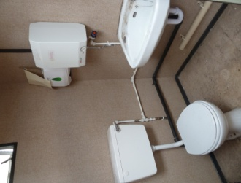
THE ESSENTIALS
Although facilities will be external to the church,
we will have a proper toilet with hot and cold running
water.
Our aim will be to continue to provide a hospitality area located in the south aisle. It will not however be possible to continue to provide “free” loose biscuits or sell any item of food that is not pre-packaged. No toast, crumpets or other such items until the new “Nave Café” opens next year.

There is a lot of work ahead – both for our contractors and ourselves – but our objective is to operate as near to normal as we possibly can.

There will be plenty of space for quiet reflection in the chancel area and our votive candles will remain available.

Our volunteers are asked to continue as normal but not to bring in any food items for sale in the café that are not pre-packaged (sealed) by the manufacturer. Arrangements will be made for items to be purchased and sold on a commercial basis, with proper stock-keeping and accounting methods introduced. We will risk-assess the activities being undertaken and observe appropriate Health and Safety requirements, including those regarding security issues. Lambert Walker will be providing a supply of fresh drinking water and an adequate electricity supply for our water heater(s). We will review additional temporary heating nearer the winter months.
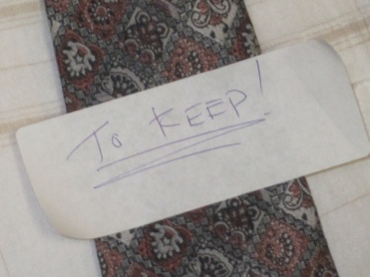
Cupboards will be cleared and various odds and ends packed and put away, - but some valuable items we will be keeping with us at all times….. and he’s all labelled up!

