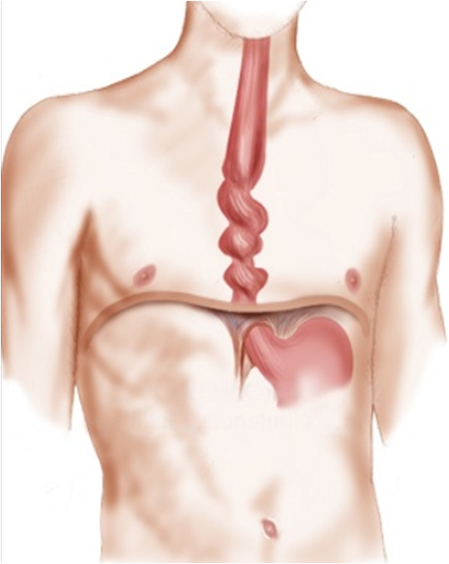
Nutcracker Esophagus

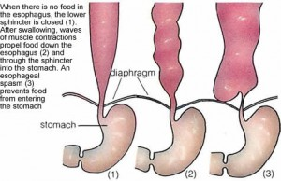

This condition is a type of esophageal spasm characterized by powerful contractions that occur when swallowing. It is usually caused by gastroesophageal reflux, the backflow of stomach acid up the esophagus, which causes heartburn. Acid reflux that occurs more than twice a week is called gastroesophageal reflux disease (GERD), a more serious condition that, left untreated, can lead to problems such as chronic inflammation of the esophagus (esophagitis) and a precancerous condition called Barrett's esophagus.
The symptoms of nutcracker esophagus can be alarming - chest pain so severe that it can be mistaken for a heart attack and the feeling that food is stuck under the breastbone.
- address lifestyle factors such as smoking and excess weight
- eat small, frequent meals instead of three large ones
- chew your food very well ... a large food chunk can trigger a spasm
- avoid lying down within three hours of eating
- avoid tight clothing, especially around your midsection.
Traditional Treatment:
- GERD medication
- over-the-counter antacids
- stomach acid blockers - It is not a good idea to use these drugs long term, both because they have significant side effects and because they can worsen the condition over time.
Natural Suggestions:
- certain foods and beverages weaken the esophageal sphincter ... avoid them (caffeine and alcohol)
- many people react to GMO wheat products
- Get regular exercise.
- Drink plenty of water.
- Manage stress well ... it can trigger the response
- Supplements:
VitalMag - morning & evening
Chewable Cal-Mag - after every meal
Chewable Bifidus Probiotic - 2 per day
Alfalfa - 6 after each meal
B Complex - to feed the central nervous system (note, Nutcracker Esophagus occurs most often in high energy individuals ... they use up a lot of B vitamins in high energy, and need optimal amounts

