AZ ARMED GUARD CERT. / RENEWAL

The Arizona Armed Guard Certification Class is designed to teach the Armed Security Guard th e necessary firearm safety, legalities, and marksmanship required to obtain a State of Arizona Armed Security Guard License. Range fees and fingerprinting are included with the course. Special pricing is available for security companies.

TOPICS COVERED & ITEMS INCLUDED WITH COURSE
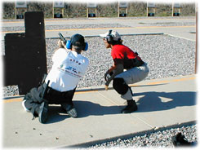
Firearm Safety Firearm Familiarization
Firearm Maintenance Equipment Selection
Use of Force Mental Conditioning
Weapon Retention & Retrieval Close Quarters Tactics
Written Test Weapons Qualification
Range Fees Fingerprinting

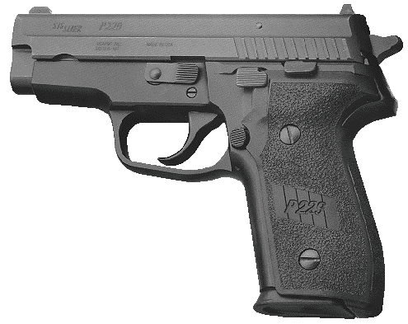
COURSE REQUIREMENTS (8 HOUR INITIAL COURSE ONLY)
Handgun
250 Rounds of Ammunition
Eye & Ear Protection
Quality Holster
Spare Magazine or Speed Loader & Pouch
COURSE PRICE
Initial Certification (16 Hour Course) $100.00
Renewal (8 Hour Course) $80.00
CALL FOR REGISTRATION: 602.577.1557

