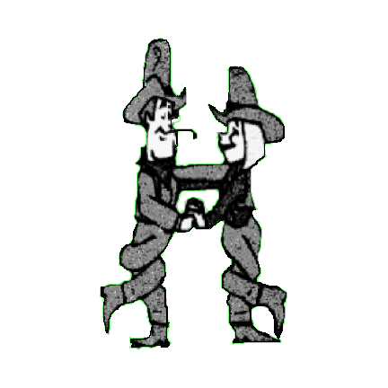COUNTRY CHOICE PARTNER DANCERS

Chris & Andy Malpass

Qualified Instructors

D&G, N.T.A. G.P.T.D YOU AIN’T DOLLY

Choreographed by: Chris & Andy Malpass 01606 883862 email: [chrisandy-partners@hotmail.co.uk](mailto:chrisandy-partners@hotmail.co.uk)

Description: 64 count Partner Dance. Start in Indian Position facing O.L.O.D

Same Footwork, except where stated

Music: “You Ain’t Dolly (and You Ain’t Porter) by Ashley Munroe and Blake Shelton 128 b.p.m. C.D Like A Rose

BOTH

01 – 08 SIDE, HOLD, ROCK, RECOVER, SIDE, HOLD, ROCK, RECOVER

01 – 04 Step side left on left, hold, cross right behind left, recover onto left

05 – 08 Step side right on right, hold, cross left behind right, recover onto right

BOTH

09 – 16 SIDE, TOUCH, SIDE, TOUCH, SIDE, BEHIND, 1/4 TURN, HOLD

09 – 12 Step side left on left, touch right next to left, step side right on right, touch left next to right

13 – 16 Step side left on left, cross right behind left, 1/4 turn left stepping onto left, hold *(facing L.O.D)*

BOTH

17 – 24 1/4 TURN, 1/4 TURN, STEP BACK, HOLD, 1/4 TURN, 1/4 TURN, STEP FORWARD, HOLD (windmill turn)

17 – 20 1/4 turn left stepping onto right, 1/4 turn left stepping onto left, step back on right, hold *(facing R.L.OD)*

21 – 24 1/4 turn left stepping onto left, 1/4 turn left stepping onto right, step forward on left, hold *(facing L.O.D)*

*(on count 17 release left hands. Bring right hands over lady’s head, rejoining left in Reverse Indian Position)*

*(on count 21 release right hands, bring left hands over lady’s head into into Sweetheart Position )*

GENT LADY

25 – 28 ROCK, RECOVER, STEP, TOUCH, STEP, PIVOT 1/2 TURN, STEP, TOUCH

29 – 32 SIDE, TOUCH, SIDE, HOLD SIDE, TOUCH, SIDE, HOLD

25 – 26 Rock forward on right, recover onto left Step forward on right, pivot 1/2 turn left stepping onto left

27 – 28 Step back on right, touch left next to right Step forward on right, touch left next to right

29 – 30 Step side left on left, touch right next to left Step side left on left, touch right next to left

31 – 32 Step side right on right, hold Step side right on right, hold

*(on count 26 release left hands. Lady turns under joined right hands to face R.L.O.D. Gent facing L.O.D)*

*(right shoulder to right shoulder)*

BOTH

33 – 40 BEHIND, SIDE, CROSS, HOLD, STEP, PIVOT 1/2 TURN, STEP, HOLD

33 – 36 Cross left behind right, step side right on right, cross left over right, hold *(changing sides)*

37 – 40 Step forward on right, pivot 1/2 turn left stepping onto left, step forward on right, hold

*(on count 34 release right hands and join left. Left shoulder to left shoulder)*

*(on count 38 release left hands and rejoin right. Right shoulder to right shoulder. Gent facing R.L.O.D, lady facing L.O.D.)*

GENT LADY

41 – 44 BEHIND, SIDE, CROSS, HOLD BEHIND, SIDE, CROSS, HOLD

45 – 48 STEP, PIVOT 1/2 TURN, STEP, HOLD ROCK, RECOVER, STEP, HOLD

41 – 42 Cross left behind right, step side right on right Cross left behind right, step side right on right

43 – 44 Cross left over right, hold *(changing sides)* Cross left over right, hold *(changing sides)*

45 – 46 Step forward on right, pivot 1/2 turn left stepping onto left Rock back on right, recover onto left

47 – 48 Step forward on right, hold Step forward on right, hold

*(on count 42 release right hands and join left. Left shoulder to left shoulder)*

*(on count 46 join right hands in Sweetheart Position both facing L.O.D)*

BOTH

49 – 56 STEP, LOCK, STEP, HOLD, ROCKING CHAIR

49 – 52 Step forward on left, lock right behind left, step forward on left, hold

53 – 56 Rock forward on right, recover onto left, rock back on right, recover onto left

BOTH

57 – 64 JAZZ BOX 1/4 TURN, TOUCH, SIDE, TOGETHER, SIDE, TOGETHER

57 – 60 Cross right over left, step back on left, 1/4 turn right stepping onto right, touch left next to right

61 – 64 Step side left on left, step right next to left, step side left on left, step right next to left

*(on count 59 returning to Indian Position both facing O.L.O.D)*

Keep Smiling