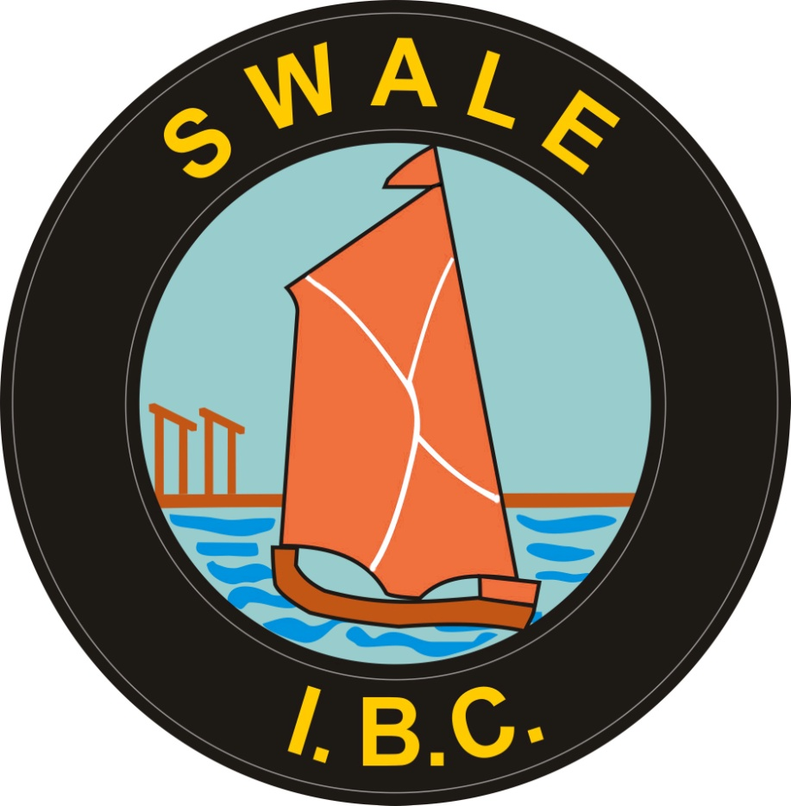
SWALE INDOOR BOWLING CENTRE

dISCIPLINARY pOLICY

1 Introduction

The purpose of the Swale Indoor Bowling Centre’s (SIBC) Disciplinary Procedure is to help and encourage all employees to achieve and maintain required standards of conduct, attendance and work performance.

The aim is also to ensure that SIBC’s services are maintained and effective while all staff are treated fairly and equitably. This procedure sets out the action that will be taken in response to alleged misconduct or poor work performance and attendance.

Management must ensure that all employees are aware of general and specific rules, standards and procedures covering work, attendance and conduct. Employees must familiarise themselves with these standards and procedures and follow them.

In cases of minor misconduct, unacceptable performance or attendance issues, informal action should normally be considered before formal disciplinary action is taken and largely depends on the severity of the infringement and the previous conduct, performance and attendance of the employee. Examples include an incidence, or incidences, of poor performance, rudeness, safety violations and unacceptable absences.

No disciplinary action will be taken until a case has been thoroughly investigated. When starting an investigation into an allegation of misconduct or poor performance, there shall be no assumption that disciplinary action will automatically follow.

Employees will not normally be dismissed for a first breach of discipline, except in the case of gross misconduct, when the penalty will be dismissal without notice and without payment in lieu of notice.

2 Who is authorised to take disciplinary action?

• Informal action/First warning/Final warning: Manager or other designated member of the Management Board
• Dismissal: Chairman of the Management Board or other designated member of the Management Board

3 What is gross misconduct?

Gross misconduct is defined as misconduct serious enough to invalidate the employment contract between SIBC and the employee, which makes further working relationship and trust impossible. Gross misconduct is normally restricted to serious offences. The principal reasons for summary dismissal could include but are not limited to:

- Criminal offence which affects the individual’s ability to carry out their job;
- Physical assault by an employee on any other person;
- Theft, misappropriation or unlawful destruction of SIBC or others’ property;
- Serious infringement of safety rules or negligence which causes unacceptable loss, damage or injury;
- Making malicious or unfounded allegations of a serious nature;
- Deliberately falsifying any documents or claims, including time sheets, overtime or expense forms;
- Misconduct at work or away from work of such a serious nature as to bring into disrepute either the employee’s position or the organisation;
- Serious discrimination relating to a protected characteristic (age, disability, gender reassignment, marriage and civil partnership, pregnancy and maternity, race, religion or belief, sex and sexual orientation);
- Harassment of a serious nature;
- Persistent alcohol or drug abuse;
- Engaging in unauthorised employment during hours when contracted to work for the SIBC or during periods of designated leave, for example sick leave, time off for training, etc.;
- Failure to disclose unspent criminal conviction(s) or any convictions, whether spent or not, in respect of posts exempt under the terms of the Rehabilitation of Offenders Act 1974;
- Providing false information on a job application form including false information concerning immigration status.

4 The procedure

If informal action fails to achieve the required improvement in performance or behaviour, then this procedure is followed. This procedure applies to all employees, once their probationary period is completed. The procedure for probationary employees is described in Section 6 below.

i. Invitation to a Disciplinary Meeting
Following an investigation the employee should, without unavoidable delay, be given letter detailing the allegation, the possible consequences and inviting them to a disciplinary meeting. At the same time the employee will be provided with copies of all documentation and supporting evidence to be presented at the meeting.

ii. Disciplinary Meeting
The disciplinary panel will comprise the Chair and where possible one other panel member. A note-taker, who must be uninvolved in the case, will take down a record of the meeting.

The manager or a designated director will chair the meeting with an explanation of its purpose and will read aloud the allegations. The Chair will ask the employee if they wish to take the opportunity to respond to the allegations or concerns and if there are any mitigating circumstances to be taken into account.

If there are any witnesses, they should not be present throughout the meeting. They should be called in, one by one, to give their evidence and asked to leave once they have done so. The Chair may question the employee and any witnesses called. The employee and their representative may also ask questions of any witnesses called.

The Chair will summarise the main points of the meeting and ask the employee if they have anything further to say. The Chair will then consider the details heard in private. They must decide whether the case against the employee has been established on the balance of probabilities, i.e. whether misconduct is confirmed or the employee’s performance is found to be unsatisfactory.

When they are considering appropriate disciplinary action, they should also consider any special, mitigating circumstances, the employee’s previous disciplinary or performance record, how SIBC has dealt with similar cases in the past and whether the proposed action is reasonable in view of all the circumstances.

The Chair will give the employee written confirmation of the decision normally within five working days of the meeting. This will include notifying the employee of their right of appeal and the procedure to be followed.

iii. Disciplinary Action
If following the disciplinary meeting it is decided to take action, one of the sanctions below may be applied:

Stage 1 - Written Warning
If conduct does not meet acceptable standards the employee will normally be given a written warning by the supervisor/manager. They will be advised of the reason for the warning, that it is the first stage of the disciplinary procedure and of their right of appeal. A copy of this written warning detailing the complaint; the change in behaviour required; and dates for review will be kept in the employee’s personal file but will be disregarded for disciplinary purposes after a specified period.

Or

Improvement Note for Unsatisfactory Performance
If performance does not meet acceptable standards the employee will normally be given an improvement note by their manager. They will be advised of the reason for the note and of their right of appeal. A copy of this note detailing the performance problem; the improvement required; the set timescale for improvement; and dates for review will be kept in the employee’s personal file but will be considered spent after a specified period – subject to achieving and sustaining satisfactory performance.

Stage 2 - Final Written Warning
If performance is still unsatisfactory or if further misconduct occurs, or if the misconduct is sufficiently serious to warrant only one written warning but insufficiently serious to justify dismissal (in effect both first and final written warnings), the employee will be given a final written warning. This will give details of the complaint; the improvement required; the set timescale for improvement; and dates for review. It will warn that dismissal may result if there is no satisfactory improvement and will advise of the right of appeal. A copy of this final written warning will be kept on file but will be disregarded for disciplinary purposes after 12 months (in exceptional cases duration may be longer) subject to achieving and sustaining satisfactory conduct or performance.

Stage 3 - Dismissal
If conduct or performance is still unsatisfactory and the employee fails to reach the prescribed standards, or if the offence constitutes gross misconduct, dismissal will normally result. The employee will be provided as soon as reasonably practicable with written reasons for dismissal, the date on which their employment will terminate and be advised of the right of appeal.

iv. Appeal
An employee may appeal against the decisions of the disciplinary meeting taken under this procedure to the Chairman of the Board, or if the Chairman is unavailable or has already been involved in an earlier stage of the procedure, to a designated member of the Management Board.

The employee wishing to appeal against a disciplinary decision, must do so in writing within five working days of receiving written notification of the disciplinary action, stating the reasons for the appeal. Any documents submitted in support of the appeal must be attached.

Arrangements for the appeal meeting will be made by the Chairman (or representative) who will ensure that a note-taker is present if possible. The appeal meeting should be held without unavoidable delay. At least two members of the Board will constitute an Appeal Panel and must exclude any who manage the employee and who made the decision which is the subject of the appeal.

The decision of the Appeal Panel or person hearing the appeal shall be final.

5 Suspension

Suspension is not a disciplinary action and will normally be on full pay. It should only take place where it is considered that the employee may impede the disciplinary investigation or commit further offences if they remain at work.

The Chair of the Board, or representative, will inform the employee in writing that they are to be suspended immediately: stating the nature of the alleged offence, the purpose of suspension, and its anticipated duration.

Suspension in these circumstances should be no longer than required to complete the investigation. If, on completion of the investigation and the full disciplinary procedure, SIBC is satisfied that gross misconduct has occurred, the result will normally be summary dismissal without notice or payment in lieu of notice.

6 Probationary employees

This full procedure does not apply to probationary employees. Nevertheless, the Acas Code of Practice on Disciplinary and Grievance Procedures may be used to ensure best practice.

The manager of a probationary employee will assess the employee’s performance through the probationary supervision and review process. Warnings will normally be given to employees before any final action being taken should there be concerns about performance or conduct.

Where dismissal of the probationary employee is considered due to unsatisfactory performance or conduct, or gross misconduct, the employee will be asked to attend a meeting, either verbally or in writing, where they will be given an opportunity to answer complaints and state their case. If the employee asks to be accompanied by a colleague, this should be permitted. They may also be accompanied by an official from any trade union even if they are not a member of a trade union themselves. The panel members will decide if dismissal is appropriate. Their companion may take notes, present and summarise their case, talk things over with the employee during the case

If the employee wishes to appeal against dismissal, they must do so in writing to the Chair of the Panel within five working days of receiving written notification of the dismissal, stating the reasons for the appeal. Any documents submitted in support of the appeal must be attached.

Arrangements for the appeal hearing will be made by the Chairman of the Management Board, who will normally ensure that a note-taker is present. Where possible, at least two members of the Board will constitute an Appeal Panel, excluding any who line-manage the employee and who made the decision which is the subject of the appeal. The employee may be accompanied by a work colleague or trade union official of their choice at any appeal hearing. The decision of the Appeal Panel or person hearing the appeal shall be final.

DISCIPLINARY PROCEDURE FLOWCHART

START
START HERE

Determine Probable level of Misconduct
Appears to be Serious Gross Misconduct

Consider Suspension if Applicable
Appears to be Minor Misconduct

Advise Employee of Potential Misconduct

No Further Action required
Address with Informal Discussion
Carry Out Formal Investigation

Arrange Support if Appropriate
Disciplinary Charges Issued

Hold Disciplinary Hearing

Decision

Appeal hearing if Applicable

Final outcome
------------------------------------

