**Introduction**

Thank you for purchasing our GSM Security Alarm System (“The System”)!

This system adopts the advanced Israeli digital security technology, with a high reliability and low false alarm rate. It features a simple design, but powerful functions. With the wired or wireless detectors, the system realizes ***fire prevention, burglary prevention, gas leak prevention, housebreaking prevention, SOS for emergent diseases***, and etc. It is widely used in houses, villas, [residence](app:ds:residence) [communities](app:ds:community), shops, stores, and offices.

For your safety and giving full play to the functions of the Alarm, please read thoroughly the user manual before installation and operation; if you have any trouble during installing or operating, please contact with local dealers or authorized technology service centers for help. .

Please keep the user manual for future reference.

CONTENTS

1. Features………………………………………………………………………………1

2. Know the system 2

2.1 Console…………………………………………………………………………..2

2.2.1 Front panel…………………………………………………………………2

2.2.2 LCD display………………………………………………………………..4

2.2.3 Rear panel………………………………………………………………….4

2.2 Door magnetic sensor…………………………………………………………....6

2.2.1 Installation…………………………………………………………………6

2.2.2 Test…………………………………………………………………………7

2.3 PIR detector/IR motion sensor…………………………………………………...8

2.3.1 installation………………………………………………………………….8

2.3.2 Test…………………………………………………………………………9

2.3.3 Detection range…………………………………………………………….9

2.4 Remote controller……………………………………………………………….10

3. Initiation…………………………………………………………………………….11

4. Program the system…………………………………………………………………12

4.1 Enter into or exit from "SET" status……………………………………………12

4.2 Program/delete an emergency phone number…………………………………..13

4.3 Program/delete a SMS number…………………………………………………13

4.4 Register/delete remote controller……………………………………………….14

4.5 Register/delete/program a wire zone/sensor……………………………………15

4.5.1 Register a wireless zone/sensor with console…………………………….15

4.5.2 Delete a wireless zone/sensor from console……………………………...16

4.5.3 Program the tributes of a wireless zone/sensor…………………………..16

4.6 Home mode…………………………………………………………………….17

4.7 Timely arm/disarm……………………………………………………………..18

4.7.1 Timely arm……………………………………………………………….18

4.7.2 Timely disarm…………………………………………………………….18

4.7.3 On/off timely arming……………………………………………………..18

4.8 Recording function……………………………………………………………...19

4.9 Turn on/off the SOS alarm on remote controller………………………….…19

5.0 Turn on/off the message confirmation…………………………………….…20

5.1 Turn on/off warning tone………………………………………………….…20

5.2 Set landline alarm……………………………………………………………21

5.2.1 Enable landline alarm………………………………………………….21

5.2.2 Ringtone times for landline alarm………………………………….21

5.3 Set clock………………………………………………………………….…..22

5.4 Change password…………………………………………………………….22

5.4.1 Change a user password…………………………………………….…22

5.4.2 Change an engineering password………………………………….…..22

5.5 Networking function…………………………………………………….…..23

5.5.1 Report to Monitoring Center Arm/Disarm status……………………...23

5.5.2 Inform report center intrusion events………………………………….23

5.5.3 Monitoring center phone number……………………………………...24

5.6 Recover the default password and default settings………………………….24

5.6.1 Recover default password……………………………………………..24

5.6.2 Restore factory settings………………………………………………..25

6. Remote con troll the console with cell phone…………………………………...25

7. Answer the emergency call………………………………………………………25

8. Maintenance……………………………………………………………………..26

Attached list 1…………………………………………………………………...27

Attached list 2…………………………………………………………………...28

1. **Features:**

* Support GSM and PSTN network
* With a quad-band GSM module for global use.
* Includes **2** wired zones and **99** wireless zones.
* Provision for **8** (at max)wireless remote controllers
* LCD screen with a built-in clock.
* With voice prompts for easy operations.
* With an external intercom speaker.
* 3 groups of timely arming/disarming
* With **6** preset phone numbers and 3 SMS receiving numbers
* Have recording function (10s long)
* Support wireless alarm siren (tailor-made function).
* Four modes selective: Away Arming, Home Arming, Remote Control Arming or Off-site Telephone Arming.
* Name an alarm location: Help, Fire, Gas Leak, Door Lock, Living Room, Window, Balcony, and Perimeter Alarm.
* Fully arm/disarm, Partial arm/disarm, Delay arm
* Priority of emergency call in event of intrusion
* With backup built-in **7.2V** [lithium](app:ds:lithium) [battery](app:ds:battery)
* Comply with the **CCC** Safety Standard and GB12663-2001 standard.

Technical Parameter:

Input Voltage: DC 12V 1.5A

Standby Current: <55mA

Alarm Current: <450mA

Wireless Frequency: 315MHz，2262 / 4.7MΩ

GSM System: Quad-Band 850/900/1800/1900MHz

Backup Battery: 7.2V [lithium](app:ds:lithium) [battery](app:ds:battery)

Alarm Siren Volume: 110d

# Know the system

# Console (the control unit)

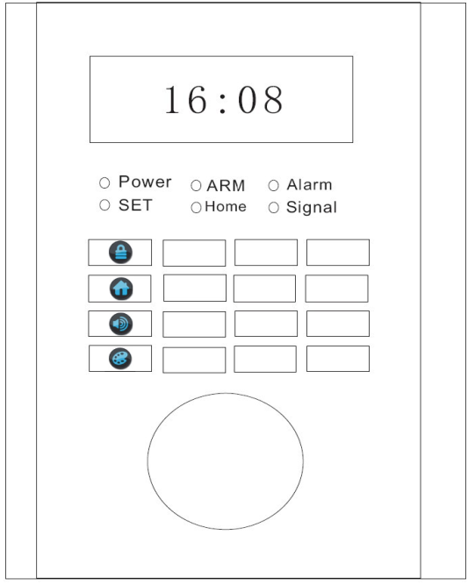**2.1.1 Front Panel**

Power:power indicator

SET: set status indicator

ARM: Arming status indicator

Home: home arming indicator

Alarm：Alarming indicator

Signal: signal indicator

Automatic Arm hotkey

HOME mode hotkey

SOS hotkey

Push-to-talk hot-key, Delete key at SET status

ARM hotkey (**)**

By pressing this key, the system will activate the arming status automatically after a preset time period. Default time period is 60S. The console will sound a beep for every second. When a long beep is heard, the system is entering into arming status. Under arming status, intrusion event report from any accessories from zone 01 to zone 99 can trigger the alarm.

On the contrary, if the system is working under **disarming** status, all zones/sensors don’t send alarm to console.

HOME hotkey (**)**

When we at home, we just need parts of zones/sensors working such as gas leak sensor, boundary sensor, fire alarm sensor, etc. With the Home hotkey on the keyboard or on remote control, all the sensors in Normal zones are armed except those in home mode zones, so that we can move freely at home.

Detail about how to program the home mode zone can be found in Chapter 4.6

SOS hotkey****

System will dial the emergency call and alarm automatically when SOS hotkey on the keyboard or on remote controller is activated.

Push-to-talk hotkey/ delete key **

This hotkey combines two functions. At SET status, it functions as a delete key.

When system is under disarming status, it can be used as a push-to-talk key and we can dial and receive phone call as a simple cell phone.

Alarm indicator

This indicator will light on when an alarm is triggered.

SET indicator

SET indicator light on notifies that the system is under setting status and waiting for your next operation. At SET status, all zones don’t send alarm to console

**2.1.2 LCD display**

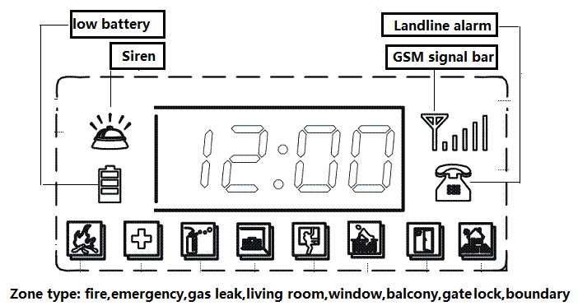

At arming status the system will send a warning message upon power failure. And LCD displays in the low battery mode.

**2.1.3Rear panel**

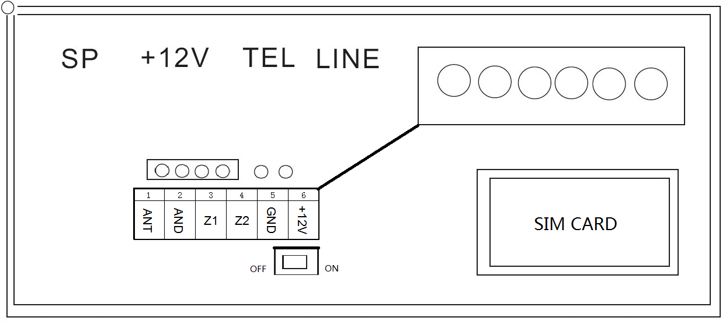

Sockets:

SP: wired exterior siren socket

+12V: Power Adapter socket

TEL: PSTN port

LINE: [Exterior](app:ds:exterior) [Line](app:ds:line) port

Connection Ports:

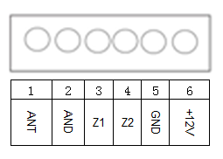

1. ANT: antenna port
2. AND: ground to earth port
3. Z1: wired sensor/detector connection port
4. Z2: wired sensor/detector connection port
5. GND: ground to earth port
6. +12V: 12v DC output port

# Door magnetic sensor

* + 1. **Installation**

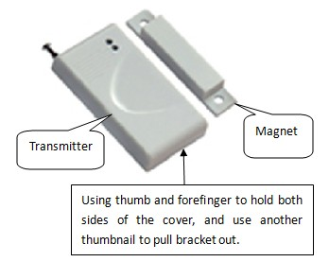

Generally, we will put an insulated paper between battery and electrode in transmitter to prevent power consumption. Please don’t forget to remove it before use.

When an appropriate location and orientation is chosen, attach the transmitter and magnet with double-sides tape (which is included in packing list). Wider tape is for transmitter and smaller one for magnet.

1. Door mounting

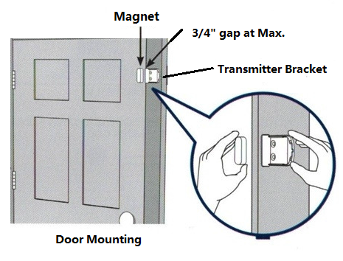

1. Window mounting



No matter door mounting or window mounting, the gap between magnet and transmitter bracket should not exceed 3/4〞.Within this distance, various orientations between the magnet and transmitter bracket can be used as bellowing photos indicate.

1. Other ways



* + 1. **Test**

Set system at arming status and remit a signal to console by means of separating transmitter from magnet, then console “Signal” LED indicator on front panel and door sensor LED will flash one time.

* 1. **PIR detector (IR motion sensor)**
     1. **Installation**

Open up the detector and remove the insulated paper on battery compartment.

There are two brackets on packing list. Mount bracket 1 on the wall at height of 1.5 to 2m (5 to 6 feet) to ground. Drill the holes, and fix the bracket by using the screws. Clinch the bracket 2 with PIR and slide them onto bracket 1. (refer to bellowing figure)

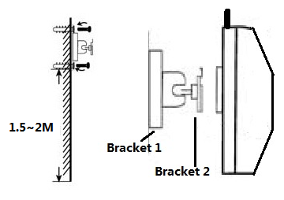

Place the motion sensor following the location recommendations (check marked locations) shown in bellowing figure. Avoid the example locations marked with “X” which are typically cause false alarms, such as heat, air conditioning, fans, or direct sunlight.

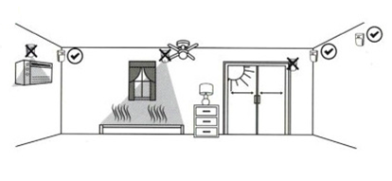

* + 1. **Test**

Switch on the motion sensor. Walk randomly. If PIR detects your movement, LED indicator flashes one time. Meanwhile the signal will be sent to console, “Signal” indicator on front panel of console flashes one time.

* + 1. **Detection range**



* 1. **Remote controller** 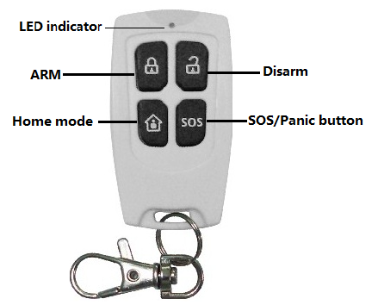

ArmARM：

If we press “ARM”, system comes to ARMING status. Console sends a voice prompt “system armed”. Under arming status, intrusion event report from any accessories from zone 01 to zone 99 can trigger the alarm.

disarmDisarm:

If we press “Disarm”, system comes to Disarming status. Any intrusion event will not trigger the alarm.

Home mode symbolHome mode:

By pressing this button, system enters into Home mode. All sensors except those at home mode zones are disarmed.

 SOS/Panic mode

It will trigger the alarm no matter the system is at what status previously.

**3. Initiation**

**3.1** Prepare a SIM card and insert it to the card slot at rear panel of console**.**

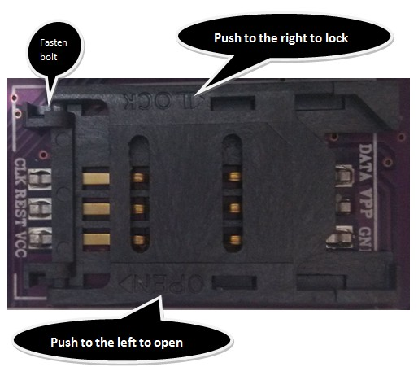

As above photo indicates, push to the left side to open the card holder, insert the SIM card and fasten it by pushing to the right side until you hear a “click”.

**3.2**. Connect the console with power by a power adapter. Power indicator in front panel lights on and console sounds a long beep. Meanwhile, console will detect the GSM network automatically and you will see the clock and GSM signal bar on LCD display

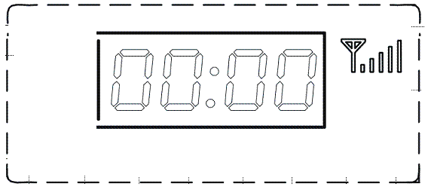

**3.3**. Switch on the back-up battery at rear panel.

***Important notices:***

1. keep the console at place with strong GSM signals, at least keep it with 2 signal bars
2. To receive the signals better from all wireless detectors, the main device should be installed in the center of the zone. Note that the main device should be installed away from large metal objects, [household](app:ds:household) [appliances](app:ds:appliances) with high-frequency interference, as well as barriers like reinforced concrete walls and fireproof doors, etc.
3. A security zone in this manual stands for one sensor or detector. Zone name /number is referring to sensor or detector name/number. They are a 2 digit number from 01 to 99.
4. The system is at disarming status as default set. To return back to disarming status from any process, we need input “1234#” on keyboard.

**4. Program the System**

## 4.1 Enter into or exit from “SET” status

**4.1.1 Enter into “SET” Status**

Before resetting every single function we have to make sure that the console or controlling unit is at “SET” status. How to enter into Set menu?

Under the disarming state (default), input the command on keyboard.

|  |
| --- |
| **Command line:8888#** |
| 8888: the default command for enter into “set” status |
| #: a function key, to confirm and execute the command |

Console responds:

a voice prompt "Please enter instruction" and "SET" LED indicator lights on

Then the console is entering into “SET” status. The console will auto exit from the setting state and return to the disarming state if no operation was done beyond 40 seconds.

*Notes: at “SET” status, press  Key to delete the input numbers and symbols.*

## 4.1.2 Exit from “SET” status

**Command line:*#**

Input command on keyboard, and console responds:

a long beep, “SET”LED indicator in front panel goes off.

**4.2 Program/delete an emergency phone number**

**4.2.1 Program an emergency phone number with console**

There are six phone numbers that can be programmed into system as emergency number in event of intrusion.. Here are steps of how to program one.

In “SET” status, input command line as below:

**Command line: 51****************#**

**Command line: 52****************#**

**……**

**Command line: 56****************#**

51~56: command of program an emergency number. One command from 51 to 56 corresponding to an unique emergency phone number.

**\*\*\*\*\*\*\*\*\*\*\*\*\*\*\*\***: emergency phone number, 16 digits at max.

#: function key

Console responds:

a long beep and a voice prompt “setting completed.

Don’t program particular phone number such as “911” as emergency phone number without permission of related departments.

## 4.2.2 Delete an emergency phone number from console

In “SET” status, input any one of the command line as below:

**Command line: 51#**

**Command line: 52#**

**……**

**Command line: 56#**

51~56: command of delete an emergency phone number. One command from 51 to 56 corresponding to an unique emergency phone number.

#: function key

Console responds:

A long beep and a voice prompt “Delete completed.

* 1. **Program/delete a SMS number**

**4.3.1 Program a SMS number with console**

There are 3 phone numbers that can be set to be alerted with message in event of intrusion.

In “SET” status, input any one of the command line as below:

**Command line: 57**\*\*\*\*\*\*\*\*\*\*\*\*\*\*\*\***#**

**Command line: 58****************#**

**Command line: 59****************#**

57~59: command of program an SMS phone number. One command from 57 to 59 corresponding to an unique SMS number.

**\*\*\*\*\*\*\*\*\*\*\*\*\*\*\*\***: SMS number, 16 digits at max.

#: function key

Console responds:

A long beep and a voice prompt “setting completed.

**4.3.2 Delete an emergency SMS number**

In “SET” status, input any one of the command line as below:

**Command line: 57#**

**Command line: 58#**

**Command line: 59#**

57~59: command of delete an emergency phone number. One command from 57 to 59 corresponding to an unique emergency phone number.

#: function key

Console responds:

A long beep and a voice prompt “Delete Completed.

## Register or delete remote controller

**4.4.1 Register a remote controller with console**

In “SET” status, input command line as below:

**Command line:20(1~8)#**

20: command to register a remote control with console

1~8: name of remote controller. you can name any number between 1 to 8

#: function key

Console responds:

a long beep, and a voice prompt of “remote control coding”

Then remit a signal by pressing any key in remote control. The “SIGNAL” LED indicator in front panel of console will flash three times and console will send a voice prompt “coding completed”.

## 4.4.2 Delete a remote controller from console

In “SET” status, input command line as below:

**Command line:21(1~8)#**

21: command to delete a remote control from console

1: name of remote controller. you can name any number between 1 to 8. The exact same number when you registered it with console.

#: function key

Console responds:

a long beep, “SIGNAL” led indicator in front panel flashes one time, and a voice prompt “Delete completed”. Then this remote controller is no longer working with the console.

## 4.5 Register/delete/program a wireless zone (or sensor)

**4.5.1 Register a wireless zone with console**

When you need a new wireless sensor to work, you have to have them registered with the console first.

In “SET” status, input command line as below:

**Command line:23(01~99)#**

23: command to register a wireless sensor with console

01~99: name of sensor to be registered. you can name any 2-digit number between 01 to 99,

#: function key

Console responds:

a long beep, and a voice prompt “detector coding”

Then, remit a signal of detector by leaning it close to console. If console receives the signal, the “SIGNAL” LED indicator in front panel of console will flash three times and console will send a voice prompt “coding completed”

**4.5.2 Delete a wireless zone/sensor from the console**

In “SET” status, input command line as below:

**Command line:24(01~99)#**

24: command to delete a remote control from console

01~99: name of a wireless zone/sensor. You can name any number between 01 and 99. The exact same number when you registered it with console.

#: function key

Console responds:

A long beep and a voice prompt “delete completed”

**4.5.3 Program the tributes of a wireless zone/sensor**

Demands vary require different status of sensors. With this feature, we can delay alarm, locate it and enable or disable siren. Here are the command lines.

**Command line: 60(01~99)(1~4)(1~8)(0/1) #**

60: command of program the tributes of a wireless zone

01~99: zone/sensor name, the 2-digit number between 01~99 you registered with console

1~4: alarming status. There are four options and you can chose any number between 1~4.

［**1**］Real Time, **［2］**40s-Delay alarm **［3］**24h at arming status **［4］**Bypass.

1~8: sensor location. There are 8 locations to be chosen.1number for 1 location.

［**1**］Help, ［**2**］Fire,［**3**］Gas Leak, ［**4**］Door Lock, ［**5**］Living Room,

［**6**］Window, ［**7**］Balcony,［**8**］Boundary

0/1: disable/enable sire

**［0］**Alarm without warning siren, **［1］**Alarm with warning siren

#: function key

Console responds:

A long beep and a voice prompt “setting completed.

For example, I want the gas leak in kitchen (zone 99) working all the time, and alarm with siren. Here is the command line:

**Command line: 6099331#**

*Notice, in above command, if you select* ***［3］****24h at arming status, the system will be kept under arming status all the time even we select “HOME” mode;* ***［4］****Bypass., the system will ignore all the intrusion alarms.*

* 1. **Home mode**

The system has three working mode: Arm, Disarm, Home.

When we select home mode by remote controller or console, System comes into Home mode status. All zones/sensors programmed by command line starting with 61 and end with 0 are defined as Home mode zones/sensors. At home mode status, all the sensors in Normal zones are armed except those in home mode zones, so that we can move freely at home.

We can define the sensor as following tips.

In “SET” status, input the command line as below:

**Command line: 61(01~99)(0/1)#**

61: command of program home mode alarm status

01~99: name of zone/sensor. The exact number you registered with console, any number between 01 and 99

0/1: 0: turn off the alarm for chosen zone,

1: turn on the alarm for chosen zone

#: function key

Console sounds a long beep and a voice prompt “setting completed.

For example, when we stay at home, we would like to keep gas leak in kitchen (zone 99) working or alarming all the time and PIR in bedroom (zone 01) stop alarming. Here are the command lines:

**Command line: 61991#**

**Command line: 61010#**

**4.7 Timely Arm/Disarm**

**4.7.1 Timely arming**

This function can bring great convenience. For example, you can preset to alarm your property on 8am and disarm at 5pm every day.

In “SET” status, input any one of command line as below:

**Command line: 330800#**

**Command line: 340830#**

**Command line: 350900#**

30, 34, 35: command of timely arming, one command corresponding to one setting time

0800,0830,0900: refer to 8am,8.30am,9am, input any time in HH:MM in 24 hour format. 3 time settings are allowable.

#: function key

Console responds:

A long beep and a voice prompt “setting completed.

**4.7.2. Timely disarming**

This feature can help us to disarm the system at a regular time, such as 17:00 when we got home.

In “SET” status, input any one of the command line as below:

**Command line: 361700#**

**Command line: 371730#**

**Command line: 381800#**

36, 37, 38: command of timely disarming, one command corresponding to one setting time

1700,1730,,1800: refer to 5pm,5.30pm,6pm, input any time in HH:MM in 24 hour format. 3 time settings are allowable.

#: function key

Console responds:

A long beep and a voice prompt “setting completed.

**4.7.3 On/Off timely arming**

In “SET” status, input any one of the command line as below:

**Command line: 390#**

**Command line: 391#**

39: command of on/off timely arming

0: turn off all timely arming/disarming functions

1: turn on all timely arming/disarming functions.

Console responds:

a long beep and a voice prompt “setting completed.

**4.8 Recording function**

We can record a 10s long message with this system which will play automatically when the emergency phone number is answered in event of intrusion.

How to record?

In “SET” status, input the command line as below:

**Command line: 701#**

701: command of recording a message

#: function key

Console will send a long beep, recording must start. 10seconds later, a long beep will be reminded as an end. Please keep close to console when recording.

**4.9 Turn on/off the SOS alarm on remote controller**

If the SOS alarm was turned off, SOS signal remitted by remote controller won’t trigger the siren. Default setting is turning on. It’s highly recommended to turning it on.

Here are steps that how to set

In “SET” status, input the command line as below:

**Command line: 76 (0/1)#**

76: command of turn on/off the SOS alarm on remote controller

0/1: 0: turn off the SOS alarm

1: turn on the SOS alarm

#: function key

Console responds a long beep and a voice prompt “setting completed.

**5.0 Turn on/off the message confirmation**

When we arm/disarm the system with console, remote controller or cell phone, we can decide if we need a message confirmation.

In “SET” status, input the command line as below:

**Command line: 77 (0/1)#**

76: command of turn on/off the message confirmation

0/1: 0: turn off the SOS alarm

1: turn on the SOS alarm

#: function key

Console responds a long beep and a voice prompt “setting completed.

**5.1 Turn on/off warning tone**

With this feature, when you turn on the warming tone, every time we arm or disarm the system, siren will sound one or two times as a warming message. Let’s see how to complete it?

In “SET” status, input the command line as below:

**Command line: 75 (0/1)#**

75: command of turn on/off the warning tone by siren when doing arm/disarm

0/1: 0: turn off the warning tone

1: turn on the warning tone (one time for arming, two times for disarming)

#: function key

Console responds:

A long beep and a voice prompt “setting completed.

**5.2 Set landline alarm**

**5.2.1 Enable the landline alarm**

Turn on the landline phone alarm can offer a higher class security environment.

It’s highly recommended to enable landline alarm.

**Command line: 71**(0/1)**#**

71: command of enable/disable landline alarm

0/1: 0: turn off the landline alarm

1:turn on the landline alarm

#: function key

Console sounds a long beep and sends a voice prompt “setting completed.

**5.2.2 Set ringtone times for landline alarm**

Ringtone times can be set as 1 time, 9 times at most.

This is the way to realize it.

In “SET” status, input the command line as below:

**Command line: 72**(1~9)**#**

72: command of set ringtone times for landline alarm

1~9: ringtone times. 9 times at most

#: function key

**5.3 Set clock**

In “SET” status, input command line as below:

**Command line:321800#**

32: command to change time on LCD display

1800: refer to 18:00 (6pm), input any time in HH:MM in 24 hour format.

#: function key

Console responds a long beep, and sends a voice prompt “setting completed)

## 5.4 Change Password

**5.4.1 Change a user password**

The user password is a key to access the System when disarming or conducting operations by the remote controller.

In “SET” status, input command line as below:

**Command line:301234#**

30: command to change a user password

1234: user password; default set is 1234

#: function key

Console responds a long beep, and sends a voice prompt “Setting completed”

**5.4.2. Change an engineering password**

The engineering password is the key to access function settings.

In “SET” status, input command line as below:

**Command line:318888#**

31: command to change a engineering password

8888: engineering password; default set is 8888

#: function key

Console responds a long beep, and sends a voice prompt “Setting completed”.

**5.5 Networking function**

This part is not included in the system at default status. The functions under this subcategory should be tailor-made.

The system can be connected with a monitoring center by contact ID, like Ademco contact ID. When the connection is built, all the intrusion warming phone-calls and messages will be sent to report center.

**5.5.1 Report to Monitoring Center Arm/Disarm status**

Provided we have already connected with monitoring center. When we arm or disarm the property, the system will report the status to monitoring center. Of course, you can chose not to.

Here is how to turn on/off the report.

In “SET” status, input the command line as below:

**Command line: 74**(0/1)**#**

74: command of turn on/off the report of Arm/disarm status.

0/1: 0: turn off the report

1: turn on the report

#: function key

Console sounds a long beep, and sends a voice prompt “Setting completed”.

Default setting is turning off.

**5.5.2 Inform report center intrusion events**

If we have connected with report center, we can decide if it’s necessary to report any intrusion events to monitoring center. Here is how to realize?

In “SET” status, input the command line as below:

**Command line: 73**(0/1)**#**

73: command of turn on/off an intrusion report to monitoring center

0/1: 0: turn off the alarm

1: turn on the alarm

#: function key

Console sounds a long beep, and sends a voice prompt “Setting completed”.

Default setting is turning off.

**5.5.3 Set monitoring center phone number**

It’s available to set a monitoring center phone number (22 digits at most) as emergency contact number in event of intrusion.

Here is the command.

**Command line: 50**XXXXXXXXXXXXXXXXXXXXX**#**

50: command of set a monitoring center phone number

XXXXXXXXXXXXXXXXXXXX: monitoring center phone number

#: function key

Console responds with:

A long beep and a voice prompt “setting completed.

**5.6 Recover the default password and factory settings**

**5.6.1 Recover default password**

There is an easy way to recover the default password. Here are tips.

In “SET” status, input the command line as below:

**Command line: 95175308249#**

95175308249: Command of recover default password

#: function key

Console responds with:

a long beep and a voice prompt “setting completed.

With this feature, only passwords are recovered to default set. But other settings remain the same.

**5.6.2 Restore factory settings**

We can restore factory settings as below.

In “SET” status, input the command line:

**Command line: 95175308246#**

95175308246: command of restore factory settings

#: function key

**6. Remote control the console with cell phone**

We can remote control the console by the preset cell phone to realize arming, disarming, monitoring, and spot intercom function.

First of all, dial the console, and you will hear a voice prompt “Please enter password”.

*Our default password is 1234. Make sure not to input the code too fast, one by one with the confirm of console with voice prompt.*

And then, press key 1 to 4 to realize different function s.

〖1〗:system armed

〖2〗:system disarmed

〖3〗:monitoring; an avail of 30seconds for monitoring the sound of intrusion site.

〖4〗:spot intercom; directly talk to intruder on intrusion site.

## 7. Answer the emergency call

In event of intrusion, console will trigger the alarm immediately and dial the programmed phone number. If the first number is not answered, the console will dial the second, third emergency number circularly for 3 times, with each phone number for continuous three times until the phone is answered.

If the emergency call is answered, first we will hear the 10s record (how to record please refer to chapter 4.8) and then a system voice prompt of the name& location of triggered zone. Provided we did not record contents into console, the system voice prompt will also be sent 10s later after the phone is answered.

Meanwhile, the system notice will be sent via SMS. For example, if console detects an intrusion event from zone 01, door sensor, you will receive a system notice with content “01 zone door alarm” by means of SMS message and voice prompt.

After the emergency call is answered, please press any key as bellowing to realize different functions.

〖*〗: read the alarm SMS message.

〖1〗: stop the emergency phone-call and alarm & system return back to arming status.

〖2〗: stop the emergency phone-call and alarm & system enters into disarming status.

〖3〗:stop the alarm, and monitor the sounds of intrusion site for 30s. Continue to press 3 for another 30s.

1. : start the spot intercom function for 30s.

# 8. Maintenance

To make sure that the System runs steadily, reliably and safely, regular inspection is a must. A full inspection to the console should be conducted every 3 months. For a more secure environment, we suggest to check the wireless accessories monthly.

**For console:**

a. Check whether it can arm or disarm normally.

b. Check whether it can make calls when alarming.

c. Check whether it can receive signals from detectors and whether the backup battery is normal.

**For wireless detectors and sensors:**

a. Check whether the detectors can give a normal alarm by manually triggering them.

b. Check if they have low battery.

c. Check if all wireless detectors can communicate with the main device by means of leaning closely them to console to remit a signal.

|  |  |  |  |  |  |  |  |  |
| --- | --- | --- | --- | --- | --- | --- | --- | --- |
| **Attached list 1: Default settings** | | | | | | | | |
| Zone name | Arming | | Home Mode | | Alarm Type | Zone | | Alarm Siren |
| Type | |
| Zone 01 | Effective | | Invalid | | Real Time | Door Lock | | On |
| Zone 02 | Effective | | Invalid | | Real Time | Living room | | On |
| Zone 03 | Effective | | Effective | | Real Time | Window | | On |
| Zone 04 | Effective | | Effective | | Real Time | Balcony | | On |
| Zone 05 | Effective | | Effective | | Real Time | Fire | | On |
| Zone 06 | Effective | | Effective | | Real Time | Gas Leak | | On |
| SOS | Effective | | Effective | | Real Time | Help | | Off |
| **07-99** | Effective | | Invalid | | Real Time | Help | | On |
| Wired Zone | Effective | | Invalid | | Real Time | Help | | On |
| （**98-99**） |
|  | | | | | | | | |
| Engineering Password: | | **8888** | | Remote Control: | | | **GSM**: On | |
| PSTN：Off | |
| User Password: | | **1234** | | Warning Tone： | | | Off | |
| Alarm Duration: | | **180**s | | Household Appliance Control： | | | Optional | |

|  |  |  |
| --- | --- | --- |
| **Attached list 2: Commands** | | |
| Function | Command | Tributes |
| Enter into “SET" status | 8888 |  |
| exit from "SET" status | * |  |
| Register remote controller with console | 20 | 1~8 |
| delete remote controller from console | 21 | 1~8 |
| Register a wireless zone/sensor with console | 23 | 01~99 |
| Delete a wireless zone/sensor from console | 24 | 01~99 |
| Change a user password | 30 | **** |
| Change an engineering password | 31 | **** |
| Set clock | 32 | HHMM |
| Timely arm | 33~35 | HHMM |
| Timely disarm | 36~38 | HHMM |
| On/off timely arming | 39 | 0/1 |
| Set monitoring center phone number | 50 | ******************** |

|  |  |  |
| --- | --- | --- |
| Function | Command | Tributes |
| Program an emergency phone number  with console | 51~56 | Phone number (16 digits at most) |
| delete an emergency phone number  from console | 51~56 |  |
| Program a SMS number with console | 57~59 | Phone number (16 digits at most) |
| delete a SMS number from console | 57~59 |  |
| Program the tributes of a wireless zone/sensor | 60 | (01~99)(1~4)(1~8)(0/1) |
| Home mode | 61 | (01~99)(0/1) |
| Enable the landline alarm | 71 | 0/1 |
| Ringtone times for landline alarm | 72 | 1~9 |
| Inform report center intrusion events | 73 | 0/1 |
| Report to Monitoring Center Arm/Disarm status | 74 | 0/1 |
| Turn on/off warning tone | 75 | 0/1 |
| Turn on/off the SOS alarm on remote controller | 76 | 0/1 |
| Turn on/off the message confirmation | 77 | 0/1 |
| Recording function | 701 |  |
| Recover default password | 95175308249 |  |
| Restore factory settings | 95175308246 |  |