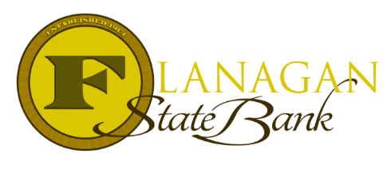
Mortgage Tidbits

Keeping you informed and in the know….

PUDs

Planned Unit Development or PUD for short, is defined as a single-family home (SFH) within a subdivision where the unit owner holds title to the lot while sharing common elements maintained by the Homeowners Association (HOA) with other unit owners.

The HOA holds title to the common elements and maintains and improves them for the unit owners to use at their leisure. Common elements can be walkways, parks, playgrounds, or recreation centers.

Zoning itself is not a basis for classifying a PUD. A PUD will have Covenants, Conditions and Restrictions similar to a Condo Association. The classification as a PUD must meet all the requirements set forth by Fannie Mae & Freddie Mac for secondary market financing.

Fannie Mae:
- The HOA membership must be automatic and non-severable
- Common property and improvements must be owned and maintained by the HOA for the unit owners use
- Subject property must not be part of a condo or co-op project
- Mandatory payment of assessments related to the unit

Freddie Mac:
- Each individual unit owner holds title to the lot & the improvements of the lot
- The HOA holds title to the Common Elements
- Unit owners have a right to use the Common Elements
- Unit owners pay a mandatory HOA fee to maintain the Common Elements

If a property has no Common Elements, no mandatory HOA fees, or no required payment of assessments then the property cannot be classified as a PUD.

Call us today for the best answers to the mortgage questions!
Insert photo here or delete box when ready to use
~ Provided to you by ~
Name: Phone:
Title: Email:
Address: City, State, Zip
Apply Now Link:

