WORMS

Signs of Intestinal Parasites:
Signs of worm infestation in horses can vary widely; some horses may should barely any signs; others will have severe disease and sometimes die as a result. Common signs of worms include;
- Loss of appetite
- Dull, rough or curly coat
- Poor growth in foals
- Coughing
- Weight loss
- Tail rubbing, due to irritation as pin worms crawl out to lay their eggs in the tail area
- Diarrhoea
- Colic

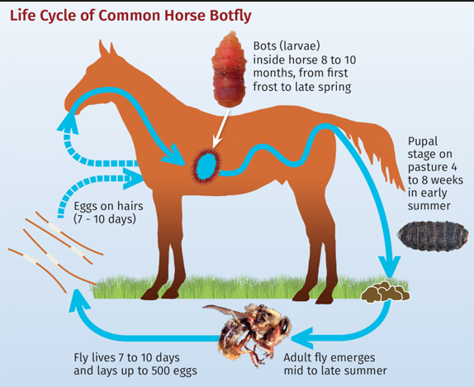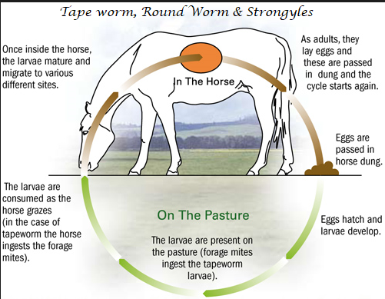

How Do Worms Hurt My Horse?
Worms are small, but they can be deadly! In large numbers, worms and bots can make life for your horse very unpleasant.
Worms, such as Strongyles, actually eat away at your horse’s intestinal walls, feeding off blood in the tender areas. Other worms, such as Tapeworms feed on the feed your horse eats, meaning that your horse actually gets little out of what you feed him! Bots attach to the walls of the gut with strong suckers and cause very serious damage to the stomach lining! Bloodworms can block blood vessels, as they travel in the arteries and irritate the areas. Roundworms irritate the lungs and windpipe - they cause coughing and pneumonia!

Traditional deworming program
A traditional rotational deworming program provides for the general prevention and elimination of most parasites/worms at the correct time of the year which helps to prevent worms becoming immune to one active ingredient. Worming calendars provide good advice on when to treat horses with which worming paste.
A traditional rotational deworming program does not however treat Encysted Small Strongyles (ESS). Encysted Small Strongyles are the larvae of Strongyles that are protected by a cyst like cover - they can lay semi-dormant stuck to the horse’s intestinal wall for many months or even years and usually hatch only in small quantities. However they can hatch in very large numbers and that can cause severe colic, scouring, or death (the reason for this is that when they emerge, they release toxins from accumulated larval waste). Toxic shock, from a large hatching, can kill an otherwise heathy horse within hours.

Hendra Pony Club deworming program
- Removal of manure from the paddocks weekly and rotational grazing
- Worming of all new horses prior to them coming to HPC and again before entering the herd
- Herd worming (every 16 weeks with Moxidectin (Equest Plus Tape), and 1 x Ivermectin + Praziquantel in January).
Giving an alternative dose of a deworming paste (ie; Ivermectin + Praziquantel) ensures that the worms in our horses do not develop an immunity to Moxidectin.

----------------------

New deworming regimes (like the deworming program introduced at our grounds in 2018) ensure that not only are horses treated for all general worms (bot, round, tape, strongyles, etc) they are also treated against Encysted Small Strongyles.
There are only two chemicals available to treat Encysted Small Strongyles; Moxidectin and Fenbendazole Panacur (note; FP must be given on five consecutive days, so is nowhere near as easy to use as a Moxidectin which is a one paste only application).
As an adjunct: Counting egg’s in horse manure called a Faecal Egg Count is a great method to determine how heavy a worm burden a horse might be carrying, sadly that does not include how many Encysted Small Strongyles there might be attached to the gut wall, but it does help with understanding how an overall deworming program is working and what, if any, additional treatment might be needed.

