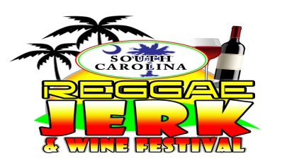
2020 South Carolina Jerk, Reggae & Wine Festival Jerk Chef Competition.

SC Reggae, Jerk & Wine Festival Jerk Chef Competition is open to all Jerk Vendors. Winner receives Prize and Bragging Rights.
All participants must complete the attached application form. The form maybe submitted along with a certified cheque, or money order in the amount of $25.00 payable to: Caribbean Rootz along with Application. It may also be paid in cash the morning of the event.
- All Jerk Vendors are encouraged to submit an application for the Jerk Chef Cook-off.
- Submit Dish for judging at 3:00 pm. Judging will be 3:00 pm – 3:30 pm.
- Each entrée should be presented with an appropriate accompaniment of your choice.
- A maximum of two main dishes may be entered by each competitor from the following categories: (a) Jerk Pork (b) Jerk Chicken (c) Jerk Fish (d) Jerk Vegetarian (e ) Jerk fish
- Food must be displayed in an appropriate container provided by the participant.
Presentation
a). Sauces and condiments must be presented in separate bowls with spoon for tasting.
b). All garnishes must be edible.
Judging
Presentation of Dish ……………………………………………… 25 points (range 1 – 25)
Tenderness……………………………………………………………25 points (range 1 – 25)
Taste……………………………………………………………………25 points (range 1 – 25)
Total…………………………….. ……………………………………..75 points (range 1 – 75)
There will be no refund of entry fees for any reason. Judges decisions are final.
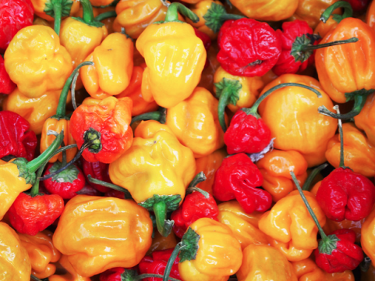
South Carolina Jerk, Reggae & Wine Festival Jerk Cook-Off Competition

NAME________________________________________________________________________________________

ADDRESS____________________________________________________________________________________

CITY_____________________________________________STATE__________________ZIP_________________

TELEPHONE___________________________________________CELL__________________________________

EMAIL_______________________________________________________________________________________
CATEGORIES Chicken_______________Pork_________________Fish___________________Vegetarian___________________
By signing this agreement you expressly release Magnolia’s SC Reggae, Jerk & Wine Festival event Sponsors, Caribbean Rootz, Magnolia Plantation and Healthy Lifestyle Network, Inc as well as the owners of the festival sites of and from any and all liability for any damage, injury or loss to any person or goods which may arise from participation in the Jerk Cook-Off. You agree to hold SC Reggae Jerk & Wine Festival, and the owner of the festival sites harmless of any loss or damage by reason thereof. You also agree to comply with all state and local regulations in the operation of your cooking area.

I, the undersigned have read and understood the terms and conditions of the Magnolia’s SC Jerk, Reggae & Wine Festival Jerk Cook-Off and agree to abide by them throughout the duration of the event.

Signature:__________________________________________________Date:______________________________

Office Use Only

Approved by: ______________________________________________Date:_______________________________

