

**IN-PERSON ASCE JOINT MEETING**

**IOWA SECTION / EASTERN IOWA YMG / IOWA STUDENT CHAPTER**

**Wednesday, March 8, 2023**

Make plans to join us for an in-person event! An early afternoon tour will be followed by an evening dinner and program. Please refer to the pages below for details. *Please RSVP using the link at the end of this document*.

**PROJECT TOUR AGENDA:**

**3:30 – 4:30 pm** **Project Tour:** UIHC Hospital in North Liberty

The site visit will include a tour of the new UIHC Hospital in North Liberty. This is a $525 million project on the corner of Forevergreen Road and HWY 965. Please come prepared with a shirt with at least a 4” sleeve, jeans/pants, leather boots or shoes with a hard sole, hard hat, vest, and safety glasses. Gloves will be provided.

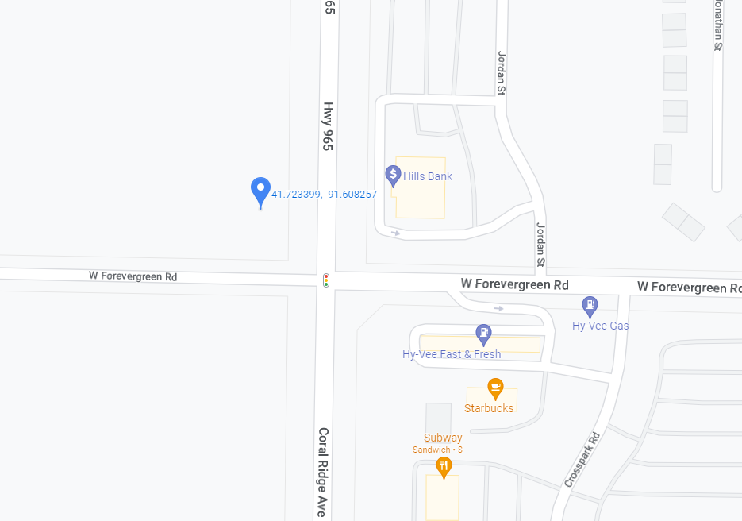

**SECTION MEETING AGENDA:**

North Room – Iowa Memorial Union 125 N Madison St, Iowa City, IA 52242

# 4:30 – 5:45 pm Social Hour

Airliner 22 S Clinton St, Iowa City, IA 52240

# 6:00 – 6:30 pm Buffet Dinner

# Pasta Buffet

# 6:30 – 6:45 pm General ASCE Announcements

EIYMG Update, UI Student Chapter Update, Iowa Section Update

# 6:45 – 7:15 pm Project Presentation –

# Greg Mulder, P.E. and Steve Mallicoat, P.E of the Iowa Concrete Paving Association (ICPA)

# 7:30pm Meeting Adjourned

# 

# Cost: $25 Cash or Check Only (Free for students)

Includes: Dinner and program with 1 PDH.

Use the following link to RSVP:

[Form](https://forms.gle/tZ1f7F123BzsXxsj9)

Please RSVP by March 4, 2022. Contact Ryan Morgan (Ryan.Morgan@terracon.com) if you encounter problems using the link.