Getting Out of the Boat
August 13, 2017
Matthew 14:22-33
Grace and peace to you from God our Father and from the one who walked on the water and stills the storms in our lives, Jesus Christ Our Lord, amen.
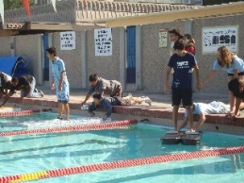
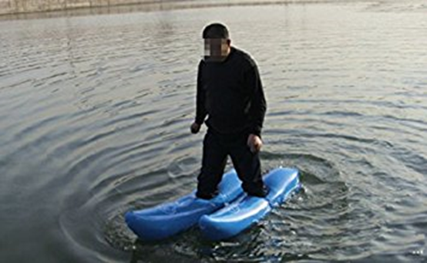
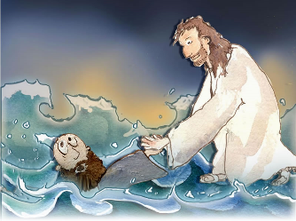
(Sermon Slide 1) Ever since Peter’s failed attempt to walk on the water people have been attempting to do what only Jesus can do. (Sermon Slide 2) As we humans do with most things we’ve even made a sporting competition out of water walking. I think Jesus is in heaven laughing or perhaps admiring our ingenuity at trying to imitate his miraculous feat.
(Sermon Slide 3)
I’ve studied this miracle story several times and I’ve preached about this story at least three times and yet I’m still not sure if Peter’s getting out of the boat was something he should be praised for or something he should be rebuked for. (Slide 4)
First of all, Peter and the rest of the disciples were terrified when they first saw Jesus approaching their battered boat. Matthew tells us they thought they were seeing a ghost. That’s when bungling Peter takes over, as he always seems to, and challenges Jesus by stating, “If it’s really you then command me to get out of the boat and walk to you.” Most scholars and preachers would probably say Peter demonstrates great faith by getting out of the boat while the sea was in an uproar. He trusted the Lord to give him the supernatural ability to walk out on the sea. Peter’s request for Jesus to command him to come to him on the water may sound very strange to us modern folks. That’s because we think of disciples and discipleship totally differently than the ancient people did. We think of disciples as students who learn from their teacher, but in ancient days a disciple wanted to be just like the master. The ancient disciple wanted to know what the teacher knew, but also to talk like the master talks, and to walk just like the master walks. Peter literally wanted to walk in the footsteps of his master, Jesus.
- SERMON
While I said most scholars would say Peter demonstrated great faith, not all agree. Some commentators say Peter was acting in a rash and unthinking manner. Think about Peter’s whole persona. He is usually the first to blurt out the first thing that comes into his head and he’s usually wrong… So, some could interpret what Peter did as testing God. If it really is you, then make me be able to do as you can do. Make me like a god. If memory serves me, didn’t Jesus rebuke Satan during his 40 days of temptation in the wilderness by telling him not to put the Lord God to the test? By getting out of the boat, Peter is challenging Jesus to prove who He really is. Also, when Peter is out of the boat he’s alone, separated from the other disciples. He doesn’t seem to care about the safety of his fellow disciples. All he cares about is proving to himself that this is really Jesus or not. So, is Peter demonstrating great faith or putting Jesus to the test? Do you see my dilemma?
As I pondered this question one more time this week, I was led to a new understanding. In the Bible, there are many cases like this one where you have a choice to interpret the meaning of a story in more than one way. Some people might insist you can’t have it both ways, but I’m not so certain. Sometimes God leaves the question of interpreting His Word open ended. I can’t presume to know the mind of God, but I suspect God loves it when well-meaning Christians debate the interpretation of His Word, in a kind and respectful manner that is... The other reason I came up with for why God leaves some questions open ended or not even answered at all is that the Bible contains the living Word of God and God must like it that way. I believe the Bible we have today, the one handed down to us over these many centuries, with its gaps and with its weird foibles, is exactly the Bible God wanted our generation to have. God’s Word is able to speak to us in many ways and always seems to address our issues we’re facing in the moment. Here’s a couple of examples of what I mean.
We’re looking for a few more people to step forward and teach Sunday School to our youngsters. We currently have precious few and they have to miss Worship quite often because we have Sunday School during our Worship Service. That might be one reason people are reluctant to make the commitment, but I suspect there might be another reason as well. Some might worry they aren’t good enough or they don’t know enough about the Bible to be a teacher. They are afraid to make the commitment, thinking the kids might ask questions they can’t answer. If that’s you, are you afraid to take the step of faith? Are you afraid to get out of the boat and trust Jesus will be there to rescue you when you start to sink? In this scenario, stepping out in faith and trusting Jesus is not only a good thing, it’s admirable and inspiring. When one or two people take that leap of faith usually others follow along in their footsteps.
Now let’s look at the same story from another perspective. Pastors have it drilled into our heads during Seminary that we are a part of a larger organization called the Evangelical Lutheran Church in America. Within the ELCA we’re also a part of the Synod where the Church is located. As part of these larger organizations we’re not alone. We have resources to draw on for help in preaching, teaching, and in spreading God’s love in the world. There’s wisdom in the many other pastors, our Bishop and her assistants to help keep us on the right track and so we’re all working together to advance God’s mission within our little piece of His Kingdom. That’s why I try to attend all the synod worship gatherings, educational opportunities and that’s why I’ve done things like attend the festival of homiletics to improve my preaching. Now suppose a pastor decides he or she has a direct conduit to Jesus and doesn’t need the help of his or her colleagues. They tell themselves they can go it alone. They step out of the boat, not with trust and faith in Jesus, but trusting their own ego instead. Sometimes we think we’re godlike and can do the things only God can do. We set ourselves up as the know-it-all and pretty soon we stop seeking advice of those more seasoned. It’s easy to see how we can start to sink pretty quickly. I rely on all of you to provide me the wise council I need so I never get out of the boat and leave you behind like Peter did with his friends. Likewise, many of you are starting to come to me as you get to know me and trust my judgment with your problems. I truly believe we’re better off together facing the storms lo life, not out chasing our own vision of what’s best, even if we’re trying to get closer to Jesus. We can do that better together than any one of us can by ourselves. Jesus created His Church as a community. We’re one Body of Christ and we function best when we function together.
There’s actually yet another way to look at this story. The early church in Matthew’s time would have immediately recognized the disciples in the boat as the Church being battered by the waves of persecution. Their image of Church was to compare that fishing boat to another boat that was batted about by the sea waves. The image of Noah’s Ark, which saved Noah and his family along with all the animals and birds would have been in their minds as they read Matthew’s Gospel. Today we still see the Church as the ship that transports us into salvation. The Latin word for ship is navis. We get English words t such as Navy and navigate from this Latin word. The space in a Church that’s used for Worship is even called the Nave. Many Churches, including our own, are shaped like an upside-down ship. Look up at our vaulted ceiling. Can you imagine the hull of an upside-down ship?
So, today we’re all the in boat with the disciples. My question for us to think about and ponder over is this: When Jesus comes to you and says “I am, it is I. Do not be afraid,” how are you going to respond? Will you get out of the boat and at least try to walk the walk of the Lord? If you decide that’s the route for you, my advice is to keep your focus on Jesus and try to filter out all the cares and distractions of the world. The other possibility is to stay in the boat and keep on rowing with the rest of the disciples. The Nave may get bounced around and we might feel like we have to grab on for dear life and we might even get a little seasick, well okay, a lot seasick, but if we stay together, Jesus will come and quite the sea and silence the winds.
Since we have a Savior who loves us, His Church will come through all the storms. Since you have a Savior who loves you, Jesus will be with you through every stormy gale of life. May you trust in the love of Jesus to lift you above the stormy seas and to buffer the winds that threaten your peace. Amen.

