LANE TINY FARM
HANDS-ON AG PROGRAM

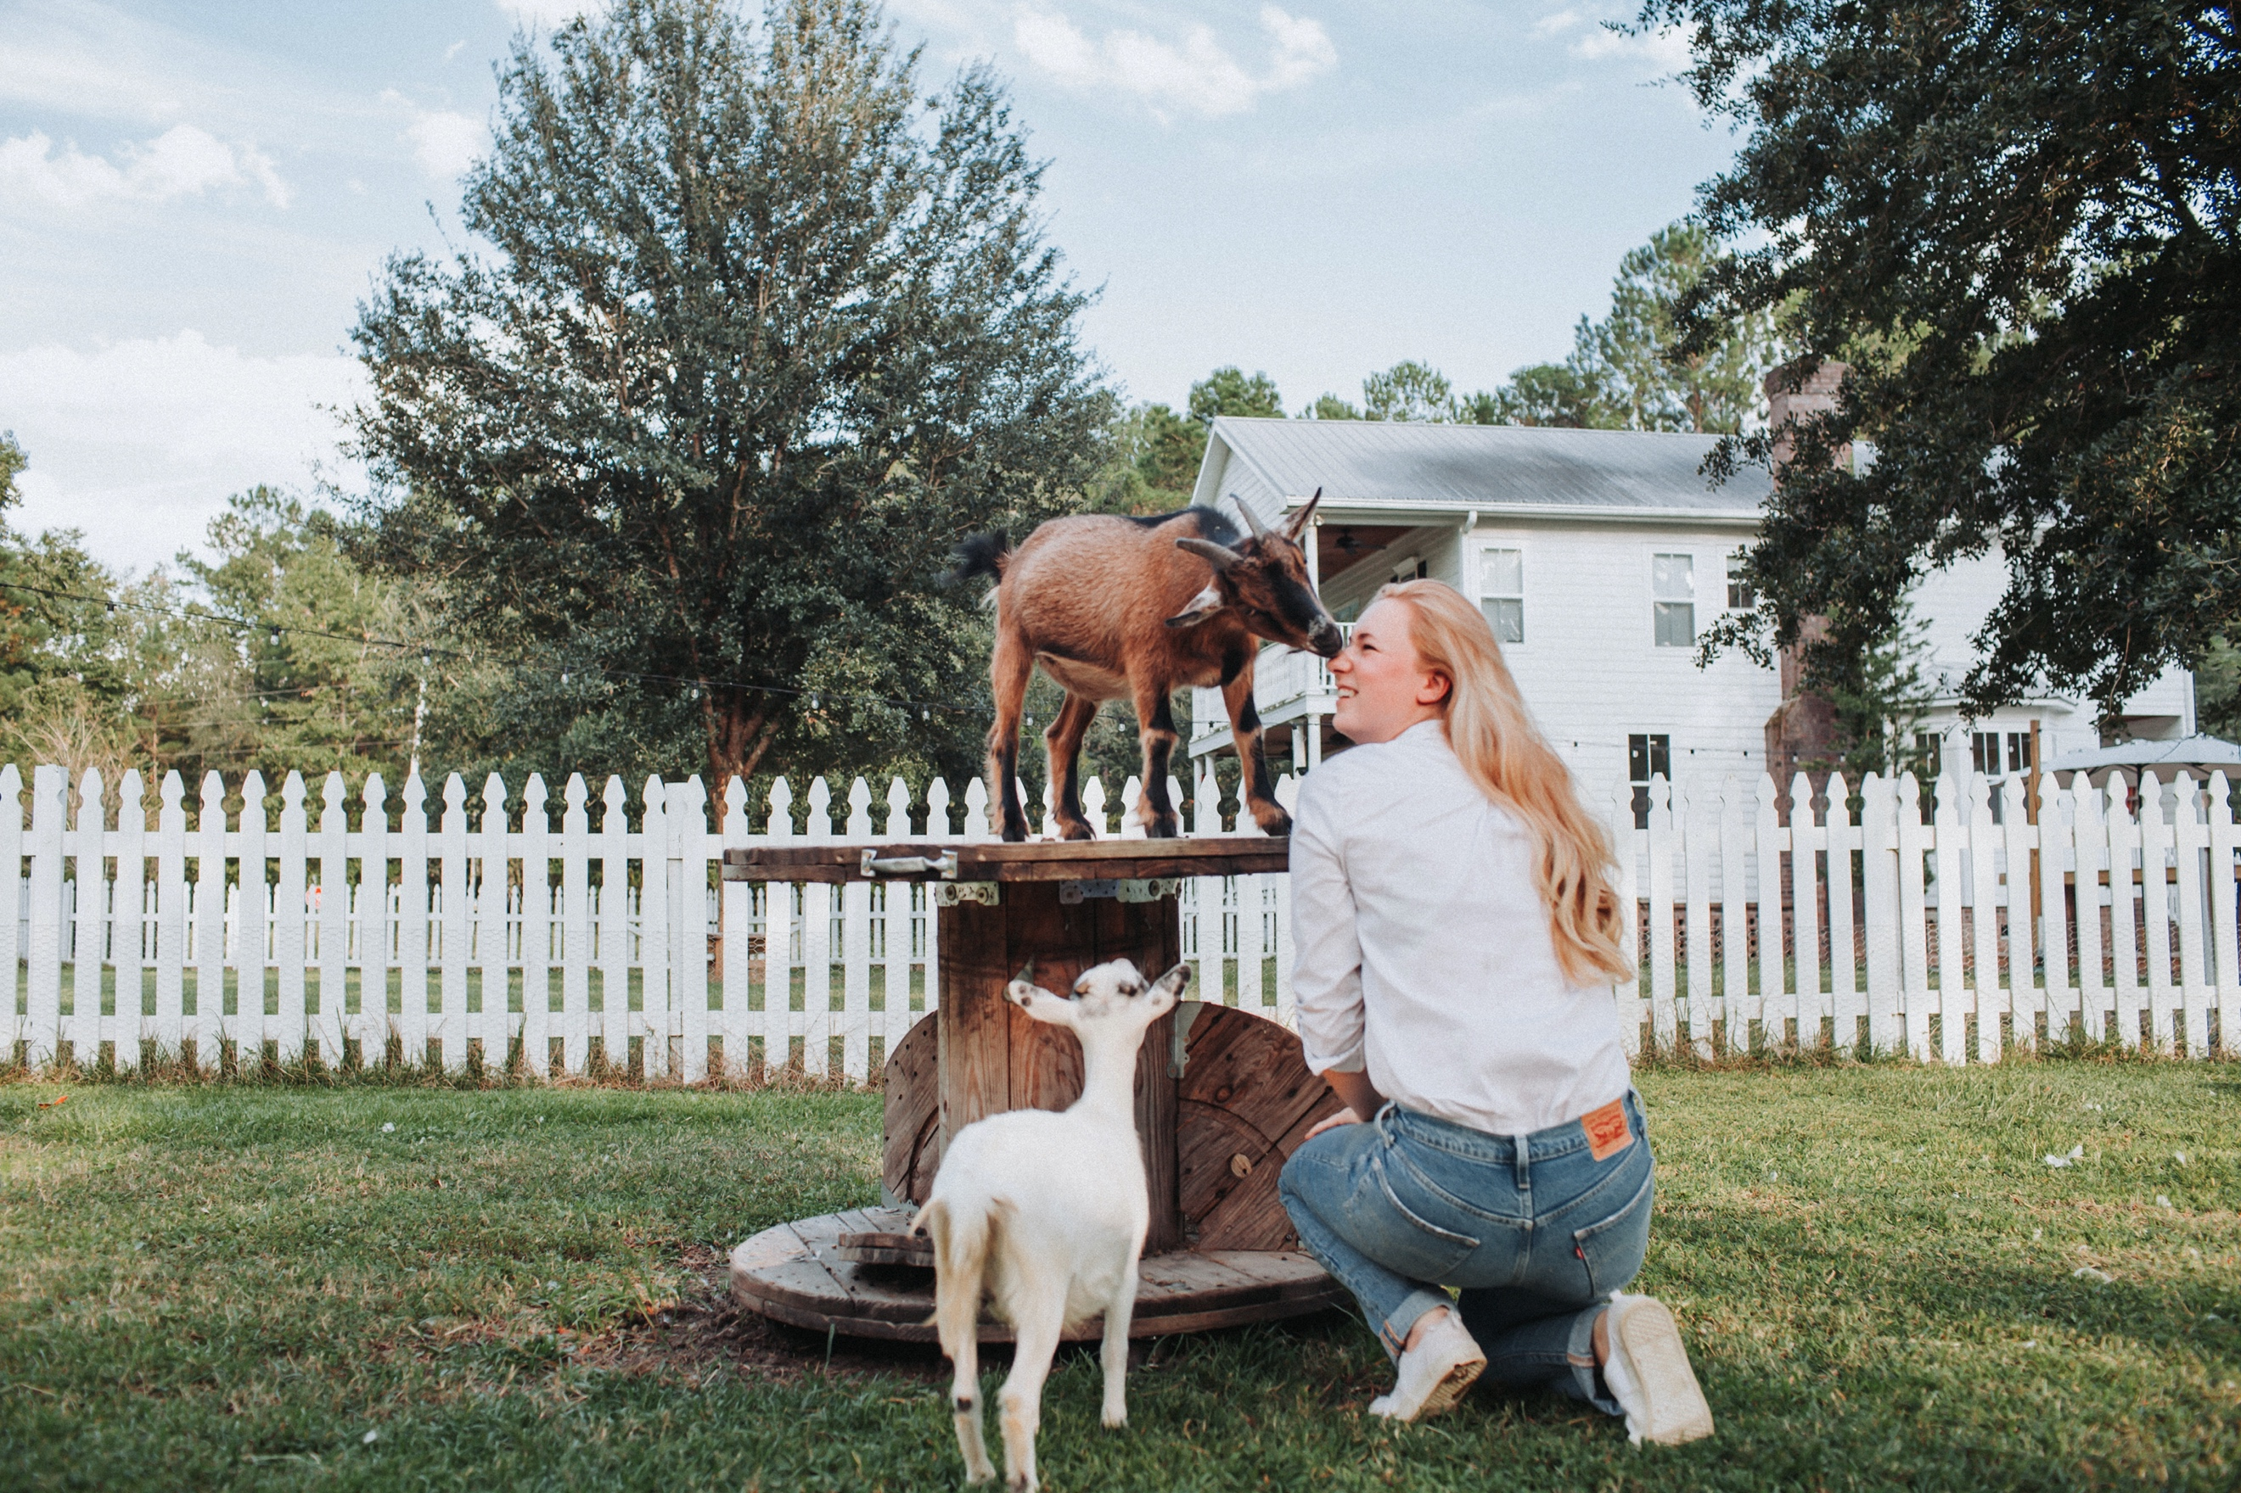

What is Farm Animal Education?

Our farm-based education program connects students to the environment, their community, and the role of agriculture in our lives.

Why choose Farm Animal Education?

- Working on a farm teaches children and adolescents responsibility beyond themselves, team work, creativity, critical thinking, and problem solving skills!
- Positive interactions with mini-goats, cows, and chickens.
- Hands-on learning. We will learn by doing. Each student will be taught how to safely handle our animals, and complete daily farm maintenance.
- They make fast friends!

Why choose Lane Tiny Farm?

- Children and adolescents get to learn from a real farmer! It’s an authentic experience they will remember forever.
- We are passionate about educating young minds on how to keep and advocate for healthy livestock.
- Woman-owned small business.

CURRICULUM

Week 1
Farm Maintenance

- What are daily barn chores? How to execute these tasks properly.
- Differences between winter & summer chores.
- Types of feed we provide our animals.
- Providing fresh, clean water.
- How to trim goat hooves.

Week 2
Anatomy

Each student will work with one of our mini-goats as we cover the material below.

- How to properly hold a goat
- Goat bone structure
- The four stomach chambers
- What is chewing cud?
- Hoof shape and care
- Horned versus polled goats
- Winter undercoat growth
- What is FAMACHA? Why is it useful in terms of health?

Week 3
Farm Health Lab, “dress like a Farmer week!”

This is your child’s opportunity to act like A REAL FARMER! This farm week will include time for pictures with the goats and cows!

Upon arrival, each student will be given a pad/pencil.
They will be asked to walk the farm and identify any farm chores that need to be completed, as well as things that are out of place and need to be put away. Guidance will be given where needed. Identified tasks will be completed.

Week 4
Chores, “dress to get dirty!”

Week 4 will put all of the concepts that students have learned together. Students will be paired up.

- Discussion about why and how keeping the land clean yields healthy animals.
- Students will help with in-depth chores like scooping and disposing of cow patties, raking wasted hay, and feeding/watering the livestock.

Last hour of our program—
PLAY TIME/CUDDLING THE GOATS & COWS! Pictures will be taken and provided to parents as keepsakes.

