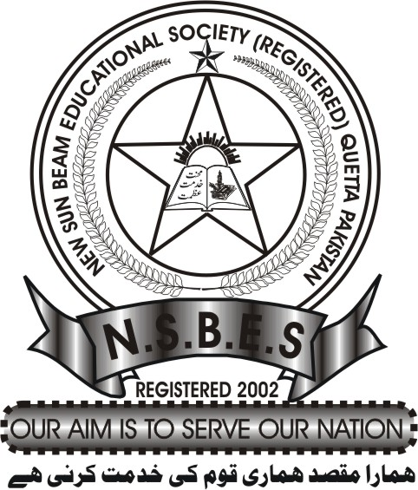
New Sun Beam educational Society®
General Musa Road, Hussain Abad, Hazara Town Quetta, Balochistan, Pakistan
Registered under Societies, act 1860 Registration Number: 831

Transfer Certificate Application

The Principal
New Sun Beam English Medium School
Hussain Abad Hazara Town Colonel Younus Road Quetta

R/Sir

I, __________________________________ Parent of _________________________________________

(Student’s name as in the B-form) Studying in NSBEMS in Academic Year ___________ in

Class_______________________ Roll Number___________ request you to issue a Transfer Certificate

with effect from ______________________________________________ to join another school.

(Name of the school) ___________________________________________________________________

Contact Number: _______________________ Residence _____________________________________

Note: All the dues must be cleared and B-Form copy of the student must be attached.

DATE: ______________________________________________ Signature of parent ______________________________________

Teacher’s Signature __________________________________ Last Date of Attendance _________________________________

*Submit the corresponding fee with this form to the Accountant.

Fee = Rs.50

Dept | Principal | Accountant | Head of the Laboratory | Librarian
Signature

Received by: _________________________________ Date: _____________________________

N.B:
- To be submitted at least a month prior to the striking off the student’s name from the register
- Once certificate has been issued, the case for re-admission will be treated as a new one.
- The TC will be issued subject to the payment of all dues on account of school fees, library books and lab equipment.
- Once the application is submitted, the Transfer Certificate will be processed immediately.

