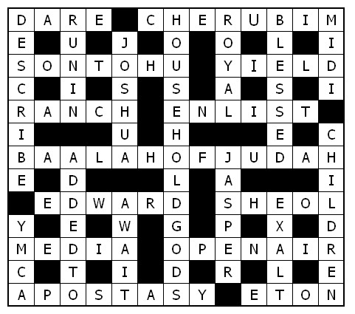

Service times at St Mary’s
Sunday: 10:30am Holy Communion
or Morning Prayer
Normally the first and third Sunday is Holy Communion with Morning on the second and fourth. Baptisms by arrangement with the Rector.
Tuesday: 10.00am Holy Communion
12.15pm Lunch-time Service

St Mary’s and the Nave Café is open – Tuesday, Thursday, Friday & Saturday from 9.00am – 3.00pm

Readers contributions to the magazine are always welcome. Hard copy (hand written if easier) to the Rectory address or by email: to : st.marysstockport@gmail.com
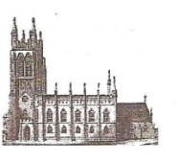
Editorial discretion with regard to content and space available will apply.
St Mary’s in the Marketplace
St Mary’s Rectory, 24 Gorsey Mount Street,
Stockport, SK1 4DU.
0161 429 6564
www.stmarysinthemarketplace.com.

St Mary’s in the Marketplace
Parish Magazine
October 2014

50p
From the Rector’s “ i-Pad”
Dear Reader
The announcement that Revd. Dr .Johnathan Gibbs, 53, Rector of Heswall on the Wirral since 1998, is to be the new Bishop of Huddersfield, is a source of rejoicing for all those who know him and who love the Bible. Johnathan's preaching and teaching ministry, complimented by his pastoral and administrative gifts, have made him a blessing to many since he was ordained in this Diocese in 1989. Jonathan served as curate near to Stockport, at Holy Trinity Stalybridge before receiving the call to serve God overseas, at least across the Channel in 1992. As Chaplain to the English Church in Basel, Switzerland ,in the Diocese of Europe, Johnathan exercised an outstanding, effective and much valued ministry in the Chaplaincy, with the support and prayers of the Intercontinental Church Society ( I.C.S.) and his home churches in the Chester Diocese.
Johnathan has been used by God not only in the parish , but more widely in the Diocese of Chester, and on General Synod, the governing body of the Church of England. He is fluent in French and German, and a member of the Real Ale Campaign . The work of a Bishop brings many new challenges to a priest ,and especially so when it is an entirely new diocesan structure , as in the Church of England's newest diocese, the Diocese of West Yorkshire and the Dales. Johnathan and his fellow bishop will be consecrated in York Minster by the Archbishop of York on 17 October.
In York, one of the " must see" tourist attractions is the Yorvik Centre, which is based on archeological finds from the Viking era in York, and really brings the spirit of the Viking age to life, even to what it might have smelt like! It's scary and at the same time entertaining "museum with a difference". After all , the Vikings were real people. And according to reports they still are! Alive and well and on their way to Stockport! Having met one of the Vikings of the 21st Century recently at the RHS Show at Tatton Park, I can say from personal experience " be afraid, be very afraid!" Maybe, when they get to
The Great War Experience
Congratulations to Stockport Heritage Trust for a day to remember.
Five displays were located down the south aisle: (1) Conscientious Objection in Stockport (2) Great War Posters (3) Heaton Mersey Red Cross Hospital (4) Postcards from the Front & (5) Willow Grove and other cemeteries.
The timed attractions were of great interest with musical items by Tiviot Dale & Offerton Methodist Choirs, St Mary’s Singers and Stockport Accordion Band.
Tea with a Soldier”, Films/Power Point displays in the Memorial Chapel as well as the talk “Women in the Great War” and tours of the war memorials located in St Mary’s. All this and activities in and around the Market too. A great day for the Heritage Trust, for St Mary’s – for Stockport!
[Tower flower arrangements
by Marion Gordon]
Concerts at St Mary’s
Stockport Medieval Viking Market
24th – 26th October 2014

Opening Concert Friday 24th October
Doors open 7pm to start at 8pm £5.00

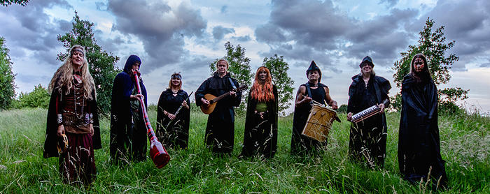
Serpentyne

Closing Concert Sunday, 26th October
Doors open 2pm to start at 4pm £5.00

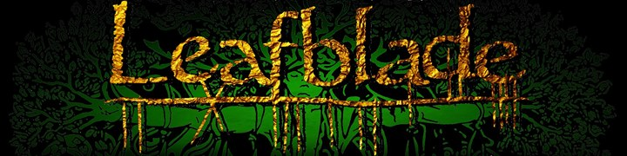

Coming in November
Saturday, 8th November 10.30am – 1.00pm
Guernsey Evacuee event with Gillian Mawson
Sunday, 9th November 10.30pm
Remembrance Sunday – Morning Prayer 10.30am
Tuesday, 11th November 10.00 Holy Communion
Remembrance Day (Armistice Day) 12.15pm Lunch-time service
November 11th 1918 was the day World War One ended

Saturday, 15th November 7.30pm
Raclette at the Nave Café (Swiss Evening) Ticket Entry Only £15.00
Sunday, 16th November 2.00pm – 5.30pm
The Bells of St Mary’s will ring thanks to a visiting band of ringers under the direct of our Steeple-keeper Clive Carlton
Saturday, 29th November 10.00am – 4.00pm
Dickensian Christmas (in liaison with Stockport Council)

Sunday, 30th November 2014 6.30pm
Advent Carol Service with the Maia Singers

What is your favourite bible passage and why?
Tell us what your favourite bible passage is – and why it is special to you – and we will feature your story in the magazine.
Starting us off this month: Catriona Smith writes:
This is such a hard question to answer and there is definitely more than one answer! However, I will pick a verse that I was first introduced to at primary school, and which made an impression on me then and still does today, 50-odd years later.
Paul’s letter to the Philippians, Chapter 4, is full of memorable verses. You may want to read the whole chapter for yourself.
My particular favourite and the one that had such an impact on me at the age of 10, is verse 8:
Finally, brethren, whatever is true, whatever is honourable, whatever is right, whatever is pure, whatever is lovely, whatever is of good repute, if there is any excellence and if anything worthy of praise, let your mind dwell on these things. (New American Standard Bible)
Finally, brothers and sisters, whatever is true, whatever is noble, whatever is right, whatever is pure, whatever is lovely, whatever is admirable—if anything is excellent or praiseworthy—think about such things.
(New International Version)
Finally, brethren, whatsoever things are true, whatsoever things are honest, whatsoever things are just, whatsoever things are pure, whatsoever things are lovely, whatsoever things are of good report; if there be any virtue, and if there be any praise, think on these things.
(King James Bible)

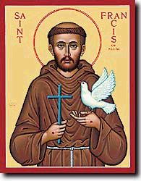
Saint Francis' feast day is observed on October 4
Prayer of St Francis
submitted to the magazine by the Rev Bernard Elsdon
Lord, make me an instrument of your peace,  Where there is hatred, let me sow love;  where there is injury, pardon;  where there is doubt, faith;  where there is despair, hope;  where there is darkness, light;  where there is sadness, joy;  O Divine Master, grant that I may not so much seek to be consoled as to console;  to be understood as to understand;  to be loved as to love.  For it is in giving that we receive;  it is in pardoning that we are pardoned;  and it is in dying that we are born to eternal life. | 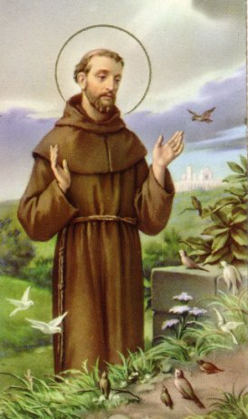
St. Francis was born at Assisi in 1182. After a care free youth, he turned his back on inherited wealth and committed himself to God. Like many early saints, he lived a very simple life of poverty, and in so doing, gained a reputation of being the friend of animals. He established the rule of St Francis, which exists today as the Order of St. Francis, or the Franciscans. He died in 1226, aged 44.
The prayer has many of the biblical truths of what it means to be a Christian - to seek to give, and in so doing, receive blessings; that the Lord's Prayer asks God to forgive us as we forgive, and that the goal of eternal life can only result from us putting to death our old sinful lives.

Rectory Cream Tea / Outdoor Service & BBQ
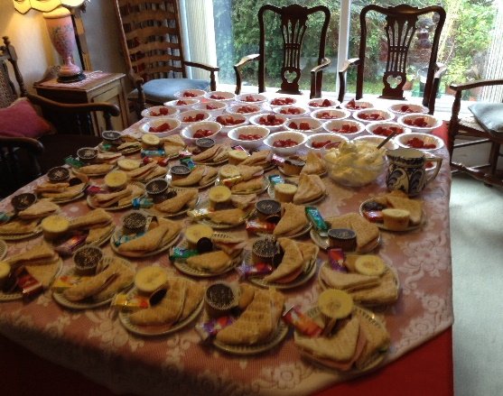
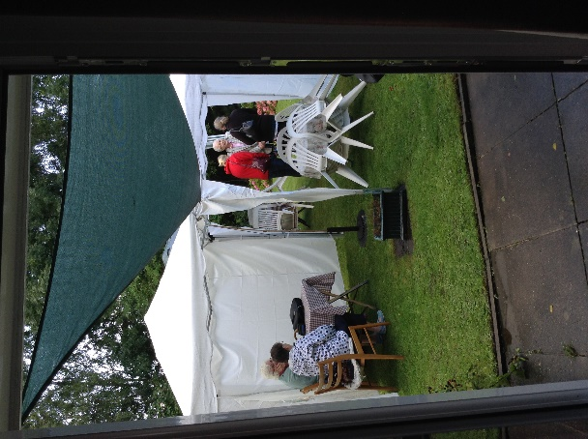
It wasn’t the best summer afternoon weather-wise, and only a few braved it outdoors initially, but it was an enjoyable afternoon at St Mary’s Rectory with afternoon tea served before the outdoor service took place in the garden.
Thanks to Frank and Ray for once again taking charge of the
BBQ.
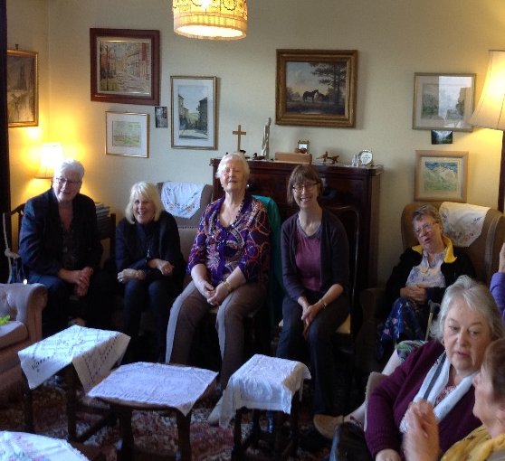
The kitchen team (Sue, Isobel, Adam and Catriona) along with the Rector thanks everyone for their support for this event which raised in the region of £212.00 towards church funds.

-------------------------------------------------------------------------------------

The Nave Café
Autumn Menu has arrived
Open: Tuesday, Thursday & Friday
with Pure Innovations, Stockport
Saturday
with the St Mary’s “Home” Team
09:00am – 3.00pm
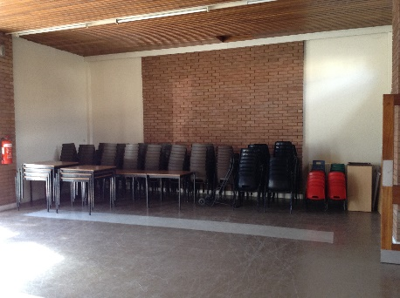
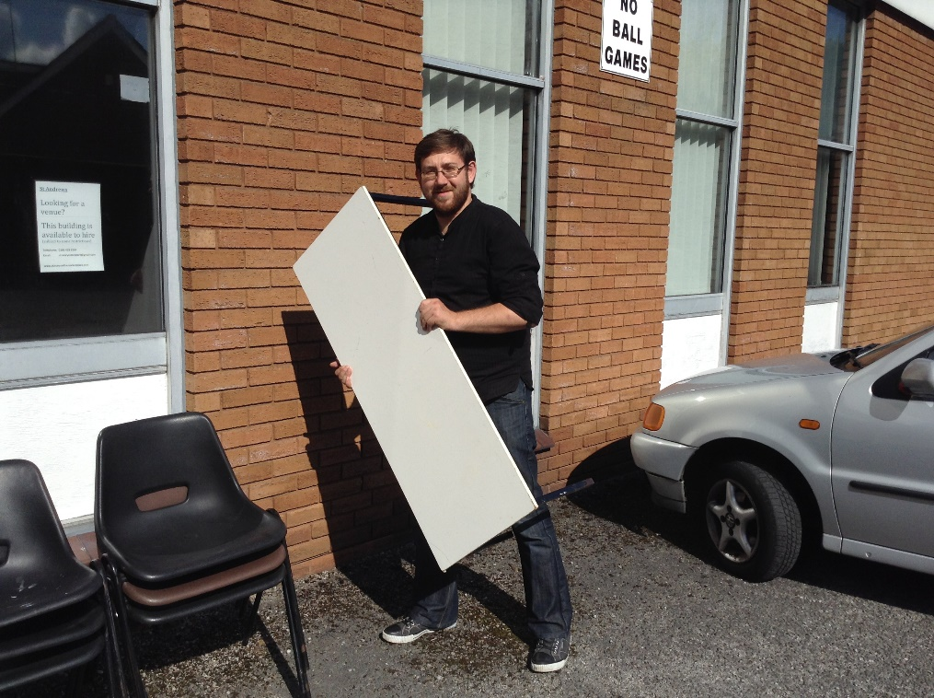
St Andrews
Thanks to Adam (shown here) along with Ann, Isobel and Catriona who spent time at St Andrews recently sorting and cleaning all our tables and chairs. It all looked lovely as everyone left, neat and tidy – alas it didn’t last long – but at least all the furniture is Health & Safety tested and cleaned for another year.
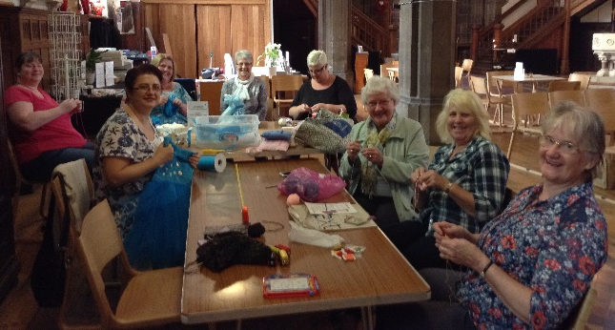
__________________________
St Mary’s “Knit & Natter”
Art, Craft, Digital Photography
Whatever your interest come along and join us
Thursday between 11.00am and 2.00pm
Welcome to St Mary’s members of the Stockport Crafters Group. This new initiative to undertake leisure activities on a Thursday morning is open to anyone who wishes to come. You are welcome to do nothing at all if you wish or to bring along work to do and skills to share with us.
Calling all knitters: to assist with the making of hats for innocent smoothie bottles in support of Age UK Stockport. Deadline for completion of hats is the end of October. Patterns available at Church.
Before we put harvest behind us…. The story behind … Come Ye Thankful People Come
Come, ye thankful people, come,
Raise the song of harvest home!
All be safely gathered in,
Ere the winter storms begin;
God, our maker, doth provide
For our wants to be supplied;
Come to God’s own temple, come;
Raise the song of harvest home! …
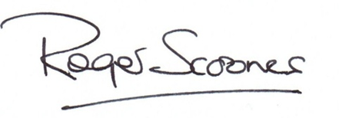
This popular hymn was written by the Rev Henry Aldford, DD, a Victorian clergyman who had been a fellow student at Trinity College, Cambridge with Alfred Tennyson, and whose transparent goodness and friendliness seem to have made him liked and appreciated wherever he went. His ministry began as vicar of Wymeswold, a tiny village in Leicestershire with a badly neglected church. Over 18 years, Henry rebuilt the faltering Christian community, faithfully visiting every person in his parish, and preaching his way through the Bible in sermons that were so clear that everyone could understand him. He then moved on to the incumbency of Quebec Chapel in London for four years, before moving to the Deanery of Canterbury, in 1857, where he lived until his death in early 1871. Henry was one of life’s good people; gentle, kindly, grateful for everything he had (he used to say ‘grace’ before AND after each meal), and eager to encourage all those whom he served. He was prodigiously productive: writing something like 50 books. The best known of these was a four volume exposition of the New Testament, which took him nearly 20 years. His famous hymn draws upon two of Jesus’ parables: the story of the wheat and tares (Mt 13:24-30) and also the story of the seed that grows unbeknown to the sower (Mark 4:26-29). Both are parables draw from agriculture; both are about the ultimate harvest of our souls before God. During this lifetime we properly give thanks to God for our harvest of his gifts of creation, but we should also reflect on what seed we are sowing in our lives, and what harvest we may expect; as one day God will gather together only his own for the eternal heavenly harvest.
Stockport, we will appeal to their more pastoral and domestic tendencies! Watch out! The Vikings are coming THIS MONTH!
St.Andrew's Community Church building, as it is at present called, now hosts a number of regular users, who not only value the excellent amenities it has to offer, but also contribute to the upkeep and well being of the building. Thanks to great efforts on the part of Sue Heap, the building is used more regularly and by a greater variety of groups, including and most importantly on a Sunday by a Christian church group, than ever before. One of the most dynamic groups, who have used the premises for a number of years now, in preparation for their fabulous shows, is the Stockport Operatic Society. It always amazes me how the cast can transfer their rehearsal routines in our building, which is admittedly quite large , onto the stage at the Plaza in Stockport, which is reportedly quite small! Their next production, 42nd Street promises to be just as entertaining as all their previous shows, rehearsed and prepared for in our very own St. Andrew's!
The model of many churches in this country today is that of a multi- use building, into which many aspects of community life are welcome to come and share their activities and enthusiasm for life. St.Mary's and St.Andrew's have that in common, that they are both places where people are welcome, not necessarily for a traditional church service, although they would be most welcome to do so, but in the wider sense to live life to the full. I'm happy with that.
Yours sincerely
-----------------------------------------------------------------------------
Falls, slips and trips combined make up more than half of reported injuries (according to statistics) but not many can claim to have received an injury at work by slipping on a bridal dress whilst conducting a wedding ceremony! Best Wishes Roger for a quick recovery.
Crossword
Across
1 ‘Those who were standing near Paul said, “You — to insult God’s high priest?”’ (Acts 23:4) (4)
3 They were assigned to guard the tree of life (Genesis 3:24) (8)
9 ‘Elkanah son of Jeroham, the son of Elihu, the — of — , the son of Zuph, an Ephraimite’ (1 Samuel 1:1) (3,4)
10 Surrender (Joshua 24:23) (5) 11 Where American livestock can be reared (5)
12 Listen (anag.) (6)
14 Alternative name for Kiriath Jearim (2 Samuel 6:2) (6,2,5)
17 He founded Westminster Abbey, — the Confessor (6)
19 Hebrew word for the place of the dead (5)
22 Allies of Persia in the fifth century BC (Esther 1:3) (5)
23 Where John Wesley was forced to preach a lot (4,3)
24 Rebellion against God; abandonment of religious belief (8)
25 Note (anag.) (4)
Down
1 Give an account of (Mark 4:30) (8)
2 ‘I — — the path of your commands, for you have set my heart
free’ (Psalm 119:32) (3,2)
4 ‘He took the ephod, the other — — and the carved image’
(Judges 18:20) (9,4)
5 ‘You are a chosen people, a — priesthood’ (1 Peter 2:9) (5)
6 The meek, the merciful and the mourners are all this
(Matthew 5:4–5, 7) (7)
7 Musical Instrument Digital Interface (1,1,1,1)
8 He was the son of Nun (Deuteronomy 34:9) (6)
13 ‘Let the little — come to me’ (Matthew 19:14) (8)
15 ‘About three thousand were — — their number that day’
(Acts 2:41) (5,2)
16 In John’s vision, the wall of the new Jerusalem was made of this
(Revelation 21:18) (6)
18 ‘Our citizenship is in heaven. And we eagerly — a Saviour from
there, the Lord Jesus Christ’ (Philippians 3:20) (5)
20 ‘Glorify the Lord with me: let us — his name together’
(Psalm 34:3) (5)
21 Young Men’s Christian Association (1,1,1,1)

Thank you to everyone who supported our events and contributed to “The Wellspring” collection during St Mary’s Harvest Weekend.

Ice Bucket Challenge
We also wish to thank Esther Morrison (formerly of Stockport Council) who bravely (or rather foolishly depending on how you look at it) allowed a bucket of iced water to be thrown on her (dressed in an evening dress may I add) for “money” – half of the proceeds payable to “The Wellspring” and the other to “St Mary’s”. A very big “thank you” for the £76.05 delivered to us from Staircase House, following Stockport Fringe Festival weekend.
AND NOW FOR THE ADVERT….. Esther having now left the employ of Stockport Council is manager of a new initiative at Style Village. Should you find yourself in that direction do pop along to Earlams – Style Village Community Shop and Café.
Style has had a village shop since the 1800’s but the new version (complete with café) is designed to enhance Style Village and create a sense of community. That sounds a little familiar don’Doors opened on the 24th July (so early days for the project) the shop and café officially opened by Maurice Earlam (89), son of Harry Earlam (who ran the shop with his family 100 years ago). Our best wishes to Esther, the management committee and all the volunteers (that run the shop and the café) for a successful future.
Please go along, have a cuppa and support them.

Bibl yr Addoliad Teuluaidd gyda nodau a sylwadau ar
Bob Pennod c'r hen Destament a'r Newydd a chyfeirnodau werthfawr, gan y Parch. Peter Williams.
Recently found left under a chair at St Mary’s (in a plastic bag) with a note to say that it had been left at a car boot sale.
Clearly in very poor condition (well falling apart actually) but nevertheless a most interesting find.
There is no publication date, nor is there any family history to indicate who this illustrated family bible may have belonged to.
It is certainly in a sad condition now and as you look through the pages you can’t help but wonder where it has been and how it came to be abandoned.
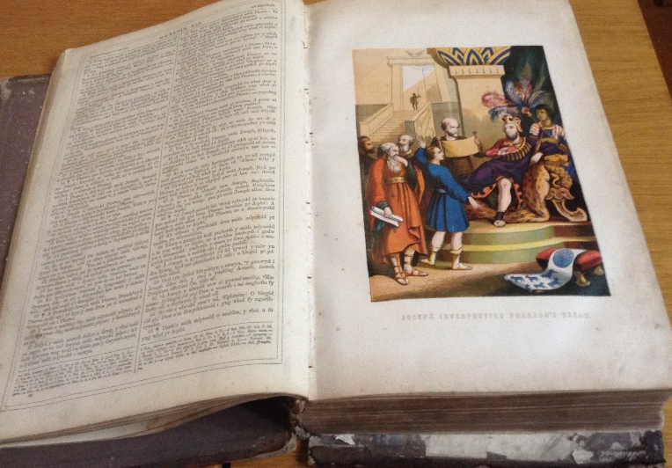
There have been Welsh translations of the Bible since the 15th Century, ours is not that old needless to say. Our acquisition, published by the London Print and Publishing Company may well have been printed around 1800-1850 (but maybe later, we’re not sure) but what we do have is the name Peter Williams – so who was he?

The Peter WILLIAMS we are interested in was a Methodist cleric, author and Biblical commentator born at West Marsh, Llansadyrnin on the 15th January 1723.

He was educated at Carmarthen Grammar School; while there, after listening to a sermon preached by George Whitefield (1743) was converted. He was for a short time a schoolmaster at Cynwyl Elfed, ordained deacon in 1745 and became a curate successively at Eglwys Gymyn, Swansea, Llangrannog and Llandysilio Gogo, but his Methodism got him into trouble in his parishes and the bishop refused to make him a priest. He joined the Methodists in 1747 and began to tour the country, preaching. He became one of the outstanding leaders of the Methodist movement in Wales.

He was also a writer and a poet. His life’s greatest achievement was the publication of successive editions of the Bible, each chapter having its own separate commentary. The first edition was published and sold out in 1770 and there were calls for many more editions, “Beibl Peter Williams” was tremendously popular in Wales for several generations and many thousands of copies were issued at one time or another.

In 1773 Peter Williams published the “Mynegeir Ysgrythurol” found to be a valuable aid to studying the Bible, however in his commentary on John he aroused the suspicion that he was inclining to Sabellianism - but it wasn’t until his next publication in 1790 (a Welsh edition of John Canne’s “Little Bible”) that he was accused of publishing the Sabellian heresy [*] and was excommunicated, spending the last years of his life in bitter controversy with the Methodists, but still publishing books in 1791, 1792 and 1794. He died at Gelli Lednais, Llandyfaelog, on the 8th August 1796.

[*]Sabellianism, also known as modalism, is a heresy which states that the Father, Son and Holy Spirit are different modes or aspects of one God, rather than three distinct persons. The heresy is attributed to Sabellius, who taught a form of this doctrine in Rome in the third century. Sabellius was excommunicated as a heretic by Pope Calixtus I in AD 220.

Freedom Sunday is a global day of worship, prayer and action on human trafficking.
On Sunday 19th October 2014 or Saturday 18th October (for those for whom Saturday is the Sabbath), churches all over the world will join together to raise awareness of the crime of human trafficking and show the world our compassion for men, women and children who are trafficked and exploited. The church will demonstrate a united and tangible response against human trafficking.

The church will make commitments to take action to prevent the crime of human trafficking in our local and global communities. Together, let’s stop human trafficking and let’s start freedom.
Archbishop urges churches to support Freedom Sunday The Archbishop of Canterbury has welcomed recent government efforts to combat human trafficking. “I am very pleased that the UK Government is bringing forward legislation to combat a shameful and shadowy practice that deprives people of their freedom and their God-given dignity. I hope MPs and Peers will take this opportunity to agree to a series of robust measures, not least in the area of business supply chains, that set the standard for the rest of the world.”
The Archbishop also welcomed the recent first UN World Day against Trafficking in Persons (30 July). “It beggars belief to think that, 200 years after William Wilberforce's success in abolishing the transatlantic slave trade, the trade in human beings continues at such a pace that we need a UN World Day against Trafficking in Persons. “I encourage churches to be at the forefront of this new abolitionist movement, by taking steps to raise awareness now and by coming together with others around the world on 19 October, Freedom Sunday, in a day of worship, prayer and action on human trafficking."

Record amount from parishes to fund ministry and mission
– except at St Mary’s unfortunately.
A “bread and butter” comment made in the September magazine seems to have sparked a little interest here and there. “Money” is always a difficult subject and the continued lack of it at St Mary’s does continue to be a problem.
It is reported that Parishes across the country raised a record amount of £929 million in 2012 in order to fund the ministry and mission of the Church of England. Parishes raised these funds from a combination of investments, legacies and donations, despite the reduced gift aid rates. It was also reported that Parish Churches also continued to give generously to other organisations, donating more than £46m to other charitable organisations. The statistics also show that after three years of deficits, parishes have successfully reduced their expenditure and encouraged more giving, to reach a break-even point in 2012.
Dr John Preston, the Church of England’s national stewardship adviser, said: “The 2012 figures are a real testimony to the generosity of people in the pews. They have raised the largest ever amount of money to support the ministry and mission of the church. The Christian principle of stewardship is clearly alive and well.”
It is brilliant news for the Church of England overall but a depressing fact that St Mary’s is not in such a happy position financially – we continue to struggle on a week to week basis with increasing debts to the Diocese and the inability to fully pay our way, or to do those things we ought to do (or are even required to do ) but can’t. Just a thought to take away…… We require in the region of £3,845 per month just to pay the Direct Debits for our Insurance, Gas, Electricity, Water, and the percentage of the Parish Share we actually pay. Our income from Planned Giving (that includes the little brown envelopes, regular “gift aid” donations using the white envelopes and those who pay directly into the bank) is just £1184.50. That’s a short fall of £2660 .50 to be found each month from “non-guaranteed” income before we even start on other necessities of life at St Mary’s.
I have put three versions in because so many people will know it in the King James – probably as the “whatsoevers”. However all the versions are very clear about our calling to let our minds dwell on the positive things of life or to count our blessings. I was, by all accounts, a difficult child (if my siblings are to be believed!) and remember constantly being told to count my blessings before I grumbled. Hmm! I would like to think that now I am older, I have finally learned this principle and try to live by it. So please feel free to pick me up on it if you find me grumbling!
But it is so easy to dwell on the bad things that happen to us and on the negative news in the paper or on the TV or radio, and we can easily fall into the trap of not seeing the good in the world, and losing sight of God’s peace. Where can we find the truth, the honest, or the pure and lovely things in this life? They are all around us, in the curl and colour of an autumn leaf, in the squirrel that bounds along the garden fence, in the stillness of early morning mist or in the depths of a lovely cup of tea made for us by a friend in a time of stress. Perhaps in a hug when you are down, an unexpected card in the post just to say Hi, or that moment in church or at home when you hear the still small voice of God speaking into your heart.
Paul goes on in verse 9 to say: “The things you have learned and received and heard and seen in me, practice these things; and the God of peace shall be with you.” We can follow his example and know the presence of the God of peace even in our busy lives.

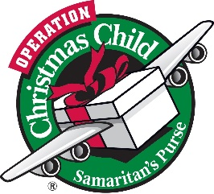
National Collection Week, November 17–24, 2014. Remember, remember …
that we need your shoebox gifts during November
Blessing of the shoebox gifts – Sunday, 23rd November
at our morning service.

