PRESIDENT’S MESSAGE
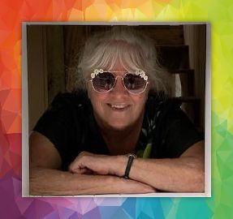
Greetings in the New Year, 2022. I was just reading New Year quotes, and there are some great ones that can really inspire us. I like this one from Dr. Seuss: "You’ll never get bored when you try something new. There’s really no limit to what you can do."

I’ve found this to be true as many of us have tried new things during our Covid time. Learned a craft, worked on a new language, tried online “how to” crochet, cooked up some new recipes. The list is endless, and the internet was a big help for many of us.

While our travels were curtailed, I’m sure many of us traveled in our minds, planning trips, or maybe seeing our own country/state/city with some mini or shorter trips. I’m a big believer in seeing our own backyards, and since we just happen to live in paradise, we have lots to explore right here. I love quotes and travel, and here is a good site you may enjoy: https://theplanetd.com/the-ultimate-travel-quotes-as-chosen-by-you.

A big thanks to our holiday party team! The party was a huge success, and we enjoyed learning about holiday traditions in many countries and personal holiday recollections. It is a time of year that brings back many memories of family, friends, food and good times and reflection on our beliefs whatever they may be.

We added new Honorary Members this year, Clyde & Jean Choong and Sandy Gourdine. These members have served our club to make it better and been very dedicated. We thank them all and congratulate them on becoming Honorary Members.

If you want to attend Ed Fletcher’s dinner theater on January 29 at 4 pm to see the comedy "Boeing, Boeing," please let me know ASAP.

I’m having a rock painting get together in February to make some shamrock rocks for our Austin incoming in March. If you are interested, let me know. I’ll put flyers on the check-in table at our monthly meeting.

Make it a great year. ”Travel is fatal to prejudice, bigotry, and narrow mindedness, and many of our people need it sorely on these accounts.”
﻿~ Mark Twain

In friendship,

Gena Cameron

