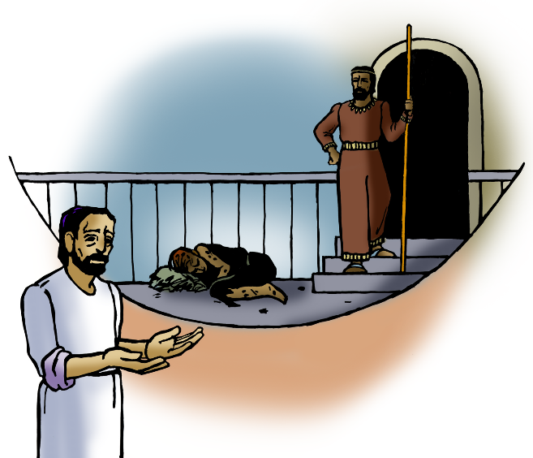
The Five Second Rule
September 25, 2016
Luke 16:19-35

Grace and peace to you from God Our Father and from the one who commands us to love our neighbor, Jesus Christ our Lord, amen.
It’s amazing what a difference five seconds can make. Have you ever heard of the “five second rule?” You know the rule about eating a piece of food after it’s fallen on the floor, but only if it hasn’t been there for more than five seconds. Most of you probably think that’s gross.
One thing’s for sure—our little Gabriel doesn’t care about the five second rule. If one of those little goldfish or some other tasty morsel has somehow found its way under the edge of the sofa three weeks ago, he doesn’t care. He’s really good at finding food we never knew was there! We have a booster chair that sits at one end of our kitchen table and Gabe is an expert at hiding food between the booster seat and the chair. I actually think he plans to save that food for the next time he comes over for a visit.
And he’s so sneaky about it. It’s almost like he knows we’re watching him and he knows not to eat food that’s fallen on the floor or been saved for later in the booster chair weeks ago, but he does it anyway. I’m the opposite. I mean, the five second rule is a fun thing to do, but only if somebody else is watching. I’m pretty repulsed by eating food that’s fallen to the floor, especially if it’s fallen on the floor at any other busy restaurant where you just can’t tell when they cleaned the floor last.
You’ll never see somebody casually reach down and put that French fry in their mouth after it’s fallen on the floor at McDonalds or Burger King. Besides, there’s no being sneaky about the five second rule anyway. The whole purpose of the five second rule is to draw attention to what you’re doing. When someone invokes the five second rule you’re supposed to loudly announce what you’re about to do and then put that hairy French fry in your mouth and pretend it actually tastes good. You have to love the five second rule. I can’t decide if it was invented by an elementary school boy or by a college student in a fraternity somewhere, but whoever invented this rule was just brilliant—and they’re probably dead by now from ingesting a disease-ridden morsel of food that had fallen under the couch in some real life version of the frat house from the movie Animal House.
Even though I have eaten food that’s fallen on the floor, I only do it when I know the floor is clean and the food’s not likely to attract a lot of foreign substances. There are people who would love to have the food we throw down or throw out—five second rule or not. The Bible is full of stories about hungry people, and hunger is no laughing matter. Our gospel lesson this morning tells us a story about hunger. Here we are given the story of a beggar who sat by the gates of a rich man’s house longing for the food that fell from his table. This story is the only place in the New Testament where a poor beggar is referred to by name—Lazarus. This isn’t the same Lazarus that lived in Bethany, the brother of Mary and Martha. This isn’t the one Jesus brought back from the dead. Lazarus was a fairly common name, and unfortunately, hunger was a fairly common problem, back then just as it is today.
When Jesus tells us Lazarus longed to satisfy his hunger with what fell from the rich man’s table, he wasn’t talking about a French fry that just happened to fall out of his happy meal. In ancient times there were no paper napkins and cloth was very expensive so, it was customary to have some flat bread around during a meal. You would not only use it to scoop up things like mashed up beans or chick peas, but the bread was what you wiped your hands with. The very rich people wouldn’t even eat the bread. They would only wipe the grease from their hands with it like we do on a napkin and then throw it on the floor for the dogs to eat. Lazarus longed for the food which the rich man threw out.
There’s several words in Greek that can be translated as eating. There was one Greek word used for eating on a special occasion. The word used for what the rich man did every day is εὐφρανῶ (Uphrano). This is the same word for the feast the father threw for the returning prodigal son. It would be a banquet like most people might throw only on a very special occasion like a wedding reception. There is another word used for just the regular consumption of meals (which doesn’t occur in this story). Then there is also a word used to refer to the way dogs and other animals eat. That’s the word used to refer to what Lazarus longs to do—to eat dog food)! The horrible irony of this story is Lazarus himself is dog food—we are told the dogs would come up and lick his sores that covered his body. Lazarus was clothed from head to toe with sores, while the rich man was clothed in purple linen. There can be no greater chasm between any two people than the one that existed between the rich man and Lazarus.
We don’t need to look to a story Jesus told 2,000 years ago to see a poor person that’s hungry and in need. We also don’t need to look to a 2,000 year old story to see rich people who are in need of something far greater than money. The main point of this story is not to degrade the wealthy or to scare people about hell. The point of this story is to make us remember those who are hungry. Sometimes in church it is easy to think that it’s all just between me and Jesus. Sometimes we all get the misguided idea that our faith is a personal thing, just between me and Jesus. This story is here to remind us that living a Godly life is more than just what’s between you and Jesus—it is also about the relationship between you and Lazarus or I should say between you and all the Lazarus’ that live today. Christianity isn’t just about heaven and hell, reward and punishment, and where you go when you die. It’s also about how you live here and now.
I love to invoke the five second rule when food falls to the floor. It disgusts people to no end especially the germaphobic. They almost lose their lunch right then and there. The five second rule is a great thing for having fun around some folks. As much fun as the five second rule is, I offer a change in the rules of this germy practice. You see, the five second rule divides people. There are those who think it’s disgusting and there are those who think it’s a bit of fun. But I suggest we change the rules entirely. Next time some food falls to the floor may I suggest you to invoke a new five second rule that can bring folks together. That is, take five seconds and remember Lazarus. Take five seconds and remember those who would love to eat your food that falls to the floor. In this day and age we still have far too many people teetering on starvation. It’s estimated that 3.6 Billion dollars would provide enough food calories to alleviate all starvation world-wide. According to the American Pet Products Association, Americans spent a total of $23.04 billion on pet food in 2015. Text time you feed your dog, cat, or iguana take five seconds and remember there are hungry people in this world that aren’t as well-fed as your pet. As you pray, maybe God will answer your prayer by telling you to donate something to a hunger organization like Bread for the World or Lutheran World Relief in the same amount you pay for your pet food. If everyone would do that starvation could be gone from the face of the earth in our lifetime. Please, take a few seconds out of your day and remember Lazarus and the poor in our time, and then do something about it. Eating food that’s been on the floor, even if it’s been five seconds or less, might be somewhat disgusting, but it won’t kill you. The hunger that leads to starvation on the other hand is the most disgusting thing of all. Yes sir, it’s amazing what a difference five seconds can make.
May you never fall victim to hunger, but have enough of every good thing from our Father’s bounty. May you take five seconds every day to just pray about what you can do to help eliminate needless deaths caused by the lack of proper nutrition. May our Church, our Southern Ohio Synod, the Churchwide ELCA, and our entire country continue work tirelessly to feed the hungry. May God bless us in our work as we do our part in closing the chasm fixed between all rich people and the Lazarus’ who have been left on our doorstep. Amen.

