Training My AQHA Stallion to Bridle Himself

University of Guelph - Equine Behaviour

Presented to: Dr. Sid Gustafson DVM

Minor Assignment, Option A

By: Kelli Carder

e-mail: bradfordsigns@hmconline.ca

June 23, 2013

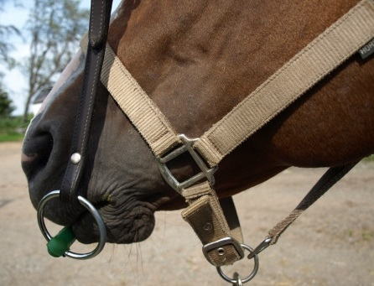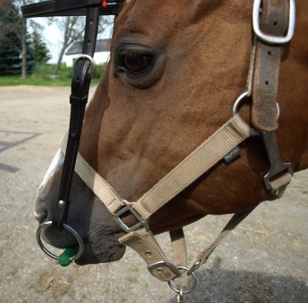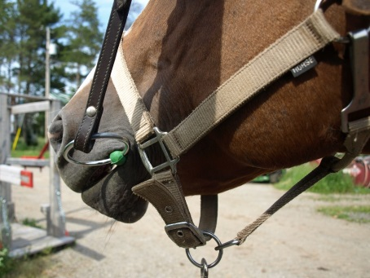

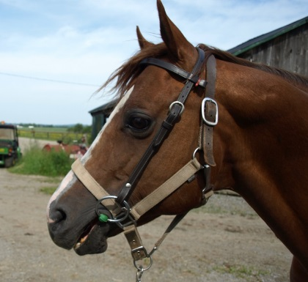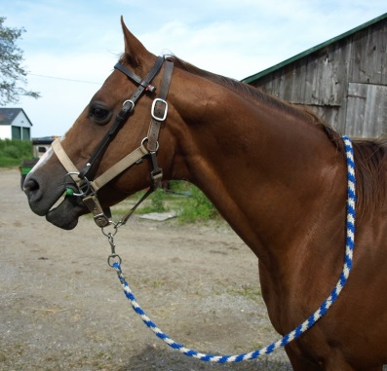

Overview

The focus of this project was to clicker train a horse to perform a useful task. I took this as an opportunity to work on an ongoing issue I had with my stallion, Lenny. While it was not a huge issue, Lenny has always been a bit resistant to wearing the bridle and we had to put a thumb in the corner of his mouth to get him to open up and take the bit. I decided to focus my efforts on not only getting him to willingly take the bridle, but to actually bridle himself with me just holding the headstall for him.

The Trainer

I have had horses for nearly 30 years, and am an advocate of natural horsemanship training techniques. My experience with clicker training is quite limited, however. I have a friend who is a big advocate of clicker training; she has trained her mare to perform many advanced tasks through clicker training and has been encouraging me to pursue this avenue for some time. I did undertake a small project last year of teaching a miniature stallion to give a “kiss” on the cheek to a person when prompted. While that was quite a simple trick to teach, the self bridling was a more complex process.

The Student

PJ Prophets Higher (barn name Lenny) is a 1998 AQHA stallion. We purchased him in Michigan in 2006 and imported him to our farm in Ontario. He is halter bred and was shown extensively at halter as a young horse, but never trained under saddle until we brought him home. He was used as a breeding stallion both by his previous owners and also by us.

He came to us with some behavior problems, mostly due to his previous owner’s misguided attempts to stop them, which inadvertently reinforced the very behaviors she was trying to stop, for instance, she would feed him treats when he attempted to bite in order to “keep his mouth busy” and she would put his grain in his stall and then let him run in on a long lead to get to it, thereby teaching him to rush through doorways. In the time we have had him, we have addressed both of these issues through positive and negative reinforcement, but have avoided feeding him by hand for fear it would cause him to want to start biting again. Research has shown that in general, hand feeding does not cause biting (Hockenbull & Creighton), but since Lenny had been rewarded with treats for biting in the past, I had some concerns.

Lenny lives outside most days and nights and is on free choice grass hay. He is lacking in conspecific social interaction however, since, as a stallion, we don’t really have anyone else suitable to keep with him that he wouldn’t either fight with or breed with. He is only a few feet from our Clydesdale team’s paddock and can see all of our other horses from where he is.

Equipment and Reinforcers

The equipment used was quite basic, a halter, lead rope, western headstall and a rubber straight snaffle bit.

The primary reinforcer used was a basic food reward of oats. I had used store bought treats for the first session, but they proved to be insufficient motivation for him and he was losing interest within 10 minutes. A study by Ninomiya and Mitsamasu in Japan showed that horses were more motivated to perform when the food reward was something they found more desirable.
The secondary reinforcer, or bridge, was the cluck noise. Due to the fact that my hands were busy with holding the bridle and delivering treats, and the fact that we were working so close to his ears and the clicker is quite loud, I opted for a single cluck noise that I made myself, rather than the actual clicker device.

Training Conditions

The training sessions were purposely kept short, averaging ten to fifteen minutes per session, never exceeding twenty minutes, in order to maintain his full attention. The time off between training sessions varied from one day to three days.

I varied the location of the lessons in order that Lenny not associate the task with a specific location, but rather generalize it to all locations. The locations included his paddock, his stall, the barn aisle, and the barnyard area. In the stall and paddock, he was free to move around at will, in the other areas, he had a lead rope attached to his halter for safety, but it was draped over his neck where I could grab it if needed, but he was not restrained.

The Process

I employed the concept of shaping behavior (McGreevy pg. 96) which involves building toward the final desired result through a series of small, progressive and logical steps. I had an objective in mind that I wanted to reach with each training session, but generally I let Lenny dictate the pace at which he was able to absorb the information presented. Most days we got to our goal and even beyond, but there were days that we didn’t get there as well. In those instances, I went back to the last point he was consistent with and made sure that we finished on a positive note. We would pick up where we left off at the next session.

The Training Sessions

#1. For our first session, the goal was to load the clicker and teach Lenny to target for the click and treat. I took the rubber snaffle off of the bridle for this, and held it out in front of him to investigate. He almost immediately sniffed it and I clicked and treated (C/T) on that. We repeated this three or four times and he seemed to be making the association well.

At this point he seemed to figure out that my pocket was where the treats were coming from and started to focus on that. To counteract that, I would apply positive pressure by pushing his nose away from my pocket, then offering the bit for him to target on again, if he touched it, I would C/T, if he went back to the pocket, I would push his nose away and present the bit again. After about three attempts to mug my pocket, he gave up and went back to targeting on the bit for treats. We finished out the session on that note. Mugging attempts were very few after this point.

#2. Lenny retained what he had learned from our first session and we were able to build upon that. We started with targeting on the bit again, and once I had established that he remembered what to do, I put the bit back onto the headstall and held it out for him by the crownpiece. I rewarded a touch anywhere on the headstall. Once he was performing that task reliably, we quit for the day.

#3. For our third session, I asked him to focus only on the bit, beginning with rewarding a touch anywhere on the bit then progressing to only rewarding for a touch on the rubber mouthpiece of the bit.

#4. This session, we moved on to only rewarding a touch on the mouthpiece of the bit if his head was in the bridle between the two cheekpieces, above the bit, as though we were preparing to put the bridle on.

#5. The focus this session was getting Lenny to be more precise with how he touched the bit. I only rewarded a touch with his lips, not his nose. By the end of the session, he was putting the bit between his lips and pushing on it with his teeth for a reward.

#6. On our sixth session, we progressed to where he was holding the position from the previous session with the bit on his teeth for a count of two.

#7. This was really the first and only session where we had a setback. The aim was to get him to actually take the bit into his mouth. Since he is usually quite mouthy with things, I thought, left to figure it out, he would eventually do it on his own and I planned to reward it with a treat jackpot (several handfuls of oats and lots of praise).

He returned to what had worked previously, holding his teeth on the bit, he tried that a few times, then reverted to tasks that had worked previously and without a reward, he began to get agitated, clicking his teeth together and sucking on his tongue, a habit he has had since we got him that he only does when he is agitated or bored. This type of episode is what is referred to as an exctinction burst (Braslau-Schneck). While I did not know the term for it at the time, I did recognize that we needed to get back to something he was familiar with to settle him down and finish on a good note. I took the bridle away for a moment, then presented it again, and he tried the press and hold again, which I rewarded and we repeated it two more times and finished for the day there.

#8. I had to think, after the previous session, about the best way to get past the block we had encountered. While I know that the aim of clicker training is to allow the horse to display the behavior spontaneously and then reward it (Kurland), I was not confident that he was going to take the bit in his mouth, and I wanted to avoid another extinction burst. We began with him holding with his teeth on the bit as before. I then proceeded to bridle him as I would have before, manually opening his mouth for the bit. As soon as he opened up, I clicked and treated him heavily with several small handfuls of oats. I repeated this twice more. I then presented the bridle to him as before, holding it out by the crown piece to see how he would react. After trying once to hold it on his teeth again with no reward, he proceeded to open his mouth to accept the bit. I C/T’ed with a treat jackpot once again. We repeated this three more times with just the normal treat and quit for the day.

#9. This was the final session that I documented for the purposes of the project, however we are continuing on with making it “prettier”. In this session, we worked at fully bridling, with me putting the crownpiece over his ears before the C/T. By the end of this session I was able to consistently bridle him by holding the bridle in one hand by the crown piece and him putting his head in, taking the bit in his mouth, and me pulling it back over his ears. Mission Accomplished!

Conclusions

It has become apparent to me over the course of this project, that clicker training can be a very effective training tool, even for fairly complex tasks. It may not be practical for all applications, such as under saddle work where it would be very difficult to deliver a treat in a timely manner. Clicker training is something I will definitely keep in my trainer’s toolbox in future. I am planning on doing this same bridling training with one of our Belgian mares that is often difficult to bridle now that I have practiced the technique on Lenny. Lenny now looks forward to seeing the bridle and comes toward it immediately rather than wanting to avoid it as he did in the past.

-------------------------------------------------------------------------------------------------------------------------

References

Articles

Braslau-Schneck, Stacey (2003) An Animal Trainer’s Introduction to Operant and Classical Conditioning, Parts 1 and 2
http://www.wagntrain.com/OC/

Creighton, Emma (2006) Equine Learning Behaviour: Limits of Ability and Ability Limits of Trainers, University of Chester, UK – available through U of Guelph online library

Ninomiya, Shigeru & Mitsumasu, Takeshi (2007) A Note on the Effect of Palatable Food Reward on Operant Conditioning in Horses, United Graduate School of Agricultural Science, Tokyo, Japan – available through U of Guelph online library

Williams, Friend, Nevill & Archer (2003) The Efficacy of a Secondary Reinforcer (Clicker) During Acquisition and Extinction of an Operant Task in Horses, Dept. of Animal Sciences, Texas A & M, Texas USA – available through U of Guelph online library

Hockenhull, Jo & Creighton, Emma (2010) Unwanted Oral Investigative Behaviour in Horses: A Note on the Relationship Between Mugging Bahaviour, Hand Feeding Titbits and Clicker Training, University of Chester & Newcastle University, UK – available through U of Guelph online library

Murphy, Jack & Arkins, Sean (2007) Equine Learning Behaviour, Univeristy of Limerick, Ireland – available through U of Guelph online library

Slater, Charlotte & Dymond, Simon (2011) Using Differential Reinforcement to Improve Equine Welfare: Shaping Appropriate Truck Loading and Feet Handling, Swansea University, UK – available through U of Guelph online library

Books:

McGreevy, Paul (2004, revised 2012). Equine Behavior; A guide for Veterinarians and Equine Scientists 2nd Edition. Saunders Elsevier Publishing; 2012

Miller, Robert M. DVM & Lamb, Rick (2005) The Revolution in Horsemanship and What It Means to Mankind. Guilford, Connecticut, The Lyons Press; 2005

Miller, Robert M. (2007) Natural Horsemanship Explained from Heart to Hands. Guilford, Connecticut, The Lyons Press; 2007

Internet
Kurland, Alexandra - http://www.theclickercenter.com/

Pryor, Karen - http://www.clickertraining.com

