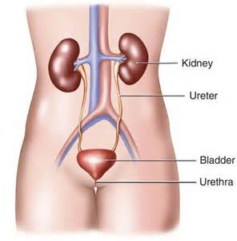
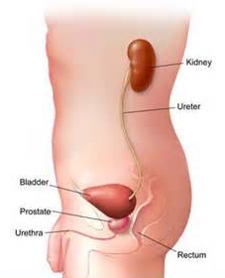
Kidney Health

It is imperative that we drink adequate water to maintain healthy kidneys
– ½ ounce per pound of body weight daily

- Each kidney contains about 1 million tiny tubes called nephrons.
- A little over 22 percent of the blood the heart pumps every second goes to the kidneys.
- This blood flows through a filter, called a glomerulus, in the nephron.
- Your kidneys remove waste and water from the blood to form urine.
- When kidney function declines, toxins build up in the blood and the kidneys begin to fail.
- The eGFR blood test is a measure of the function of the kidneys.
- The Glomeruli (tiny filters in the kidneys) allow waste products to be removed from the blood, while preventing the loss of important constituents.
- The glomerular filtration rate refers to the amount of blood that is filtered by the glomeruli per minute.
- When a person's kidney function declines due to damage or disease, then the filtration rate decreases and waste products begin to accumulate in the blood.
- Kidney function is very related to blood pressure.

eGFR Blood Test Result What it may mean
90+ normal GFR
60 to 89 mild decrease in GFR
30 to 59 moderate kidney damage
- o 29 severe kidney damage
Less than 15 kidney failure (dialysis or transplant may be needed soon)

Kidney Health
- Drink optimal purified water each day
- Reduce animal protein … increase vegetable protein
- Do a Kidney Cleanse at least twice annually (more often if challenges are occurring)
- Optimize Probiotics
- Optimize Vitamin D3
- Keep your diet 75% alkaline foods … (Alfalfa, as a supplement, helps to support this effort)
- Alfalfa, as a mineral supplement, helps to support “healthy filtering” within the kidneys
- Since lack of digestive enzymes occurs with chronological aging, start to introduce digestive enzyme support appropriately:
- Always provide probiotics for digestive support
- Alfalfa is a natural digestive enzyme support
- Shaklee Stomach Soothing Complex provides digestive support to the upper GI tract
- Shaklee EZ-Gest is a vegetable based digestive enzyme capsule, and is wise to introduce as we age

What if you have PROTEIN show up in your URINE TEST?
- This is a DIGESTIVE PROBLEM … It is caused by not making enough “Protease” (digestive enzymes) to digest proteins properly.
- How do you address the root of the problem?
- animal protein is much harder to digest than vegetable protein, so switch the majority of your protein to vegetable protein.
- provide protease enzymes before there is permanent kidney damage.

Kidney Cleanse (will get rid of Kidney Stones if you have them)



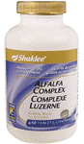


People who have kidney problems are wise when they do the flush often … at least every three months.
EVERYONE should flush at least twice yearly.

This is a Cleanse, not a fast. … This flush is very beneficial for people who suffer with:
- chronic kidney infections
- cystic kidneys
- kidney stones, (this flush will cause you to pass kidney stones if you have them)
- high blood pressure triggered by malfunctioning kidneys.

Products needed to do this cleanse
- 3 gallons of purified water
- 18 fresh lemons
- 80 Shaklee Alfalfa tablets
- 40 Shaklee Sustained Release Vitamin C (500 mg)
- 20 Shaklee Herbal Laxative

DAY 1
- 1 gallon of purified water - Shaklee Get Clean Water (1 gallon = 16 – 8 oz glasses of water) to which you have added 6 fresh squeezed lemons. Drink in a 12 hour period.
- 1 Alfalfa tablets and ½ Sustained Release Vita C with each 8 oz. glass of water (16 Alfalfa and 8 Vita C in total)
- 6 to 8 Shaklee Herbal Laxative divided up throughout the day (the nine herbs in Herbal Laxative expand the urethra and allow kidney stones to pass)

DAY 2
- 1 gallon of purified water – Shaklee Get Clean Water (1 gallon = 16 – 8 oz glasses of water) to which you have added 6 fresh squeezed lemons. Drink in a 12 hour period.
- 2 Alfalfa tablets and 1 Sustained Release Vita C with each 8 oz. glass of water (32 Alfalfa and 16 Vita C in total)
- 3 to 6 Shaklee Herbal Laxative divided up through the day

DAY 3
Same as Day 2.
NOTE: If you have kidney stones that are being stubborn and do not pass in 3 days, repeat Day 1 & 2, or Day 1, 2, & 3
NOTE: It is very common to experience more frequent bowel movements during this time. Do not be alarmed … this cleanse is also initiating a partial bowel cleanse as well.
DAILY MAINTENANCE AFTER THE CLEANSE: Between cleanses, it is wise to provide DAILY kidney maintenance or support. A good DAILY program would include:
- 1 Shaklee Alfalfa per 10 lbs of body weight daily
- 2 Shaklee Vitamin C 500 mg daily
- 1 Herbal-Laxative daily
- ½ oz of water for every pound of body weight daily

