Registration Form
Please check all weeks that your gymnast plans to attend.
Name
Week 1 June 19th – June 22nd
Week 2 June 26th – June 29th
Week 3 July 3th – July 6th
Week 4 July 10th – July 13th
Week 5 July 17th – July 20TH
Week 6 July 24th – July 27th
Week 7 July 31st – August 3RD
Week 8 August 7th – August 10th
Week 9 August 14th – August 17th
Week 10 ____ August 21st – August 24th

Price per week is $75 if registered by May 20th
For registrations after May 20th the cost per week is $95.

If you DO NOT register prior to the start of the week, registration is $100 for the week.

CHECK/MONEY ORDER PAYMENT ONLY MADE OUT TO WATER TOWER

Water Tower Gymnastics Camp
Water Tower Gymnastics Camp is run by Head Coach Andre Agard and he is assisted by a number of USAG certified coaches.
Andre is a former men’s horizontal bar and men’s vault champion for Central High School. He has coached at Water Tower for 15 years and is responsible for forming Water Tower’s first USAG competitive team, the Thunder Cats.
Fred Brannon was a long-time Water Tower coach before Andre took over the program, taking the first USAIGC Water Tower team to Nationals, as well as serving as the head coach to Central High School’s gymnastics team. Fred has also coached many elite gymnasts for over 30 years.
Tatiana Sliner is a former level 7 national champion on vault, balance beam, and floor exercise. She has been coaching at Water Tower for 11 years.
Jessica Browne started gymnastics at Water Tower over 20 years ago. She was one of Mr. Brannon’s first nationally competitive gymnasts and later went on to compete for West Chester University.
Tytianna Broadwater was a gymnast with Water Tower for 10 years. She was a city champion as a beginner, intermediate, and advanced tumbler. She has been coaching at Water Tower for four years.
Our coaching staff will also feature highly qualified and talented coaches and dancing instructors this summer; the gymnast to coach ratio will be approximately 9:1, allowing a great deal of individual instruction and attention to detail.

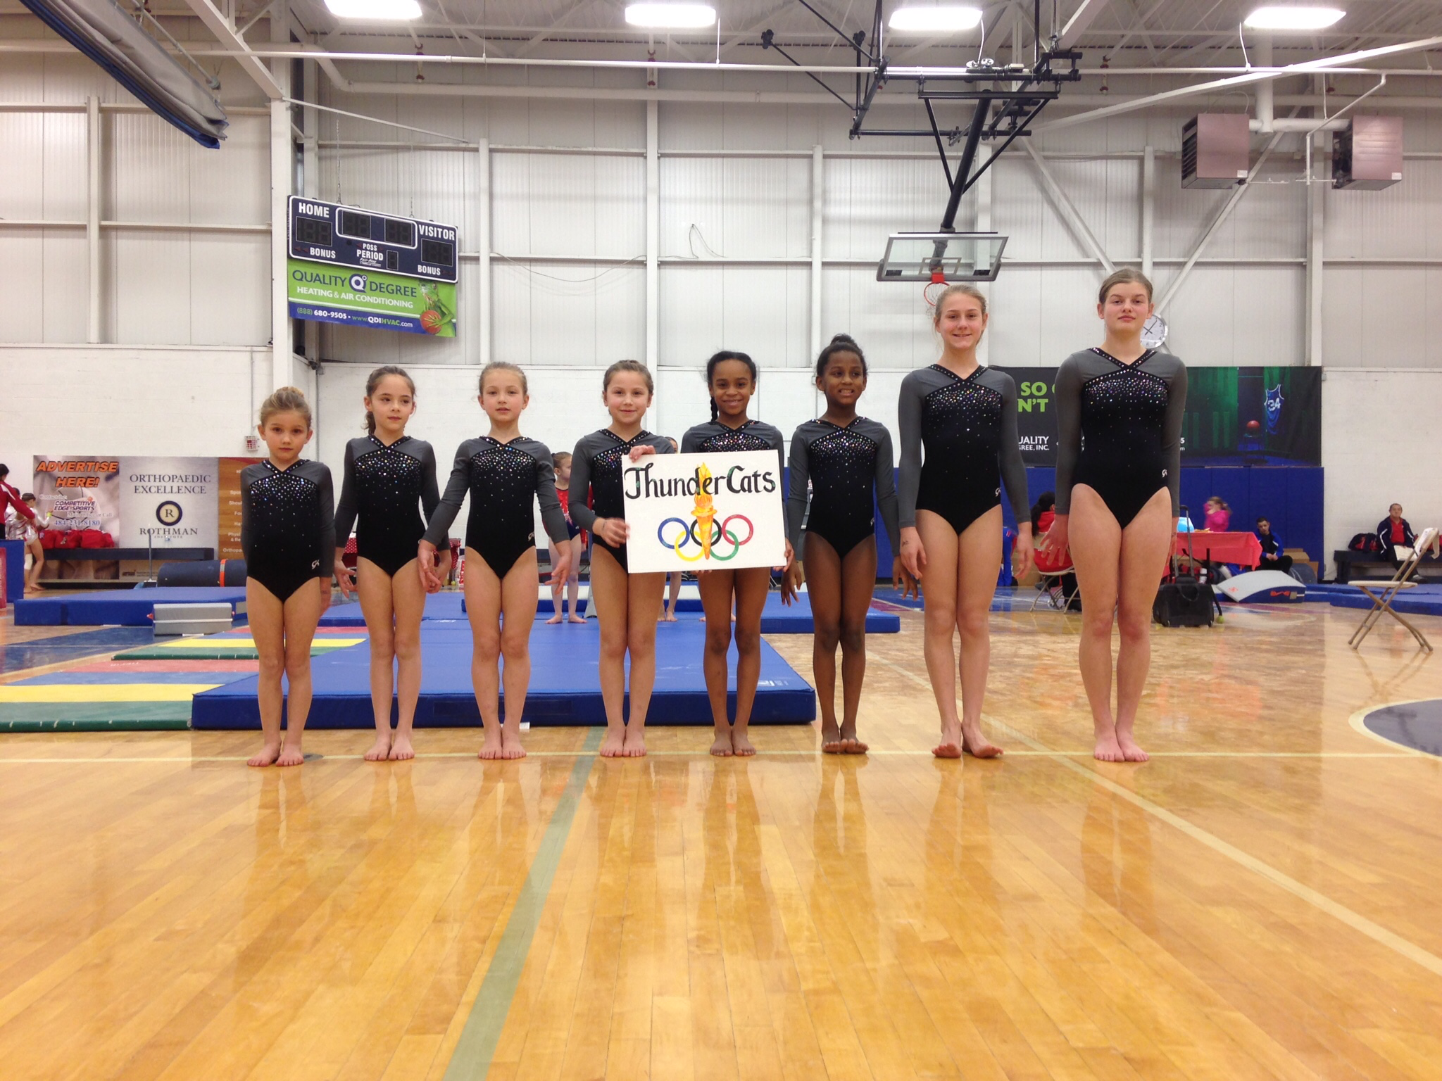

THUNDER CATS
GYMNASTICS CAMP 2017
Water Tower Recreation Center
209 E. Hartwell Lane
Philadelphia, PA 19118
267-581-3798
watertowergymnastics@gmail.com
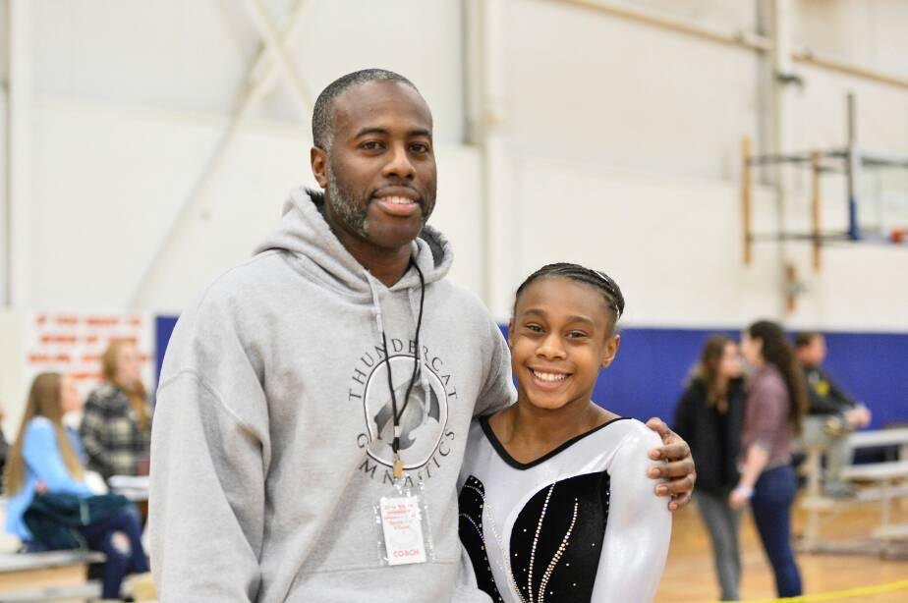
Why Gymnastics Camp?
Water Tower Gymnastics Camp is a program that allows gymnasts to work out on all four gymnastics apparatus. Gymnasts work new skills on Vault, Uneven Bars and Balance Beam, while working to improve upon their tumbling skills on Floor. Our program allows gymnasts to learn new skills in a fun environment after our competition season has ended. While the main purpose of our camp is to become a better gymnast, gymnastics camp is also a great opportunity for the participants to make new friends and have a great time.
What is Camp Like?
Gymnastics Camp is from 4:00-8:00 PM on Monday, Wednesday and Thursday. During the four hours, gymnasts are split into groups and spend time on Vault, Bars, Beam, Floor, and dance. There is a 30 minute dinner/ snack break in the middle where the kids get to eat, relax, and be social. Thursday night every week is game night. Gymnasts compete in games to win prizes! This camp utilizes two gymnasiums with 8,000 square feet.
What to Bring?
Gymnasts should bring a water bottle and a light dinner. If your child has an inhaler or any other device to be used in an emergency medical situation, please make sure they bring it to camp with them.

Who Can Sign Up?
Gymnasts who want to participate must be able to do a minimum of forward and backward rolls, headstand rolls, handstand rolls, cartwheels and round offs. There are ten weeks of camp to choose from. All gymnasts currently enrolled in Water Tower’s Tumbling and Gymnastics Program are strongly recommended to attend at least four weeks of camp, to give them the best opportunity to prepare for the upcoming competition season. We can only take 40 gymnasts per week, so hurry up and register!

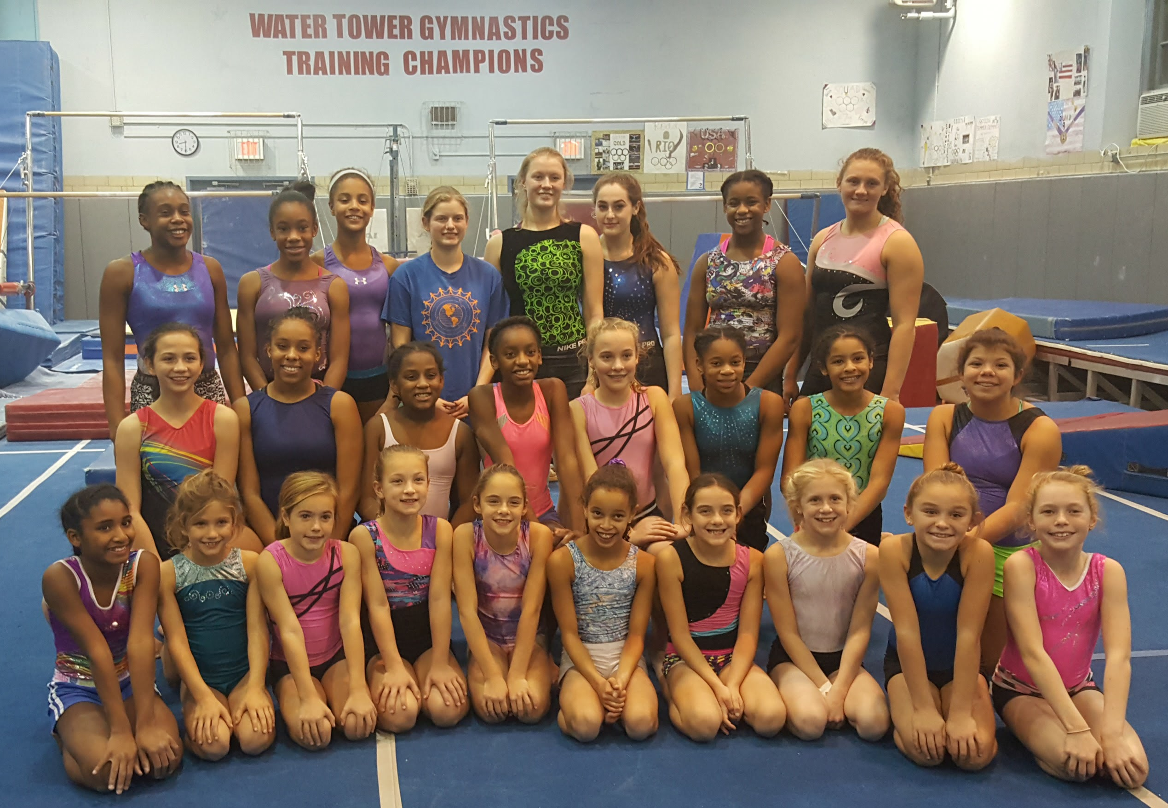

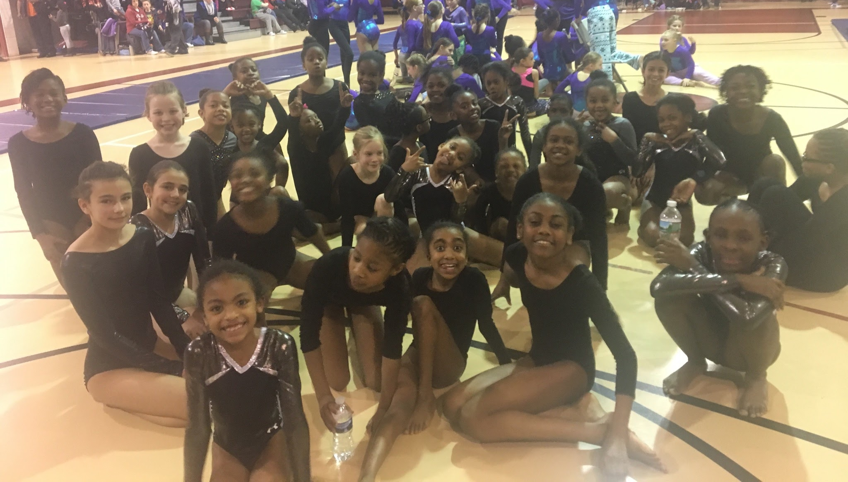

Registration Form (continued on back)
Name ________________________________
Age: ______ Birth Date:____________
Parent/ Guardian: ___________________________________
Address:____________________________
City:____________________ Zip: __________
Phone: ________________________________
Emergency Contact: _____________________
Phone: ________________________________
Any Medical Conditions? _____________________________________________________________________________________________________________________

