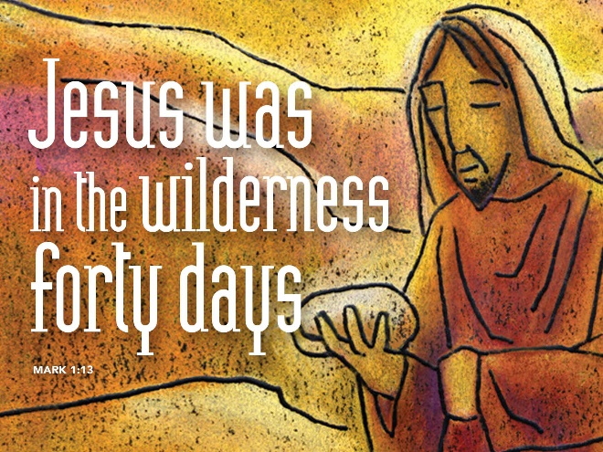
Following Jesus-God’s GPS
February 18, 2018
Mark 1:9-15

Grace and peace to you from God Our Father and from Our Savior and Our Lord, Jesus Christ, amen.
How many of you have or use GPS either like a Garman device or the GPS on your phone when you’re traveling in the car? I use my Garman almost every time I go someplace. I like the idea of knowing when I’m going to arrive and it gives me a digital reading of my speed so I can tell precisely how fast I’m going. I know most newer cars have that feature, but I drive a 2012 truck and it doesn’t… Anyway, I read someplace on the internet, so it has to be true, right… There was a couple driving along following their GPS and ended up in a pier that collapsed and their car ended up in like 20 feet of water at the bottom of the lake. Another instance a man was nearly killed when following the instructions on his GPS he turned onto railroad tracks into an oncoming train. I guess at some point you have to evaluate the instructions you’re following and decide if they’re appropriate… The same is true for us in our spiritual life. We need to take a moment from time to time to evaluate the path we’re on to see if we’re following the truth or some fake version of the truth that’ll lead us into a watery or more likely a fiery end or into an oncoming train.
In these days of the Lenten season I invite you to think about our role as followers of Jesus Christ. In recent months we’ve moved from the anticipation of the birth of the Christ child to seeing Jesus’ ministry begin to unfold. He’s already healed a man possessed by demons in the synagogue, he healed Peter’s mother-in-law, and even healed all the towns people of Capernaum brought before him. Now, in this first week of Lent, we move backwards through the Scriptures. Today’s Gospel takes place immediately after Jesus is Baptized. In coming weeks we’ll watch and follow our Lord as he turns his face toward Jerusalem, as he walks to Jerusalem and on to Golgotha in an unswerving straight to the Cross.
So, what does it mean for us to follow Jesus? During Lent, we’re called to turn and face our true nature. Our own true, yearning, needy nature as it is, laid bare before us to examine. It is not a time for self-loathing or wallowing in self-pity. It’s a time of being honest, a time to look at our whole self; body, soul, and Spirit. A time for us to examine ourselves and see where there is room for God's grace and where we may need to yield to His Lordship. It’s easy to accept Jesus as our Savior, the one we turn to in times of trouble, but it’s a different matter to submit to His Lordship and follow where we may not want to go.
This self-reflection isn’t easy, but it is necessary. It’s necessary so we can continue to be transformed into the image of Christ. That we can move forward on our journey Faith. This reflection should be an ongoing process, but is emphasized by the Church during these 40 days. We always need to evaluate our pathway, but Lent gives us a dedicated time to formalize the process. Lent’s way more than a season to give up something, or to pray more, give more, and fast more… It’s a time to examine where we are and who we’re following… Where Jesus leads we are called to follow. We are to follow not sit back and mindlessly flip through channels of a stagnant spiritual life. We’re called into relationship with the one we call Lord. A solid relationship requires participation our full participation.
So, we follow Jesus our Leader, our GPS, into these days of Lent. To examine ourselves once again, to look into life's mirror, to be honest with ourselves and with God, to seek the things that distract us from God and God's kingdom work. To say it another way, we are to examine those things that keep us from being transformed and from reflecting the image of Christ.
Are we feeling so safe in ourselves, in our pews, our houses, our relationships that we no longer work to maintain spiritual health and wholeness? What are you tempted to believe or deny, to do or to neglect as you journey into self-reflection? Jesus, the One we are called to follow, knows about temptation. God's very Spirit, in Mark's telling ... descended upon Jesus identified Him as the beloved Son. Then this same Spirit drives Him into the wilderness. The Greek word is “Ekballo” which is a pretty violent word. Think projectile vomiting… The Holy Spirit vomited Jesus out and into the wilderness… And Mark makes it clear Satan is there, and temptation is there too.
Does it seem strange to anyone besides me that God’s own Holy Spirit would force Jesus into a time of encountering the Devil and temptation? The more I think about it though I guess we should all accept that the life of faith often leads us as followers into that very same wilderness. I’ve felt it many times. God's Spirit driving, or swiftly kicking me in the posterior and the next thing I know there I am in the wilderness staring at this temptation or another… For me, the temptation is always to preach sweetness and honey, the things people like to hear while ignoring the more harsh word of God. Other times our wilderness is often the landscape of where we live, where we reside. It can even encompass our very own family. Can you feel the dry desert air of the wilderness of our world and our culture? Mass shootings, earthquakes, wars and rumors of wars…
Do you ever feel like me, that you need to be driven by the Holy Spirit, or that you need a swift kick from the Holy Spirit in order to get up--to wake up and follow Jesus? ... To follow the Leader? Perhaps we all do. Perhaps we need to wake up and put on our spiritual big boy and big girl pants and follow the commands of our Lord. We have a great privilege in the days of Lent, and in all the days of our life in faith to be led by God's Perfect Spirit. We pay particular attention during Lent to how the wilderness of temptation can teach us, shape us, and help us to be more Christ Like. To be better Christians. The wilderness prepares us to follow the leader whenever wherever he may lead. The wilderness prepares us to boldly proclaim I will go Lord where you lead me.
During these 40 days of Lent we enter into the wilderness to see what God has in store for us. We follow God’s Perfect Spirit or God’s GPS to learn what God's Spirit has to teach us, so we can passionately follow. Remember Jesus our Leader, didn’t stay in the wilderness. The forty-day's end and Jesus went forth in fulfilling His ministry. The temptation does not last beyond its appointed time. Just like for Jesus, the wilderness time of self-examination should also lead us to ministry. It leads us to action. Jesus, our Leader has walked through the wilderness, but when he returned, he returned to Galilee and proclaimed to all: “The time is fulfilled and the kingdom of God has come near; repent and believe in the good news.”
The Leader of the Universe turns to those who have ears this day, and proclaims “The time is fulfilled. The Kingdom of God is at hand, repent.” We are called to do something--to Repent! Repent means to turn away from the direction we’re heading. Sometimes that means a 180 degree turn. After we turn we’re called to make another decision. Jesus calls, “follow me.”
In our relationship with God we have choices. We can choose if and what we will believe. We can choose which path we will or will not take. We can choose if, who, how long, and how far we will follow. It’s not much different than following your car’s GPS. You make choices in life. You set your priorities. You decide who and when to follow. Or we can choose to trust Jesus and follow wherever he may lead. To repent requires the action of turning ourselves around. To follow also requires an action. It requires us to pursue, to follow in the footsteps of the one who is leading. The fundamental question that we each must ask is this: Do I truly trust Jesus? Do I trust him to be not only my Savior, but also my Lord? That’s a question we each must answer every single day. As you reflect, on your inner life and as you begin to walk through these 40 days of Lent ask yourself--do you trust Him? How much do you really trust Jesus?
May your Lenten journey into the wilderness of self-examination prove to be a blessing. May the Spirit of the living God accompany you on your way. May your trust in Jesus be deeper and greater because of the trials and temptations you overcome in the wilderness. May you come out of your time in the wilderness better prepared to follow God’s Perfect Spirit (GPS) trusting not to be led anyplace other than the everlasting Kingdom of God and His perfect world prepared just for you. Amen.

