Little Lanes

Health and Safety Policy
Little Lanes considers health and safety to be of utmost importance. We comply with The Health and Safety at Work Act 1974 and the Workplace (Health, Safety and Welfare) Regulations 1992 at all times.
The Club has appropriate insurance cover, including employer’s liability insurance and public liability insurance.
Each member of staff follows the Club’s Health and Safety policy and is responsible for:
- Maintaining a safe environment
- Taking reasonable care for the health and safety of themselves and others attending the Club
- Reporting all accidents and incidents which have caused injury or damage or may do so in the future
- Undertaking relevant health and safety training when required to do so by the manager.
Any member of staff who disregards safety instructions or recognised safe practices will be subject to disciplinary procedures.
Responsibilities of the registered person
The registered person for the setting holds ultimate responsibility and liability for the safe operation of the Club. The registered person will ensure that:
- They nominate a Health and Safety Officer. The designated health and safety officer is Clare Greenham
- A copy of the current Health and Safety At work poster is displayed (poster is available here: http://www.hse.gov.uk/pubns/books/lawposter.htm )
- All staff receive information on health and safety matters, and receive training where necessary
- The Health and Safety policy and procedures are reviewed regularly
- Staff understand and follow health and safety procedures
- Resources are provided to meet the Club’s health and safety responsibilities
- All accidents, incidents and dangerous occurrences are properly reported and recorded. This includes informing Ofsted, child protection agencies and the Health and Safety Executive under RIDDOR (Reporting of Injuries, Diseases and Dangerous Occurrences Regulations 1995) where appropriate.
- All reported accidents, incidents and dangerous occurrences are reviewed, so that preventative measures can be taken.
Responsibilities of the manager
The Club’s manager is responsible for ensuring that at each session:
- Premises are clean, well lit, adequately ventilated and maintained at an appropriate temperature
- The premises are used by and solely available to the Club during opening hours
- All the Club’s equipment is safely and securely stored
- Children are only allowed in the kitchen if properly supervised (eg for a cooking activity)
- A working telephone is available on the premises at all times
- Chemicals and cleaning materials are stored appropriately, and in accordance with COSHH data sheets.
- External pathways are cleared in severe weather
- Daily environment checks are carried out in accordance with our Risk Assessment policy.
Security
Children are not allowed to leave the Club premises during the session unless prior permission has been given by the parents (for example, to attend other extra-curricular activities).
During Club sessions all external doors are kept locked, with the exception of fire doors which are alarmed. Staff monitor the entrances and exits to the premises throughout the session.
All visitors to the Club must sign the Visitor Log and give the reason for their visit. Visitors will never be left alone with the children.
Security procedures will be regularly reviewed by the manager, in consultation with staff and parents.
Toys and equipment
All furniture, toys and equipment are kept clean, well maintained and in good repair. We select toys, equipment and resources with care, and we carry out risk assessments before the children are allowed to use them. Broken toys and equipment are disposed of promptly.
We ensure that any flammable equipment is stored safely.
Food and personal hygiene
Staff at Little Lanes maintain high standards of personal hygiene, and take all practicable steps to prevent and control the spread of infection.
- A generally clean environment is maintained at all times.
- Toilets are cleaned daily and soap and hand drying facilities are always available.
- Staff are trained in food hygiene and follow appropriate guidelines.
- Waste is disposed of safely and all bins are kept covered.
- Staff ensure that children wash their hands before handling food or drink and after using the toilet.
- Cuts and abrasions (whether on children or staff) are kept covered.
Dealing with body fluids
Spillages of blood, vomit, urine and faeces will be cleaned up immediately in accordance with our Intimate Care policy.
Staffing levels
Staff ratios and levels of supervision are always appropriate to the number, ages and abilities of the children present, and to the risks associated with the activities being undertaken. A minimum of two members of staff are on duty at any time.
Related policies
See also our related policies: Illness and Accidents, Emergency Evacuation, Healthy Eating, Safeguarding, Administering Medication, Risk Assessment, Manual Handling, Fire Safety, and Intimate Care, Visitor.

This policy was adopted by: Cheri Garratt | Date: February 2022
To be reviewed: February 2023 | Signed:  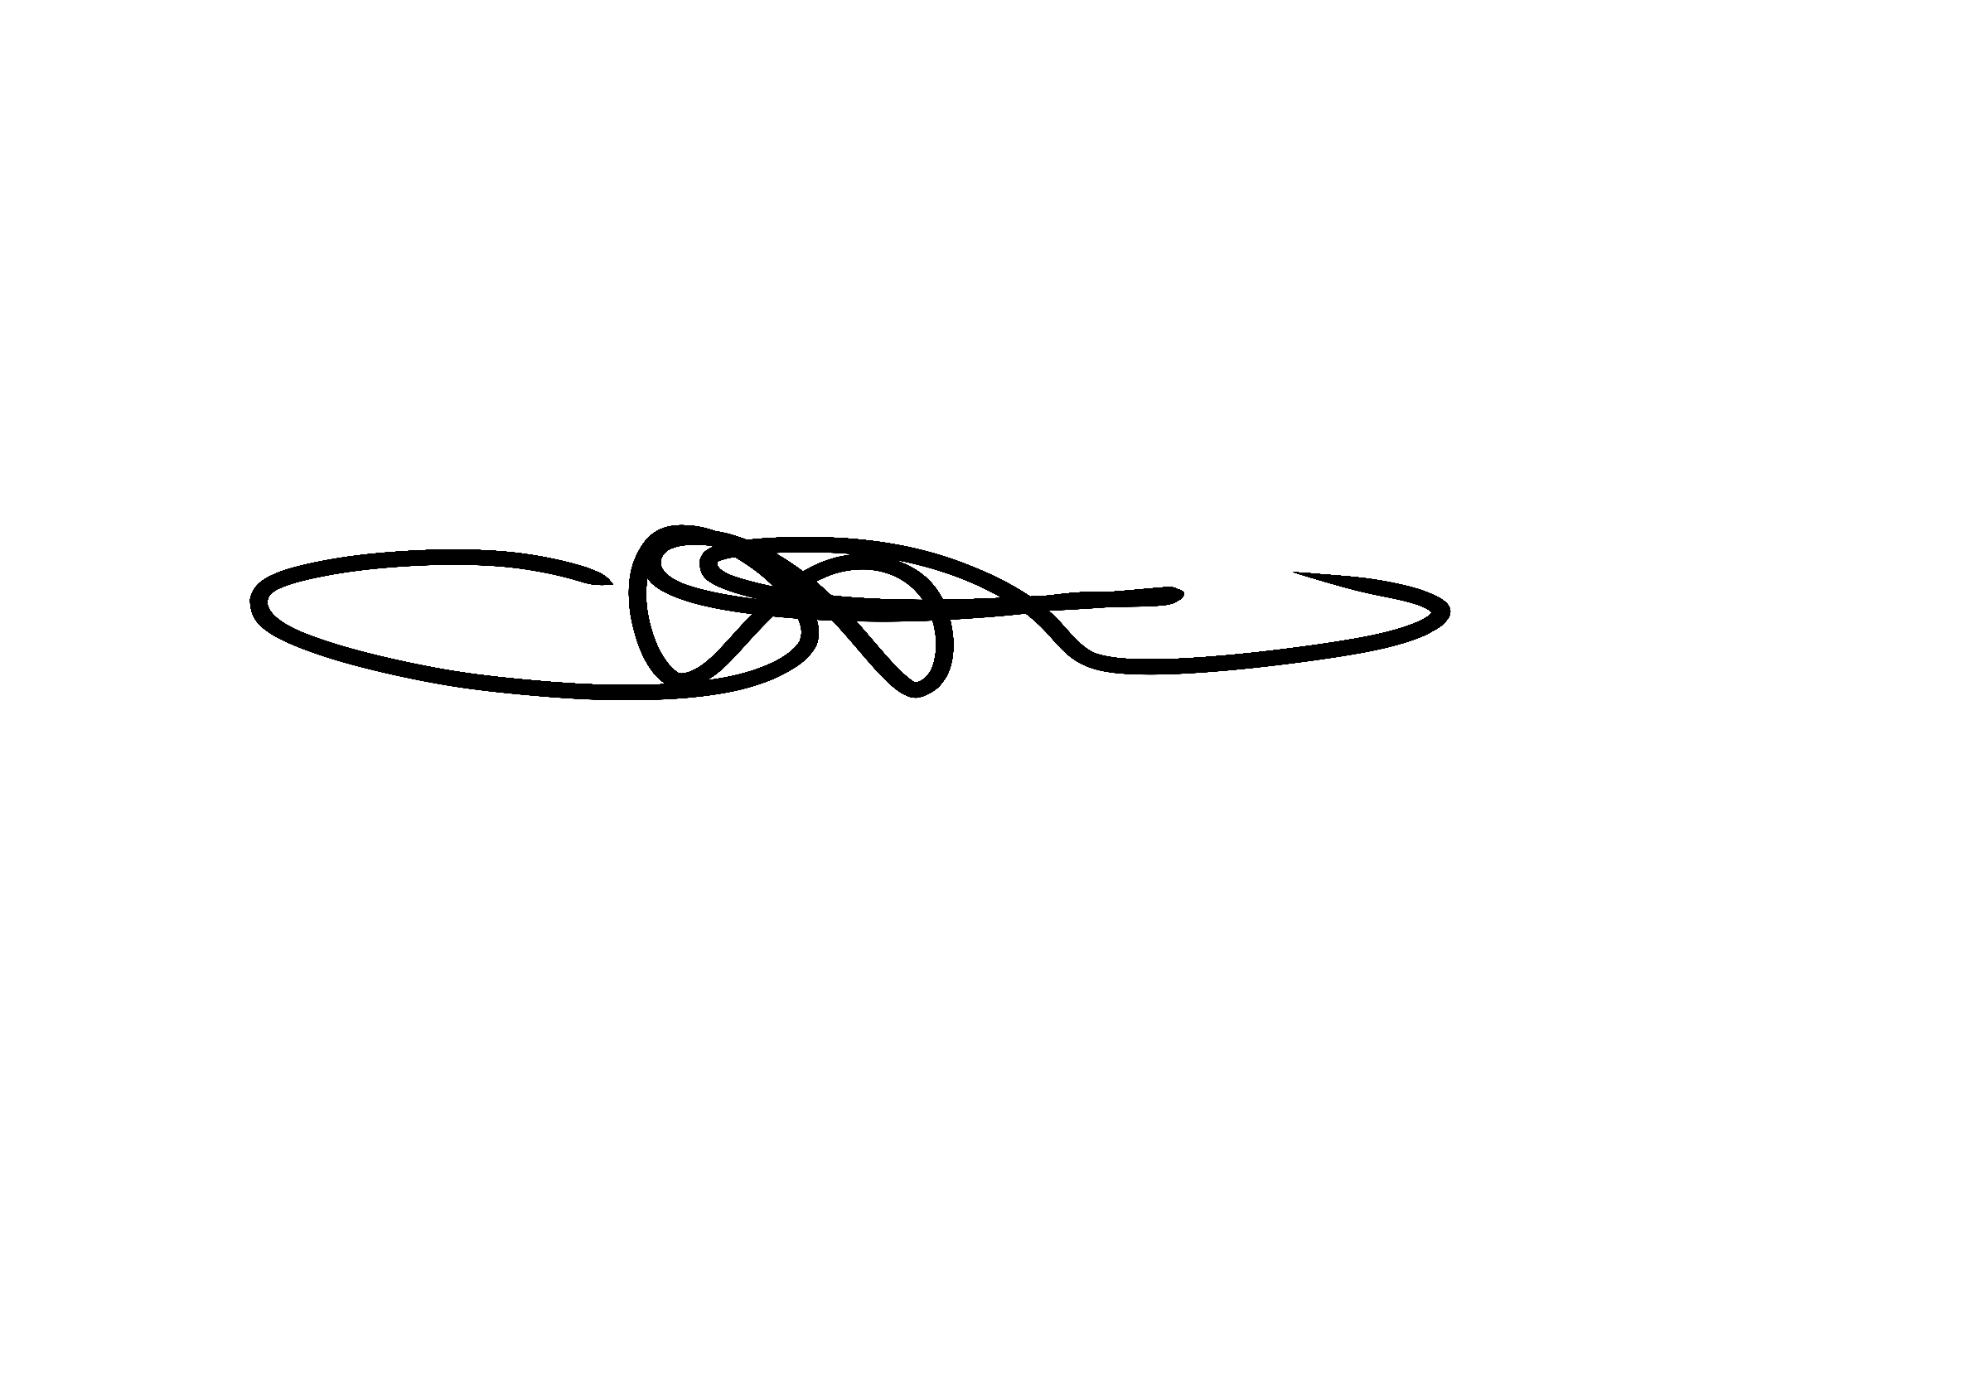

Written in accordance with the Statutory Framework for the Early Years Foundation Stage (2021): Safeguarding and Welfare Requirements: Safety and suitability of premises, environment and equipment [3.55-3.65].

