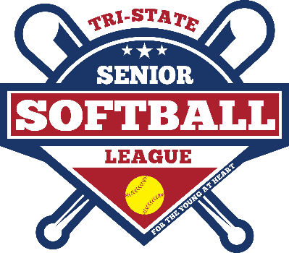
Note: Men must be 50 and women 35 to participate in Tri-State Senior league play. Please provide a completed registration form, your signed waiver, and a payment of $50.00 is required BEFORE you can practice. Registration forms are available on the webpage at www.tsssl.org Registration deadline is April 24, 2023.

2023 Tri-State Senior Softball Registration Form
Name: Nick Name: _ Mailing/Home Address: _

Your Contact Information: Home Phone:

Cell Phone:

Email Address:

Date of Birth: _____________ Your age in 2023: ________

Field Position 1st Choice: Field Position 2nd Choice:

Circle your Shirt Size: S M L XL 2XL 3XL

What % of games will you attend? Less than 50% 75% over 90% (Circle one)

Do you have any physical disabilities that make the game of softball a challenge for you?
_______________________________________________________________
Do you authorize the league to use your image/video for promotional purposes on
Its website and social media?* Social Media Authorization: Yes ____ No ____

Emergency Contact Person:
Contact Person Phone Number:
First practice is April 3rd, 2023, weather permitting. Two games a week will be played at Marty Snook Park. Games start at 6:30 and will be scheduled on Monday, Tuesday or Thursday with make-up games played on Wednesday.
All players must read and agree to the rules listed on our web site. Registration fee of $50.00 MUST be paid prior to you practicing and can be paid at the first practice. NO EXCEPTIONS WILL BE MADE!!
If you withdraw your name prior to the draft your fee will be returned.
WAIVER, RELEASE AND ASSUMPTION OF RISK

In consideration of my participation in the TRI-STATE SENIOR SOFTBALL LEAGUE, I hereby waive, release, and discharge all claims for damages of death, personal injury, or property damages which may occur because of my participation in the softball league or any activity incident thereto. This release discharges in advance WASHINGTON COUNTY, its officers, agents, servants, and employees (hereinafter referred to as “COUNTY “) from liability even though that liability may arise out of the COUNTY’S active or passive negligence or carelessness. I acknowledge that some recreational activities, including softball, involve an element of risk or danger of accidents, injury, and even death. Knowing these risks, I freely and voluntarily assume the risks of injury and or death and further promise not to sue or exercise any legal right to seek damages from the COUNTY. By this Agreement I also intend to waive, release and discharge all claims for personal injury, death, or property damage caused by the condition of the softball fields or any equipment thereon including bases, backstops, bleachers, or balls.

I certify that I have no medical condition that would cause participation in the Tri-State Senior Softball League to increase the risk of hazard to my health. I accept responsibility to provide or cause to be provided any such medical treatment that may be necessary or appropriate if I am injured while participating.

PLAYER NAME Printed ________

SIGNATURE DATE

Safety Statement: Only ASA approved bats are to be used during practice & games in the TSSSL. All bats must be inspected & approved by the Bat Committee & have a valid TSSSL ID tag on the bat prior to use in the TSSSL games, including any practice.

Please make checks payable to TSSSL. Registration and Waiver Forms may be sent directly to:

Mr. Tommy Hyme
146 S. Mulberry Street Hagerstown, MD 21740
Phone: 301-573-5199
hymehyho@aol.com

