Meet Vera Bacon
by Kathleen Jamison

Thanks to a murder mystery dinner at the Safety Harbor Library and the chance meeting with Friendship Force member Laura Wilson, we are lucky to be welcoming Vera Bacon to the club. (That's a reminder that word of mouth about FFI is the best way to increase our membership.)

"Laura invited me to come to the spring picnic, and I'm so glad she did. I am very happy to be making so many new friends," Vera says. "It's always been my dream to travel, so I'm looking forward to that part of Friendship Force." It didn't take her long to become an active member, putting her years of work in the printing business to use helping with publications for the Vancouver club visit and volunteering to bring a dessert to their farewell party.

Vera was born and raised in Rochester, New York, living there for 74 years until she moved to Florida six years ago. "My daughter Coreen moved to North Carolina and my son David moved to St. Pete. I wasn't going to be left behind up there," she laughs. She now lives with David and his family in Safety Harbor.

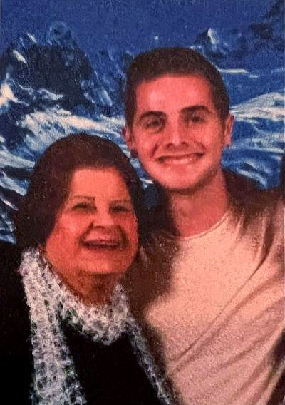
Visiting relatives and camping trips were a part of growing but "unfortunately, my traveling dream didn't happen until after my husband died in 1993." At that time, she started taking classes at a local community college. "I was 51 and I got all A's and an associates degree in liberal arts!"
An Italian Renaissance course led to a college trip to Italy followed by several return trips to Italy then Russia, Finland and most recently Alaska. Cruises are her new passion. "When it's time for me to go to a nursing home, I've told my kids to put me on a cruise instead. They are wonderful and a lot cheaper!"

For 10 years Vera owned a ceramic shop with her husband and has been an active member of Beta Sigma Phi, an international non-academic sorority, for 60 years. While still in New York, she chaired a sorority convention that hosted 500 members. In any spare time, she knits and crochets prayer shawls and lap robes for individuals who have lost a loved one, hats for homeless veterans, and blankets for babies.

Welcome, Vera.

