Amelia-Nottoway Technical Center News 3/19/2021
ANTC STUDENT SPOTLIGHT!
Nicholas Noblin, NHS Senior
Auto Body II

What brought you to ANTC? I wanted to take Auto Body.
What is your dream job? I want to work with cars.
What is your favorite class that you have taken so far? Why? Auto Body because it is fun working on card and fixing them up.
What is the best advice you have been given by your instructor at ANTC? “Listen before you speak.”
What is your favorite memory at ANTC? I like being a good person to friends.
What was the first feeling you had when you attended ANTC? I thought, “Don’t hurt yourself.”
What words of wisdom do you have for other students? “Don’t run.”
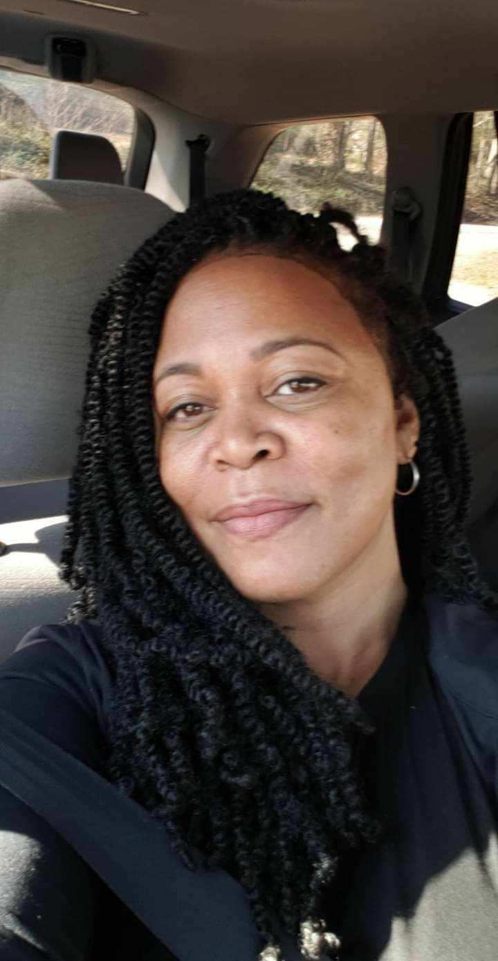
ANTC ALUMNI HIGHLIGHT!
Freda Todd Perry
High School: Nottoway High School 1990
ANTC Program: Nurse Aide
Career: Therapist at VCBR
Master’s in Professional Counseling
Future: Working on Doctorate in Counseling
“There is no dream unreachable, set goals, create small objectives until you get to your goal.”

How Does CTE Impact Women?
Men participate in significantly greater numbers than women do in the military, the police force, the fire department, manufacturing jobs and other and in “blue collar” industries, such as construction and plumbing. Creating more opportunities for women in these fields entails addressing biases around gender roles — and expanding access, support and encouragement for women to pursue these fields. That means supporting Career and Technical Education (CTE) training opportunities as a viable alternative pathway for women.

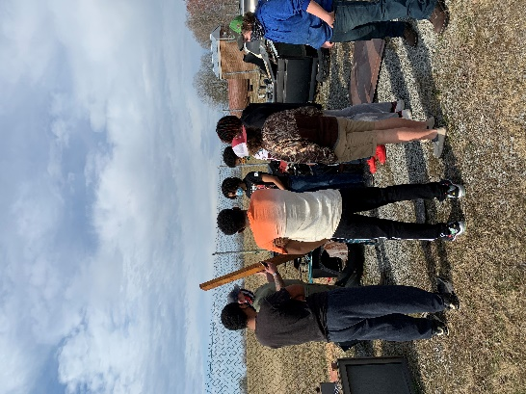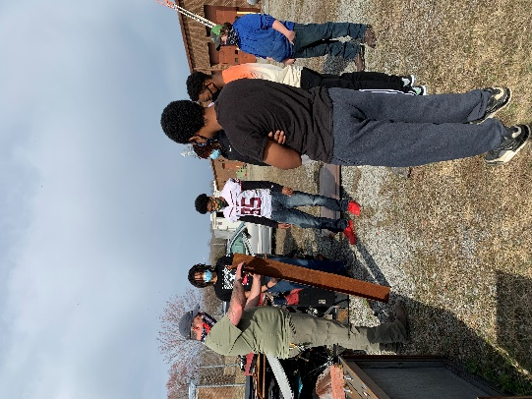
Program: Auto Body l & II; Amelia and Nottoway

Skills: Cutting Metal & Mounting and Balancing Tires

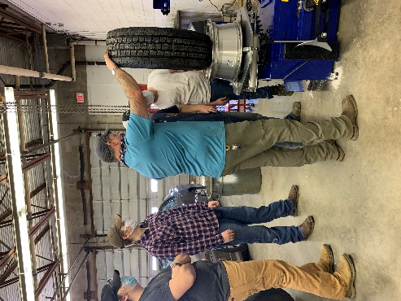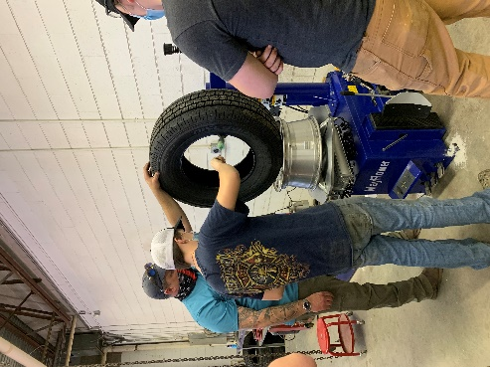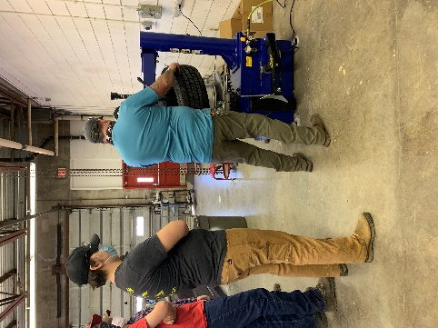

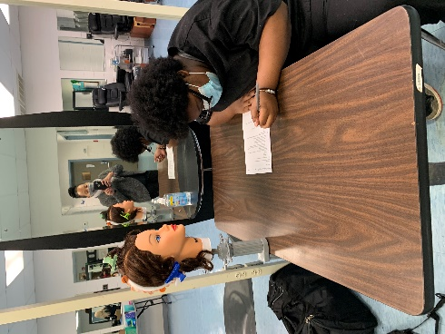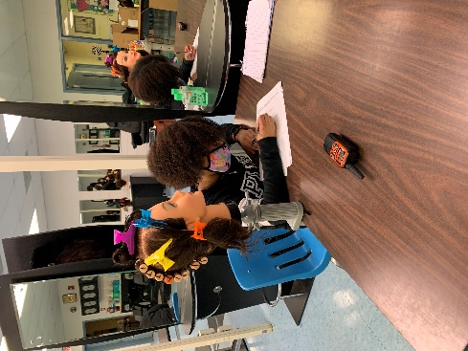
Program: Cosmetology l & II; Amelia, Cumberland and Nottoway

Skills: State Board (Written) & Cutting

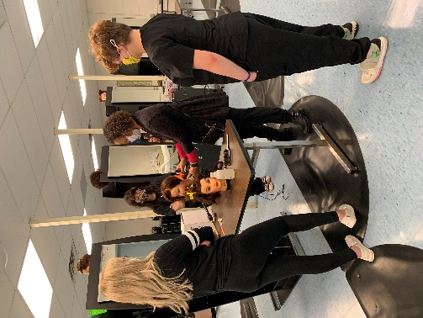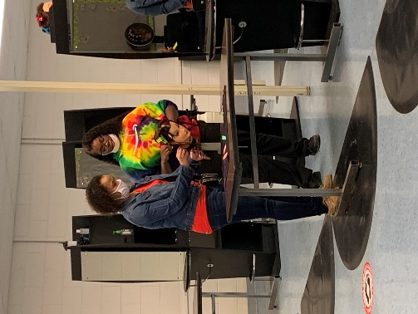
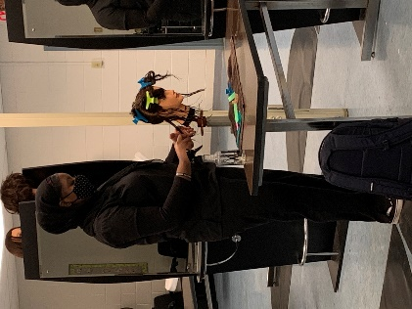
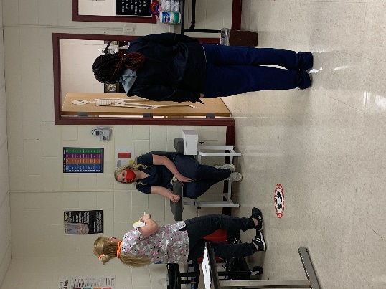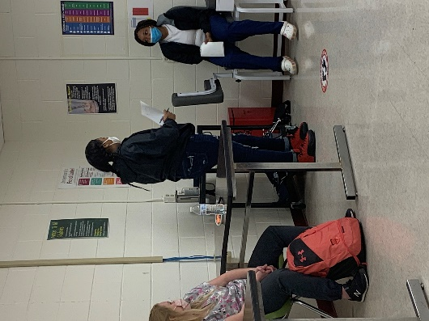
Program: Medical Assistant I & II; Amelia and Nottoway

Skills: Scenarios & EKG

