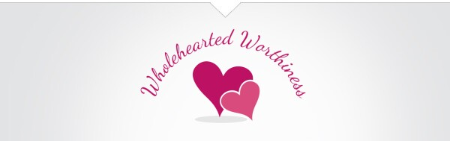
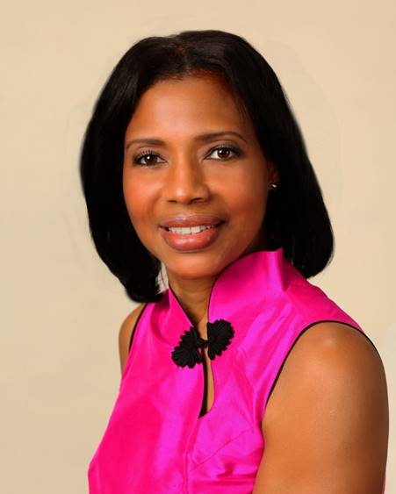
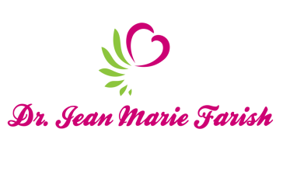

LOVE LIGHT NewsLetter
I am excited to host my VoiceAmerica Empowerment Show-LOVE LIGHT with amazing Guests to cultivate a lifestyle of love and wholehearted connections through worthiness. My show is aligned with my mission to live an altruistic and heart centered life.

MEET LOVE LIGHT GUEST

L. Hillary BASDEN, RN, MSN
UMMC PROGRAM MANAGER OFFICE OF PATIENT EXPERIENCE

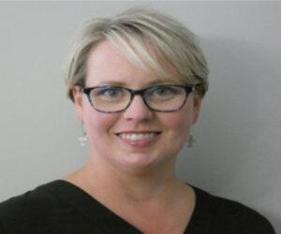

March 27, 2020
HEALING ARTS AND EMPOWERING HEALTH CARE WORKERS

ABOUT L. Hillary Basden

L. Hillary Basden is a registered nurse who has worked in direct patient care for more than 10 years. She has clinical experience in emergency medicine, medical/surgical nursing, and cardiology. Through the course of her early nursing professional career, she began to recognize the signs of burnout and compassion fatigue with in care teams, and its impact in patient care delivery. This along with her strong faith and servant focused principles, motivated her to explore innovative strategies for elevating teams to promote better outcomes with staff engagement and improved patient and family experiences.

As the University of Mississippi Medical Center began to expand its Office of Patient Experience services in 2019, Ms. Basden became Program Manager joining a growing team dedicated to enhancing organizational culture and patient and family centered care. During 2019, she led the development of hospital based programmatic work including the launching of Healing Arts programs, Pet Therapy, and Patient and Family Advisory Councils. UMMC’s Healing Arts program gives patients and their families an emotionally and culturally fulfilling experience aimed at speeding the healing process. It also enriches staff well-being and engages the broader surrounding community through collaboration with participating artists.

https://www.umc.edu/Healthcare/Patients-and-Visitors/Patient%20Experience/Healing_Arts_Program.html
https://www.umc.edu/news/News_Articles/2019/08/Pet-Therapy.html
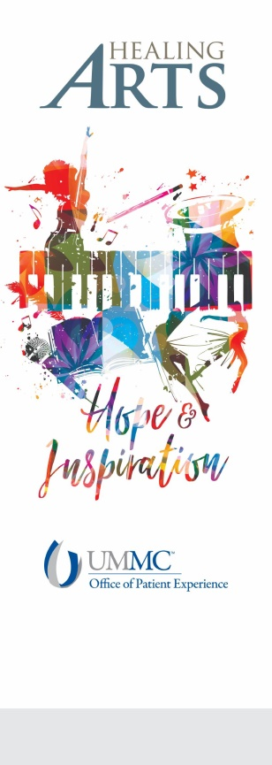

“An empowered self is a loving self and keep your love light shining”

