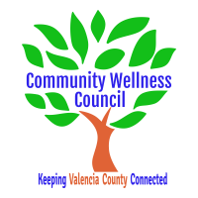
Board Meeting
July 3, 2019
1:00pm-3:00pm Wellness Center

1:00PM-1:10PM

- Call Meeting to Order
- Welcome Guests
- Agenda
- Consent Agenda
  - Minutes of 5/2/19
  - Treasurer Report April
  - Coalition Reports
- Social Media/Website Report
- Consent Exemptions
Business
- Presentation by Dana Millen from the Health Securities Act 1:10 PM-1:35 PM
- Coordinator’s Report (Noelle) 1:35 PM-1:45PM
- Grant, Grant deliverables/Activities Update (Diana/Noelle) 1:45-1:55PM
- Financial Management Update/Monthly Match (Noelle) 1:55PM-2:00PM
- Anna Age 8 Community Planning Action Lab (Diana/Noelle) 2:00PM-2:10PM
- KAH (Noelle) 2:10pm-2:15PM
- Debrief on June CRUNCH at Ana Becker Park (All) 2:15-2:25PM
- Review Timeline for upcoming planning for events (All) 2:25-2:40PM
- OSAP/Community Survey update (Linda) 2:40-2:50PM
- MRGDA Update (Noelle/Diana) 2:50pm-2:55pm
- Review of Activities/Time Line/Action Items 2:55 PM-3:00PM

Additional Items of Discussion
- Adjourn

