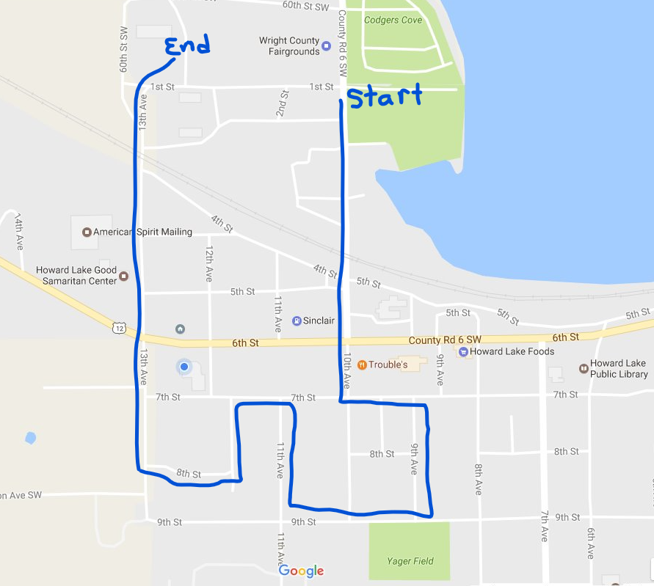
Grande Day Parade. Line up at Fairgrounds at 1:00 PM. After Troubles… going up 7th Street to 9th Avenue, back onto 9th Street, then onto 11th Ave, back on 7th Street, turn up 12th Avenue (street not showing up on map), to 8th Street and then onto 13th Ave.

